Tender No: 2024-25/Estate/1B/LNM-670
The LNM Institute of Information Technology, Jaipur

TENDER NOTICE

The LNM Institute of Information Technology, Jaipur is a Deemed-to-be-University, set up as a Non-Profit Making institute engaged in imparting higher learning in Engineering, Technology and Science. We are located at Gram-Rupa Ki Nangal, Post-Sumel, Via-Jamdoli, Jaipur, Pin 302031 Rajasthan, under the joint venture of the Government of Rajasthan and Lakshmi & Usha Mittal Foundation.
The institute invites proposals from competent vendors for “Registrar Office Aluminum Work with Wooden table”. Bidders can submit their sealed/password-protected offers/s at the following address by Email/Speed-Post/ Registered Post/ By-hand/courier before 05:00 PM on 10.08.2024.
Filing of Tender:
Option 1: Physical submission of offers (hard copy) in sealed envelopes.
Bids shall be addressed to the undersigned and deposited in the tender box available at the main gate of the institute in person/ Speed-Post/ Registered Post/ By-hand/courier of the Institute after marking due entries in the Receipt Book available with the Security Officer at the main gate.
The tender subject Registrar office Aluminum Work with Wooden table. Further, the Tender Number must be mentioned on the envelope.
Director
The LNM Institute of Information Technology,
Gram – Rupa Ki Nangal, Post – Sumel,
Via – Jamdoli, Jaipur- 302031
Email: directoroffice@lnmiit.ac.in

Option 2: Password-protected online submission via Email
Password-protected offers can be submitted by the bidders via email at the below-mentioned email IDs.

tender-document@lnmiit.ac.in (password-protected document)
tender-password@lnmiit.ac.in (password only)
The tender subject (Item name) and Tender Number must be mentioned in the subject line of the emails.

Bid Process:
The Techno-commercial offers on the company’s letterhead, duly signed by the authorized signatory, are required to be submitted in sealed envelope/ emails.
Envelope/Email should be duly marked as follows:
Techno-commercial bid for the Registrar office Aluminum Work with Wooden table, Tender No: 2024-25/Estate/1B/LNM-670”

Bids are liable to be rejected:
- If the above-mentioned bid submission procedure is not followed.
- Incomplete and non-conforming bids.
- Arbitration: All disputes and differences arising between the two parties in connection with this order shall be mutually settled as far as possible, failing which, all such disputes shall be referred to arbitration and settlement under the provision of the Arbitration and Conciliation Act, 1996 and as amended from time to time or any such law for the time being prevailing in India. The venue of such arbitration shall be Jaipur.
Techno-commercial Bid for the
“Registrar office Aluminum Work with Wooden table”.

Tender No: 2024-25/Estate/1B/LNM-670
Sr. No. | Description | Qty. | UOM | Rate | Amount
1 | Providing and fixing of 2.5 × 1.5 anodised aluminium partition with door, 5mm glass, and low height 12mm particle board, PVC rubber complete size 13'×10.5 feet, Hardware & Glass Make:- Moda, Hettich, 3M. | 137 | Sqft
2 | Providing and fixing of wooden table of 19 mm solid board with laminate drawer, Shuttering complete  Size 13×2.5 feet, Make:- Sanik 710 | 1 | Nos
3 | Cartage | 1 | Nos
Total
GST
Total including GST

- Taxes like GST shall be clearly mentioned. If nothing is mentioned, these charges shall be deemed included.
- If the supplier does not have a particular item offered in the tender or a different make is being proposed by him, the same should be highlighted/mentioned especially by him.
- The prices should include everything (Packing, forwarding, Transit Insurance, Transportation Loading, unloading up to 50mtr., Installation etc.).
- Bid should be submitted for F.O.R delivery at the destination i.e. The LNM Institute of Information Technology, Gram – Rupa Ki Nangal, Post – Sumel, Via – Jamdoli, Jaipur- 302031
- The bid should be valid for a minimum period of 30 days. The Change in prices shall not be accepted within the validity period.
- The LNMIIT reserves the right to reject any quotation(s) without assigning any reasons.
- Payment terms shall be decided mutually.
- There should not be any conflict of interest (Declaration to be submitted by the Vendor).
- Bid should be on the company’s letterhead and should submit their bid in the LNMIIT format only. Otherwise, LNMIIT reserves the right to reject any quotation(s).
- Item/Service not supplied by the supplier/service provided should be mentioned separately.
- Vendor should provide a photocopy of the cheque/cancelled cheque while presenting the Invoice to LNMIIT.
- Pre-bid meeting can be done before quoting the rate in the tender to clear up any confusion regarding project details, the scope of work, and solicitation of documents.

All charges applicable shall be clearly mentioned in the offer. If nothing is mentioned in the offer, the quoted price shall be treated as final and nothing extra shall be paid extra.

Signature with seal

Office Cabin Drawing
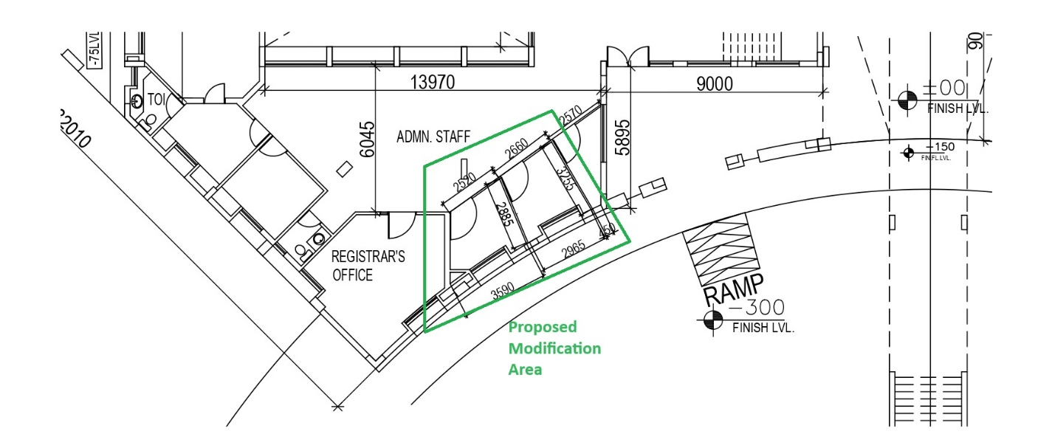

Aluminum Partition for office cabin sample photographs
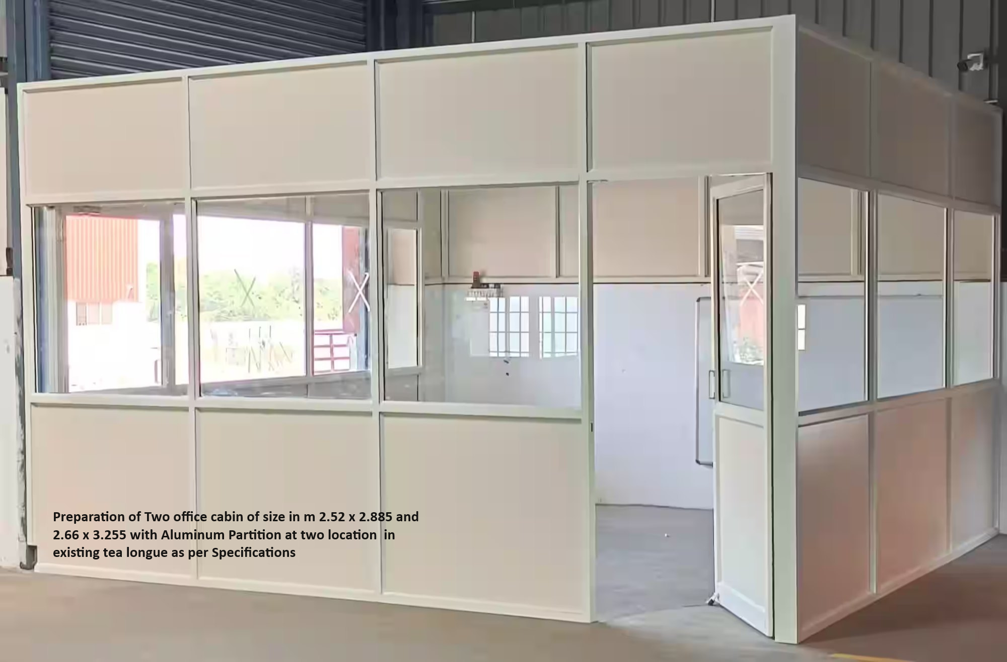

Reception Table L shape Sample photographs


