Tender No:. 2024-25/Estate/2B/LNM-782

The LNM Institute of Information Technology, Jaipur

TENDER NOTICE

The LNM Institute of Information Technology, Jaipur is a Deemed-to-be-University, set up as a Non-Profit Making institute engaged in imparting higher learning in Engineering, Technology and Science. We are located at Gram-Rupa Ki Nangal, Post-Sumel, Via-Jamdoli, Jaipur, Pin 302031 Rajasthan, under the joint venture of the Government of Rajasthan and Lakshmi & Usha Mittal Foundation.
The institute invites proposals from competent vendors for “Supply, Installation, Testing, and Commissioning of 4 Kw 3 Phase Vertical Multistage Centrifugal Pump with complete accessories”. Bidders can submit their sealed offers/s at the following address by Email/Speed-Post/ Registered Post/ By-hand/courier before 05:00 PM on 21.12.24
Filing of Tender:
Option 1: Physical submission of offers (hard copy) in sealed envelopes.
Bids shall be addressed to the undersigned and deposited in the tender box available at the main gate of the institute in person/ Speed-Post/ Registered Post/ By-hand/courier of the Institute after marking due entries in the Receipt Book available with the Security Officer at the main gate.
The tender subject and reference number must be mentioned on the envelope.

Director
The LNM Institute of Information Technology,
Gram – Rupa Ki Nangal, Post – Sumel,
Via – Jamdoli, Jaipur- 302031
Email: directoroffice@lnmiit.ac.in

Option 2: Password-protected online submission via Email
Password-protected offers can be submitted by the bidders via email at the below-mentioned email IDs.

tender-document@lnmiit.ac.in (password-protected document)
tender-password@lnmiit.ac.in (password only)
The tender subject and reference number must be mentioned in the subject line of the emails.

Bid Process:
Technical & Commercial details on the company’s letterhead, duly signed and sealed by the authorized signatory, are required to be submitted in two separate envelopes/emails.
Envelopes/Emails should be duly marked as follows:
- Technical bid for the “Supply, Installation, Testing, and Commissioning of 4 Kw 3 Phase Vertical Multistage Centrifugal Pump with complete accessories”.
- Commercial Bid for the “Supply, Installation, Testing, and Commissioning of 4 Kw 3 Phase Vertical Multistage Centrifugal Pump with complete accessories”.
Both Envelopes/files should be enclosed/attached in a single envelope/email bearing the heading “Bid for the “Supply, Installation, Testing, and Commissioning of 4 Kw 3 Phase Vertical Multistage Centrifugal Pump with complete accessories (Item Name) (Tender No. : 2024-25/Estate/2B/LNM-782) ”.
Bids are liable to be rejected:
- If the above-mentioned bid submission procedure is not followed.
- Incomplete and non-conforming bids.
- Arbitration: All disputes and differences arising between the two parties in connection with this order shall be mutually settled as far as possible, failing which, all such disputes shall be referred to arbitration and settlement under the provision of the Arbitration and Conciliation Act, 1996 and as amended from time to time or any such law for the time being prevailing in India. The venue of such arbitration shall be Jaipur.
Technical Bid: (in a separate sealed envelope/via email)

Bid for Supply, Installation, Testing, and Commissioning of 4 Kw 3 Phase Vertical Multistage Centrifugal Pump with complete accessories (Tender No. : 2024-25/Estate/2B/LNM-782)

While submitting quotations, the following procedure/ formalities and conditions may kindly be adhered.
- Company profile or brief note about the bidder's company, PAN number, and GST number should be submitted by the Vendor.
- The List of Directors/Partners/Proprietor/Members of the Firm to be attached.
- Detail of other associated/sister concerns (if any) of Directors/Partners/ Proprietor/ Members to be provided.
- Turnover for the last three years to be mentioned. (Copy to be enclosed)
- List of the client to whom the vendor has delivered the goods or provided the services in the past.
- Specification as mentioned below, shall be provided as per the details given below:

Scope of work
- The scope of work will cover the supply/service/SITC of given items at LNMIIT Jaipur campus.
- The Vendor is required to submit the complete documentation of the supplied item after delivery.
- SITE CONDITION:
Before quoting, the contractor must visit the site to inspect the work and shall fully acquaint himself about the conditions and scope of work with regards to accessibility of site required for the satisfactory execution of work. No compensation on account of any site difficulties will be entertained at a later date, after the award of the works.

TECHNICAL SPECIFICATIONS FOR 4 Kw 3 Phase Vertical Multistage Centrifugal Pump

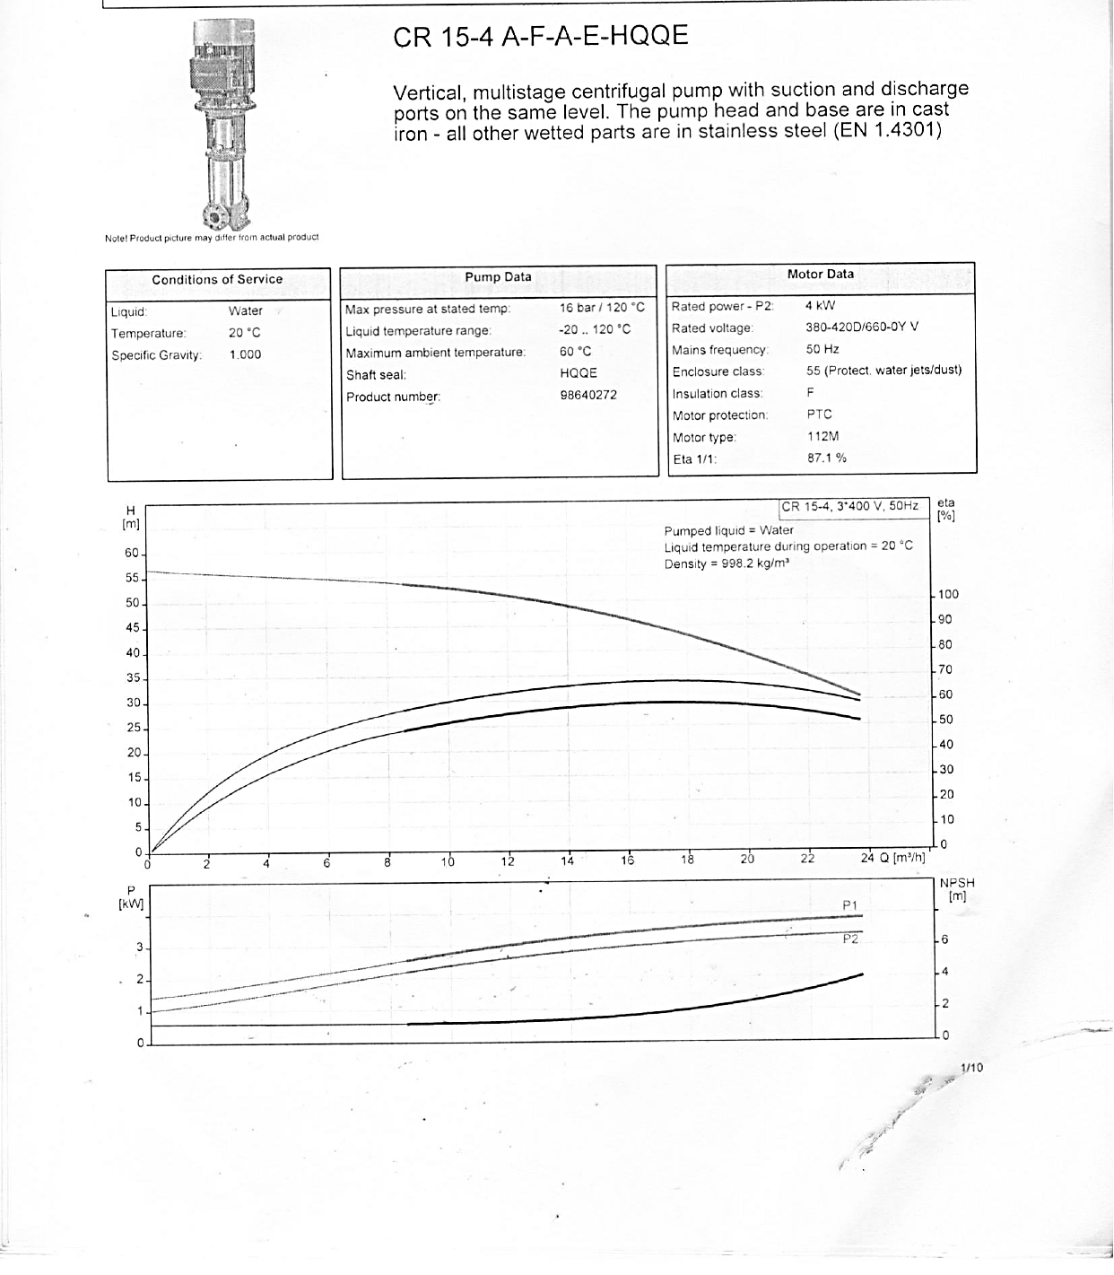

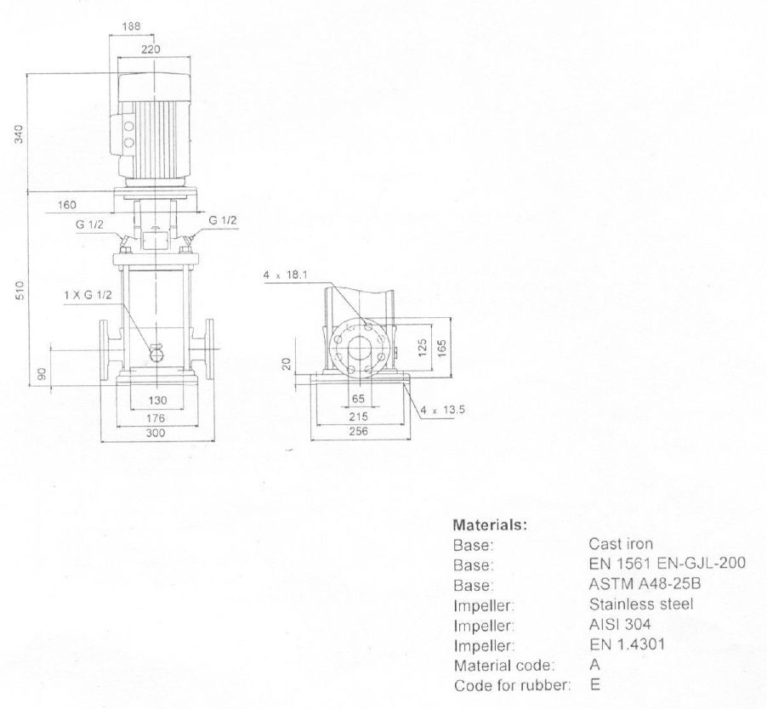

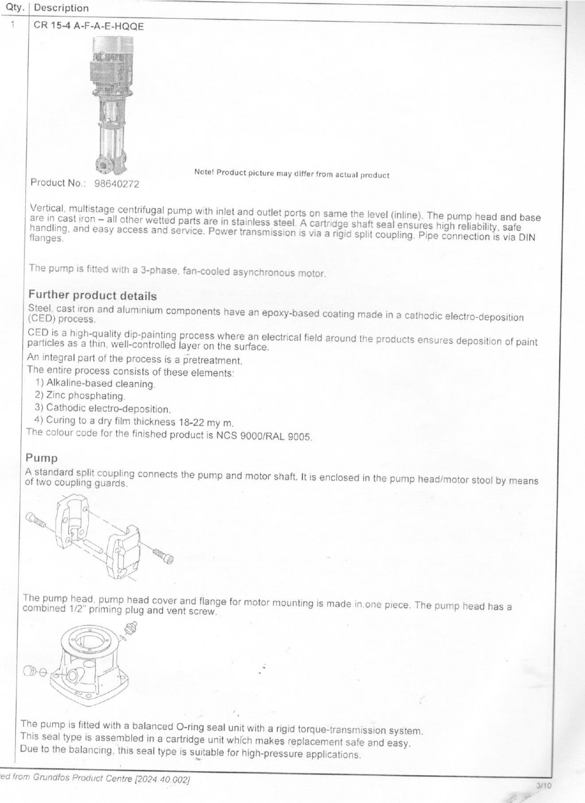
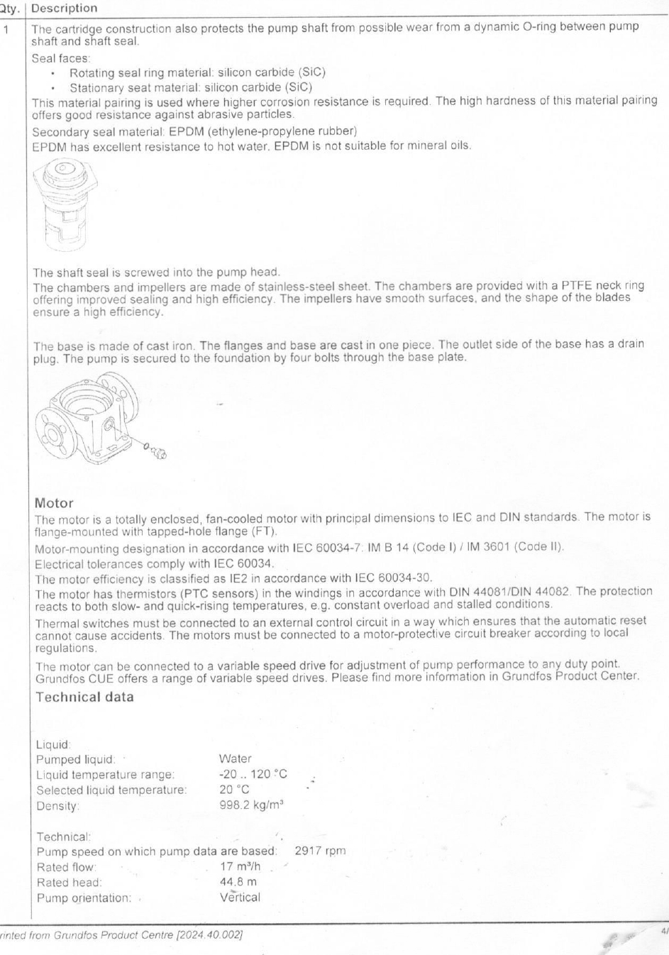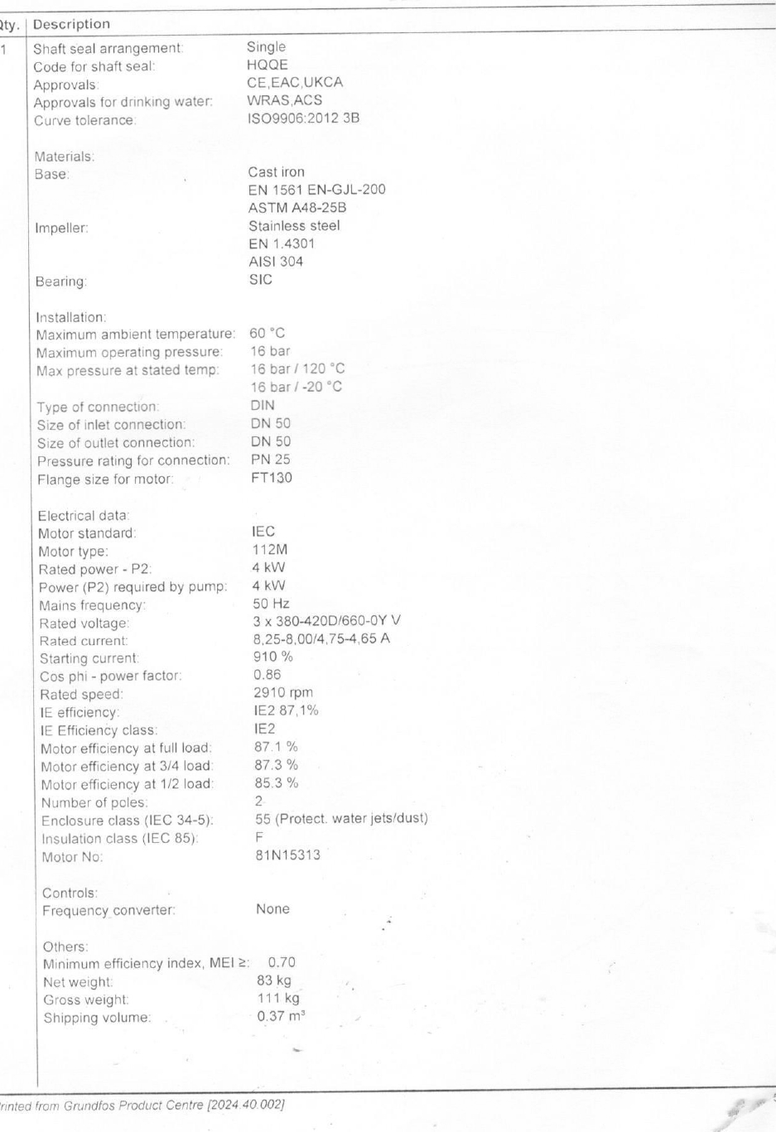
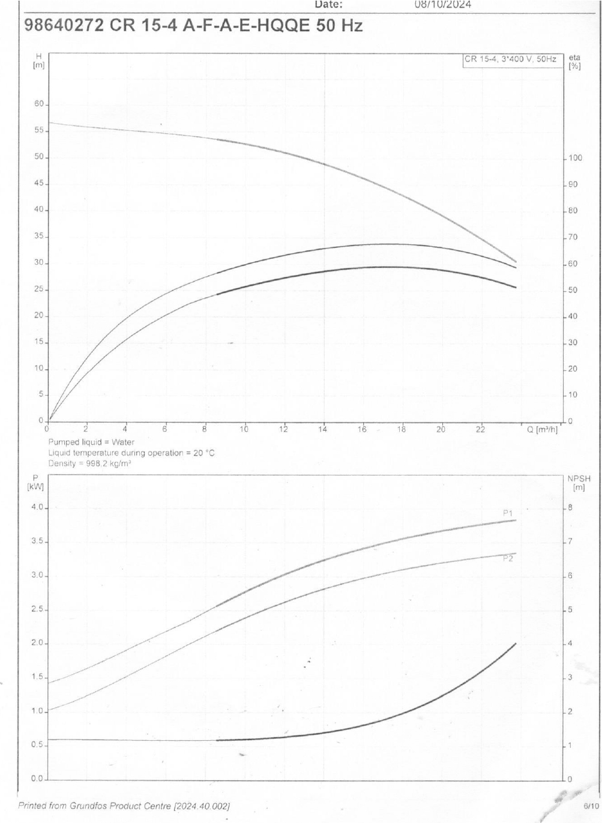

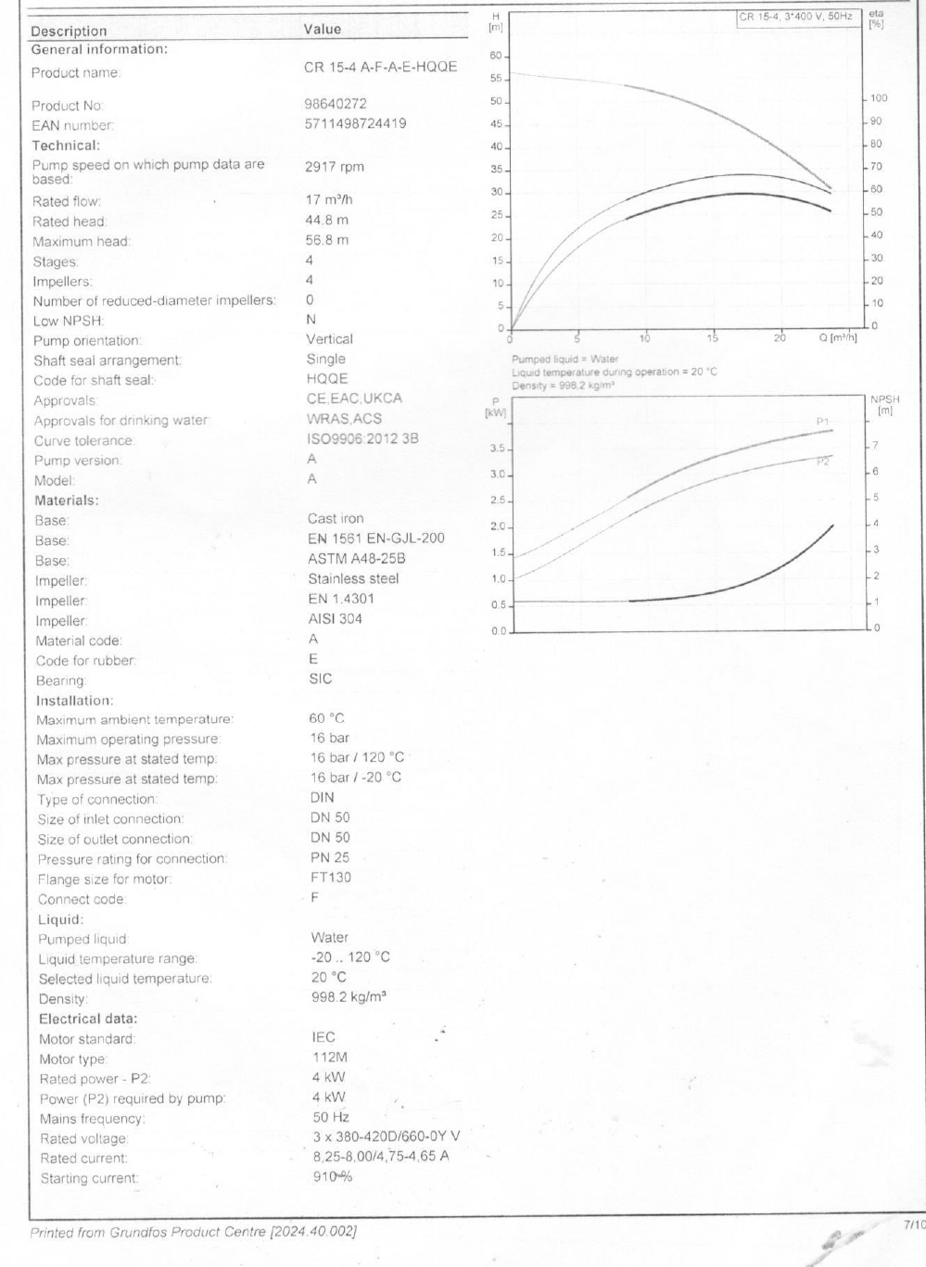
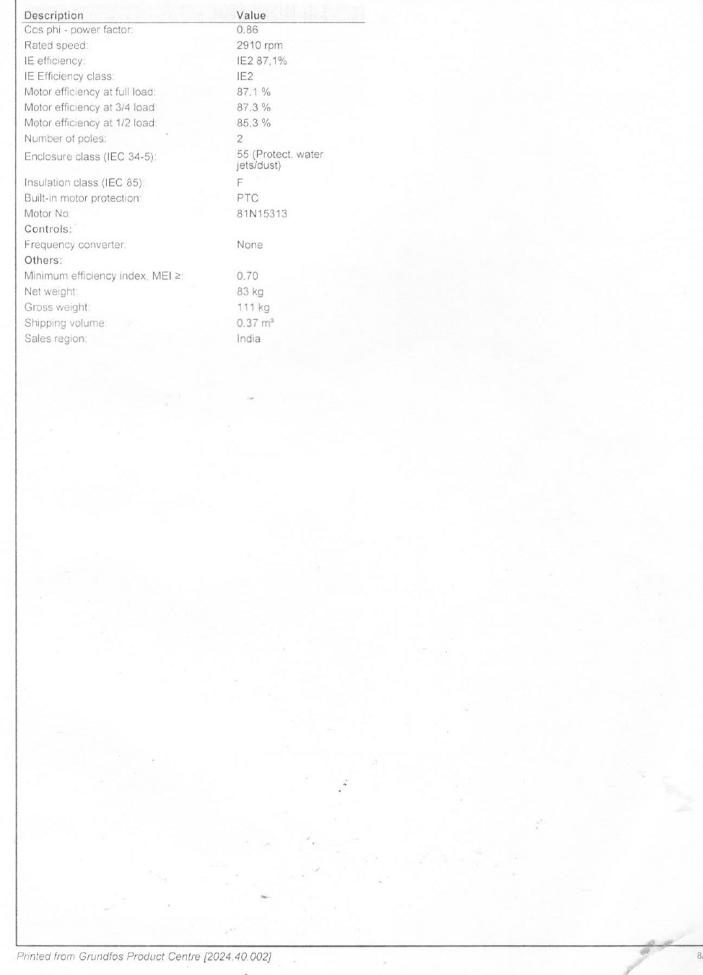

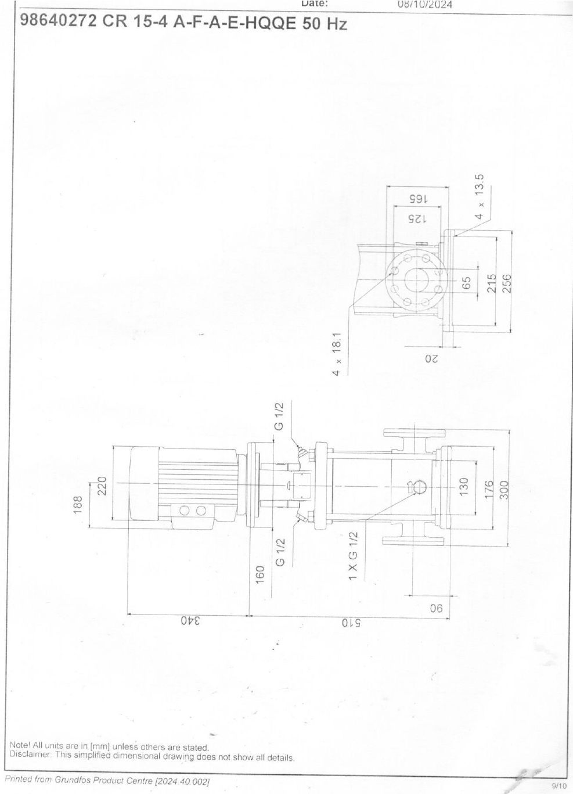
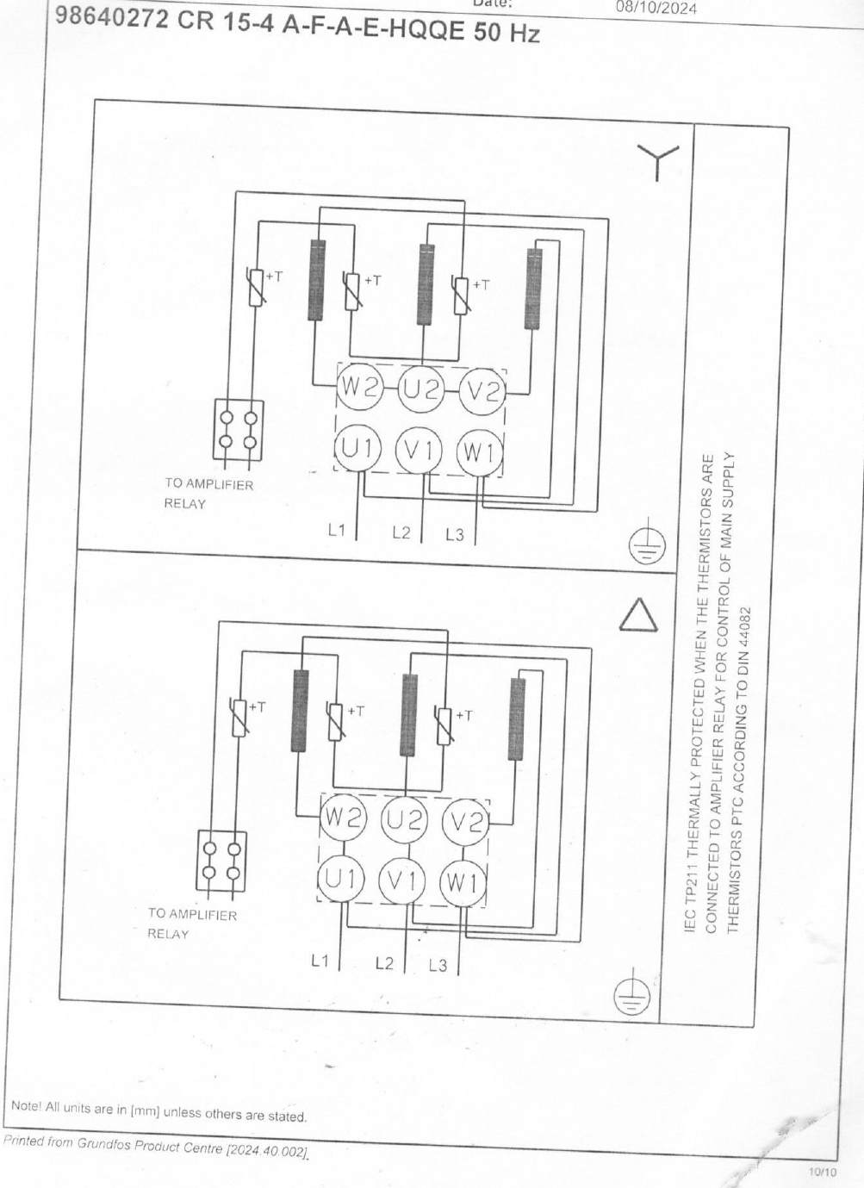

Commercial Bid: (in separate sealed envelope/password protected file in Email)\

Bid for Supply, Installation, Testing, and Commissioning of 4 Kw 3 Phase Vertical Multistage Centrifugal Pump with complete accessories (Tender No. : 2024-25/Estate/2B/LNM-782)

S.No. | Item Name | Specification/Detail | Qty. | UOM | Rate | Amount
1 | Supply, Fixing, Testing and Commissioning Work of Vertical, Multistage Centrifugal Pump for WTP | Make : Grundfos, Model : CR 15-4 A-F-A-E-HQQE ,Rated Power : 4 KW, Phase : 3) | 1 | Nos.
Total
GST
Total including GST

- Taxes like GST shall be clearly mentioned. If nothing is mentioned, these charges shall be deemed included.
- If the supplier does not have a particular item offered in the tender or a different make is being proposed by him, the same should be highlighted/mentioned especially by him.
- The prices should include everything (packing, forwarding, transit insurance, transportation, loading /unloading, installation etc.). Loading/unloading up to 50 mtr. shall be done by the supplier.
- Bid should be submitted for F.O.R delivery at the destination i.e. The LNM Institute of Information Technology, Gram – Rupa Ki Nangal, Post – Sumel, Via – Jamdoli, Jaipur- 302031
- The bid should be valid for a minimum period of 30 days. The Change in prices shall not be accepted within the validity period.
- The LNMIIT reserves the right to reject any quotation(s) without assigning any reasons.
- Payment terms shall be decided mutually.
- There should not be any conflict of interest (Declaration to be submitted by the Vendor).
- Bid should be on the company’s letterhead and should submit their bid in the LNMIIT format only.
- Item/Service not supplied by the supplier/service provider should be mentioned separately.
- Vendor should provide a photocopy of the cheque/cancelled cheque while presenting the Invoice to LNMIIT.
- Pre-bid meeting and pre-bid site visit can be done before quoting the rate in the tender to clear up any confusion regarding project details, the scope of work, and solicitation of documents.
- All charges applicable shall be clearly mentioned in the offer. If nothing is mentioned in the offer, the quoted price shall be treated as final, and nothing extra shall be paid extra.

All charges applicable shall be clearly mentioned with the offer. If nothing is mentioned in the offer, the quoted price shall be treated as final, and nothing extra shall be paid extra.

Signature with seal

