Tender No:. 2024-25/Estate/2B/LNM-862

The LNM Institute of Information Technology, Jaipur

TENDER NOTICE
The LNM Institute of Information Technology, Jaipur is a Deemed-to-be-University, set up as a Non-Profit Making institute engaged in imparting higher learning in Engineering, Technology and Science. We are located at Gram-Rupa Ki Nangal, Post-Sumel, Via-Jamdoli, Jaipur, Pin 302031 Rajasthan, under the joint venture of the Government of Rajasthan and Lakshmi & Usha Mittal Foundation.
The institute invites proposals from competent vendors for “Supply and Installation of 250LPH,50LPH and 20LPH Capacity Reverse Osmosis Systems with Grade 304 Stainless Steel Enclosed Body”. Bidders can submit their sealed offers at the following address by Email/Speed-Post/ Registered Post/ By-hand/courier before 05:00 PM on 10th January 2025.
Filing of Tender:
Option 1: Physical submission of offers (hard copy) in sealed envelopes.
Bids shall be addressed to the undersigned and deposited in the tender box available at the main gate of the institute in person/ Speed-Post/ Registered Post/ By-hand/courier of the Institute after marking due entries in the Receipt Book available with the Security Officer at the main gate.
The tender subject and reference number must be mentioned on the envelope.

Director
The LNM Institute of Information Technology,
Gram – Rupa Ki Nangal, Post – Sumel,
Via – Jamdoli, Jaipur- 302031

Option 2: Password-protected online submission via Email
Password-protected offers can be submitted by the bidders via email at the below-mentioned email IDs.

tender-document@lnmiit.ac.in (password-protected document)
tender-password@lnmiit.ac.in (password only)
The tender subject and reference number must be mentioned in the subject line of the emails.

Bid Process:
Technical & Commercial details on the company’s letterhead, duly signed and sealed by the authorized signatory, are required to be submitted in two separate envelopes/emails.
Envelopes/Emails should be duly marked as follows:
- Technical bid for the “Supply and Installation of 250LPH,50LPH and 20LPH Capacity Reverse Osmosis Systems with Grade 304 Stainless Steel Enclosed Body”.
- Commercial Bid for the “Supply and Installation of 250LPH,50LPH and 20LPH Capacity Reverse Osmosis Systems with Grade 304 Stainless Steel Enclosed Body”.
Both Envelopes/files should be enclosed/attached in a single envelope/email bearing the heading “Bid for the “Supply and Installation of 250LPH,50LPH and 20LPH Capacity Reverse Osmosis Systems with Grade 304 Stainless Steel Enclosed Body (Tender No. : 2024-25/Estate/2B/LNM-862) ”.
Bids are liable to be rejected:
- If the above-mentioned bid submission procedure is not followed.
- Incomplete and non-conforming bids.
- Arbitration: All disputes and differences arising between the two parties in connection with this order shall be mutually settled as far as possible, failing which, all such disputes shall be referred to arbitration and settlement under the provision of the Arbitration and Conciliation Act, 1996 and as amended from time to time or any such law for the time being prevailing in India. The venue of such arbitration shall be Jaipur.
Technical Bid: (in a separate sealed envelope/via email)

Bid for Supply and Installation of 250LPH,50LPH and 20LPH Capacity Reverse Osmosis Systems with Grade 304 Stainless Steel Enclosed Body (Tender No. : 2024-25/Estate/2B/LNM-862)

While submitting quotations, the following procedure/ formalities and conditions may kindly be adhered.
- Company profile or brief note about the bidder's company, PAN number, and GST number should be submitted by the Vendor.
- The List of Directors/Partners/Proprietor/Members of the Firm to be attached.
- Detail of other associated/sister concerns (if any) of Directors/Partners/ Proprietor/ Members to be provided.
- Turnover for the last three years to be mentioned. (Copy to be enclosed)
- List of the client to whom the vendor has delivered the goods or provided the services in the past.
- Authorized Supplier Certificate
- Specification as mentioned below, shall be provided as per the details given below:

Scope of work
- The scope of work will cover the supply/service/SITC of given items at LNMIIT Jaipur campus.
- The Vendor is required to submit the complete documentation of the supplied item after delivery.
- SITE CONDITION:
Before quoting, the contractor must visit the site to inspect the work and fully acquaint himself with the conditions and scope of work with regards to accessibility of site required for the satisfactory execution of work. No compensation on account of any site difficulties will be entertained later, after the award of the works.

Technical specification:
Supply and Installation of 250 LPH Capacity Reverse Osmosis Systems with Grade 304 Stainless Steel Enclosed Body

Technical Specification of 250 LPH R.O System

DESIGN BASIS:
The chemical composition of raw water is considered as follows:
T D S | : 2000ppm
PH | : 7.5
PRODUCT WATER QUALITY
TDS : <100 ppm
PH: 7.6
SCOPE OF SUPPLY FOR R.O. PLANT & FACILITIES:
Flow Rate: 250 Liters per Hour
Raw Water Feed Flow: 1500 Liters per Hour
Recovery: 50-60%

1. RAW WATER PUMP
- Flow Rate: 1500 LPH
- Head: 35 m
- Power: (1 HP)
- Quantity: 2 Nos.
- Make: Kirloskar / Crompton Greaces /CRI
- Type : Self Priming Centrifugal
- Pressures : 3-4 Kg/Cm2
2. MULTI GRADE/PRESSURE SAND FILTER
- Make and size: Wave Cyber (1054)
- MOC: FRP
- Dia :10 Inch
- Height :54 Inch
- Back Wash time : 10 to 15 minutes
- Quantity: 1 Nos.
- Multi-Port Valve : ¾ Inch
- Volume : 50 Liter

3. ACTIVATED CARBON FILTER
- Make and size: Wave Cyber (1054)
- MOC: FRP
- Quantity: 1 No.
- Equipped with 1” Muli port Valve, Media and respective Pipeline
- Dia : 10 Inch
- Height : 54 Inch
- Volume : 50 liter
4. ANTISCALANT DOSER
Antiscalant dosing system
- Pump Type: Electronic Metering/Electronic Diaphragm type
- Pump Flow: Maximum 0-5 Liters / Hour
- Maximum Pressure: 5-6 Bar
- Tank MOC: HDPE
- Tank Capacity: 100 Ltrs
- Power requirement: 25 W
- Dosing pump: 1 Nos.
- Make : I- smart /Kyro or Equivalent
5. MICRON FILTER
Housing:
• Make : Amete / Gentee, USA
• MOC of Housing : PP
• Length X Diameter : 20” X 4”
• Quantity : 1 No.
Cartridge:
• Make: Filterite / Pratham /Ametek USA
• Cartridge MOC: Polypropylene
• Length: 20”
• Diameter: 4”
• Quantity: 1 No.
• Micron rating: 5 Micron
6. HIGH PRESSURE PUMP
• MOC: Stainless Steel
• Type: Vertical Centrifugal Multistage
• Flow Rate: 3500 Liters per Hour
• Head: 125 M
• Power Supply: 2 HP, 220 V
• Make: C.R.I/Shakti /Lubi
• Quantity: 2 Nos.

7. R.O. MEMBRANES
• Type of Membrane: HR /TFC (Poly Amide)/ OVEY/UKL
• Diameter of Membrane: 4.0 inch
• Length of Membrane: 40 inch
• No. of Membrane: 1
• Make of Membrane: Hydraunatics / Koch / Dow / Trisep (All USA)
• System Recovery: 50-60 %
8. R.O. HOUSING
Specifications
• MOC: FRP
• Diameter of Pressure Vessel: 4 inch
• Length of Pressure Vessel: 40 inch
• No. of Pressure Vessels: 1
• No. of Membrane per Vessel: 1
• Make: Advance / Wave Cyber/Sealux
• Position: Horizontal

9. R.O. CLEANING/ FUNGUS REMOVAL SYSTEM:
• Flushing time: 20 Minutes
• Flushing Media: Treated Water / Chemical
• Flushing Tank Size: 100 Ltrs
• Tank MOC: HDPE (Sintex / Sheetal)
10. FLUSHING PUMP
• Flow Rate: 1000 LPH
• Head: 35 M
• Power: (1 HP)
• Quantity: 1 No
11. ELECTRICAL PANEL
A control panel is provided as a safety measure for the pump & other electrical
items.
• Complete Starters, Overload Relays, Single Phase Preventer for Pump
• Voltmeter, Ammeter, MCB’s, Indicating Lights
• Puss Buttons
• Rocker switches for dozers
• Incomer, Auto-manual Switches
12. INSTRUMENTATION
• Rotameter : To measure the online flow of water
• Low Pressure Switch : To Protect RO Pump from dry running
• High Pressure Switch : To protect RO pump from back pressure
• Pressure Gauges : For calculate ^P for each unit in RO System
• Rotameter:
• Quantity : 2 Nos (permeate & Reject Line)
• Flow Rate : 3000 ltr/hr
• Pressure Switch:
• Quantity : 2 Nos (Low & High)
• Range : 20 – 125 psi
• Make : Orion / Eqv, India
• Pressure Gauges
• Quantity : 5 Nos
• Range : 0 – 7, 0 – 21 bar
• Dial Size : 2.5 inch
• Type : Line Mounted / Panel Mounted
• Make : Dynamic / Gluck / Reputed, India

13 Pipe Line
- CPVC pipe line from sand filter to high pressure pump and CPVC pipe from high pressure pump to end point of system.
- Type of Body : Enclosed & floor mounted body
14. SCHEDULE OF EXCLUSION:
1. All Civil Works such as plant foundation of the equipment, mass concreting etc.
2. Supply of power to Motors, regeneration chemicals for trial run and commissioning.
3. Laboratory testing facility, Instruments and reagents.
4. Lubricants, oil and Greece as and when required.
5. Raw water storage tank and Raw Water Pump.
6. All equipment’s work and services not specifically mentioned in our proposal.
7. Storage and site security.

15. TERMINATION POINTS:
1. Suction of Raw Water Pump.
2. Permeate / Reject Out Let of Reverse Osmosis System.
3. Outlet of Final U.V. Outlet Water.
4. Overflow or drain pipe work of all vessels.
5. Power control termination at High pressure pump, RO Product / Raw water transfer pump.

16. PRE-TREATMENT SCHEME
A. PRE-TREATMENT: MULTI GRADE SAND FILTER
The Raw Water from the Raw Water Storage tank is passed through Multi Grade Sand Filter. Before passing through the sand filter the water is chlorinated in Raw Water tank and effective chlorination will be possible only if retention is provided for 2-3 hrs. This is a FRP Pressure vessel with internal arrangements and Media of different grades of Sands. The Purpose of Sand Filter is for reduction of Turbidity and Suspended Solids. The Filter should be backwashed whenever the Pressure drop increases beyond 0.8 Kg/cm2 or after 22 Hrs of operations, whichever occurs first.
ACTIVATED CARBON FILTER
From Sand Filter the Filtered Water is passed through Activated Carbon Filter. The Activated Carbon Filter is a FRP pressure vessel having a bed of carbon in order to remove the Color, Odour & Traces of Organics & free chlorine present in the filter water.
ANTISCALENT DOSING PUMP:
We are proposing Antiscalent dosing system, which prevents saturation of various organic salts on R.O. membrane surface. The system comprises of dosing pump and solution preparation tank.
MICRON CARTRIDGE FILTER
we have provided micron filter unit, which removes fine suspended solids, which may have escaped from upstream units. This unit can remove fine solids up to 5 microns, which if carried over can clog the RO membrane.
B. R.O. SECTION.
HIGH PRESSURE PUMP
The Filtered Water is then pumped to a R.O. System through a High-Pressure Pump. For the
development of High pressure required for the RO System we have offered HORIGENTAL PROCON Pumps.
REVERSE OSMOSIS SYSTEM
the R.O. System consists of spirally wound R.O Membranes with FRP Pressure tubes. The R.O system is offered for Salt reduction so as to achieve the desired treated water quality. Normally the RO Membranes has a salt rejection of 90-95% as per manufacturer standard tests procedures.

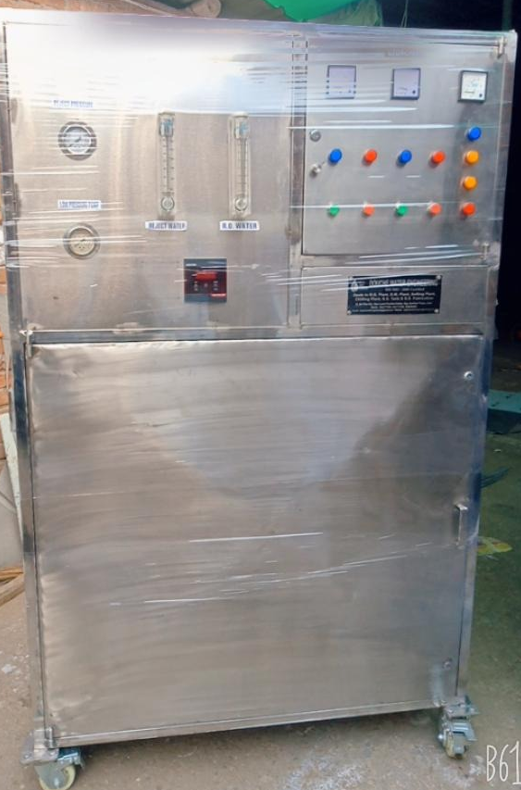

Made By: - KENT/AQUA GUARD/HI- TECH/MAXPURE/ DOUCHE
Warranty: 2 Years

Supply and Installation of 50 LPH Capacity Reverse Osmosis Systems with Grade 304 Stainless Steel Enclosed Body

Technical Specification of 50 LPH R.O System

- DESIGN BASIS:
The chemical composition of raw water is considered as follows:
T D S | : 2000ppm
- PRODUCT WATER QUALITY
TDS: <100 ppm
- SCOPE OF SUPPLY FOR R.O. PLANT & FACILITIES:
- Technology: RO+UV+UF+TDS Control
- Operation Mode: Automatic
- Membrane: Thin Film composite (Spiral Bound) – Multilayer
- Purification Capacity: 50 Liters per Hour (LPH)
- Storage Tank: 100 Liters
- Filter Cartridge: Sediment, Activated Carbon, UF, Post Carbon
- Number of Purification Stages: 7 Nos.
- Power Consumption: 75 Watt
- Voltage: 230 V AC
- Frequency: 50 Hz
- Dimensions (L x W x H): 300 x 485 x 840 mm
- Weight: 45 Kg
- Made By: - KENT/AQUAGUARD Reviva/HI- TECH/MAXPURE/ DOUCHE
- Warranty: 2 Years
- ACTIVATED CARBON FILTER
- Make and size: Wave Cyber
- MICRON FILTER
Housing:
• Make: Amete / Gentee, USA
Cartridge:
• Make: Filterite / Pratham /Ametek USA
- R.O. MEMBRANES
• Make of Membrane: Hydraunatics / Koch / Dow / Trisep (All USA)
• System Recovery: 50-60 %

- ELECTRICAL PANEL
A control panel is provided as a safety measure for the pump & other electrical
items.
• Puss Buttons
• Incomer, auto manual Switches

8. Pipeline
- CPVC pipeline from sand filter to high pressure pump and CPVC pipe from high pressure pump to end point of system.
- Type of Body: Enclosed & Wall mounted body
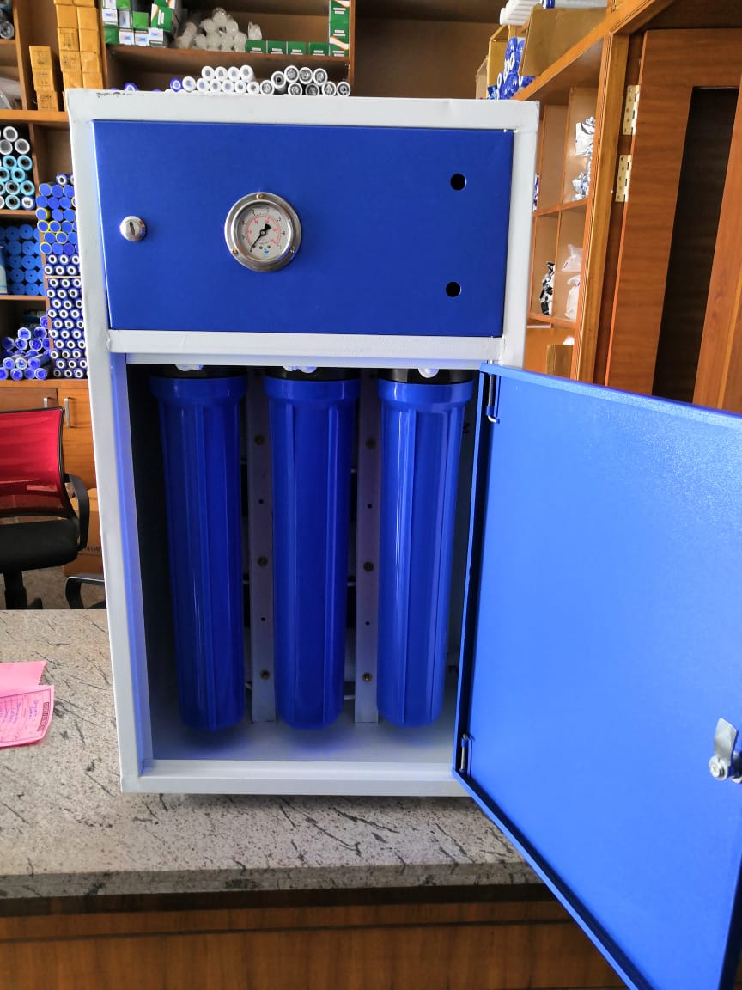

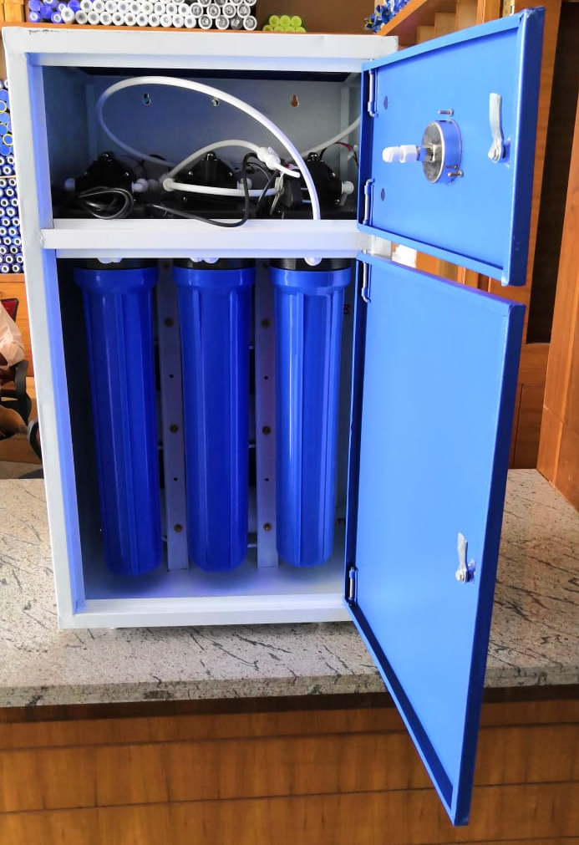

Supply and installation of 20 LPH Capacity Reverse Osmosis Systems with enclosed body

Brand | ‎KENT
Special Feature | ‎UV, RO
Product Dimensions | ‎29L x 44W x 60.5H Centimeters
Power Source | ‎Corded Electric
Model Name | ‎RO+UV+UF+TDS
Manufacturer | ‎Kent Ro Systems Ltd
Item model number | ‎kent grand star

Commercial Bid: (in separate sealed envelope/password protected file in Email)

Bid for

Supply and Installation of 250LPH,50LPH and 20LPH Capacity Reverse Osmosis Systems with Grade 304 Stainless Steel Enclosed Body (Tender No. : 2024-25/Estate/2B/LNM-862)

S. No. | Particulars | Make and Model | Qty. | UOM | Rate | Amount
1 | Supply and Installation of 250 LPH Capacity Reverse Osmosis Systems with Grade 304 Stainless Steel Enclosed Body_ 2 Year Warranty | KENT/AQUA GUARD/HI- TECH/MAXPURE | 1 | Nos.
2 | Supply and Installation of 250 LPH Capacity Reverse Osmosis Systems with Grade 304 Stainless Steel Enclosed Body_ 2 Year Warranty | KENT/AQUA GUARD/HI- TECH/MAXPURE | 1 | Nos.
3 | Supply and installation of 20 LPH Capacity Reverse Osmosis Systems with enclosed body_ 2 Year Warranty | Kent grand star | 6 | Nos.
 | GST_______
TOTAL (including taxes)

- Taxes like GST shall be clearly mentioned. If nothing is mentioned, these charges shall be deemed included.
- If the supplier does not have a particular item offered in the tender or a different make is being proposed by him, the same should be highlighted/mentioned especially by him.
- The prices should include everything (packing, forwarding, transit insurance, transportation, loading /unloading, installation etc.). Loading/unloading up to 50 mtr. shall be done by the supplier.
- Bid should be submitted for F.O.R delivery at the destination i.e. The LNM Institute of Information Technology, Gram – Rupa Ki Nangal, Post – Sumel, Via – Jamdoli, Jaipur- 302031
- The bid should be valid for a minimum period of 30 days. The Change in prices shall not be accepted within the validity period.
- The LNMIIT reserves the right to reject any quotation(s) without assigning any reasons.
- Payment terms shall be decided mutually.
- There should not be any conflict of interest (Declaration to be submitted by the Vendor).
- Bid should be on the company’s letterhead and should submit their bid in the LNMIIT format only.
- Item/Service not supplied by the supplier/service provider should be mentioned separately.
- Vendor should provide a photocopy of the cheque/cancelled cheque while presenting the Invoice to LNMIIT.
- Pre-bid meeting and pre-bid site visit can be done before quoting the rate in the tender to clear up any confusion regarding project details, the scope of work, and solicitation of documents.
- All charges applicable shall be clearly mentioned in the offer. If nothing is mentioned in the offer, the quoted price shall be treated as final, and nothing extra shall be paid extra.

All charges applicable shall be clearly mentioned with the offer. If nothing is mentioned in the offer, the quoted price shall be treated as final, and nothing extra shall be paid extra.

Signature with seal

