Tender No:. 2024-25/CWO/2B/LNM-888

The LNM Institute of Information Technology, Jaipur

TENDER NOTICE

The LNM Institute of Information Technology, Jaipur is a Deemed-to-be-University, set up as a Non-Profit Making institute engaged in imparting higher learning in Engineering, Technology and Science. We are located at Gram-Rupa Ki Nangal, Post-Sumel, Via-Jamdoli, Jaipur, Pin 302031 Rajasthan, under the joint venture of the Government of Rajasthan and Lakshmi & Usha Mittal Foundation.
The institute invites proposals from competent vendors for “Supply & Installation of Invisible grills for Monkey/ Bird proofing at Boys Hostel-4 Tower1 and Tower-2 and Girls hostel”. Bidders can submit their sealed offers at the following address by Email/Speed-Post/ Registered Post/ By-hand/courier before 05:00 PM on 09.02.2025 (Last date of bid submission).
Filing of Tender:
Option 1: Physical submission of offers (hard copy) in sealed envelopes.
Bids shall be addressed to the undersigned and deposited in the tender box available at the main gate of the institute in person/ Speed-Post/ Registered Post/ By-hand/courier of the Institute after marking due entries in the Receipt Book available with the Security Officer at the main gate.
The tender subject and reference number must be mentioned on the envelope.

Director
The LNM Institute of Information Technology,
Gram – Rupa Ki Nangal, Post – Sumel,
Via – Jamdoli, Jaipur- 302031
Email: directoroffice@lnmiit.ac.in

Option 2: Password-protected online submission via Email
Password-protected offers can be submitted by the bidders via email at the below-mentioned email IDs.
tender-document@lnmiit.ac.in (password-protected document)
tender-password@lnmiit.ac.in (password only)
The tender subject and reference number must be mentioned in the subject line of the emails.

Bid Process:
Technical & Commercial details on the company’s letterhead, duly signed and sealed by the authorized signatory, are required to be submitted in two separate envelopes/emails.
Envelopes/Emails should be duly marked as follows:
- Technical bid for the for “Supply & Installation of Invisible grills for Monkey/ Bird proofing at Boys Hostel-4 Tower1 and Tower-2 and Girls hostel”.
- Commercial Bid for the for “Supply & Installation of Invisible grills for Monkey/ Bird proofing at Boys Hostel-4 Tower1 and Tower-2 and Girls hostel”.

Both Envelopes/files should be enclosed/attached in a single envelope/email bearing the heading for “Supply & Installation of Invisible grills for Monkey/ Bird proofing at Boys Hostel-4 Tower1 and Tower-2 and Girls hostel” Tender No.: 2024-25/CWO/2B/LNM-888)”.

Bids are liable to be rejected:
- If the above-mentioned bid submission procedure is not followed.
- Incomplete and non-conforming bids.
- Arbitration: All disputes and differences arising between the two parties in connection with this order shall be mutually settled as far as possible, failing which, all such disputes shall be referred to arbitration and settlement under the provision of the Arbitration and Conciliation Act, 1996 and as amended from time to time or any such law for the time being prevailing in India. The venue of such arbitration shall be Jaipur.

Technical Bid: (in a separate sealed envelope/via email)

While submitting quotations, the following procedure/ formalities and conditions may kindly be adhered.
- Company profile or brief note about the bidder's company, PAN number, and GST number should be submitted by the Vendor.
- The List of Directors/Partners/Proprietor/Members of the Firm to be attached.
- Detail of other associated/sister concerns (if any) of Directors/Partners/ Proprietor/ Members to be provided.
- Turnover for the last three years to be mentioned. (Copy to be enclosed)
- List of the client to whom the vendor has delivered the goods or provided the services in the past.
- The Client List with some purchase orders and satisfactory certificate (to whom the vendor has delivered the goods/provided the services in the past).
- Vendor will submit sample of 2ft X 2ft of the proposed grill with the technical bid. Bids without sample will be rejected.
- Specification shall be provided as per the details given below:

Scope of work, technical data sheet, and Specification of the items:

Scope of work
- The scope of work will cover the supply and installation of for “Supply & Installation of Invisible grills for Monkey/ Bird proofing at Boys Hostel-4 Tower1 and Tower-2 and Girls hostel” at the LNMIIT Jaipur campus.
- The Vendor is required to submit the complete documentation of the supplied item after delivery.

Specification of Invisible grills :

Stainless Steel SS 304/ SS 316 wire rope will be fixed aluminium frame.

Technical data sheet and Specification of the items:

Bid for “Supply & Installation of Invisible grills for Monkey/ Bird proofing at Boys Hostel-4 Tower1 and Tower-2 and Girls hostel”
Tender No.: 2024-25/CWO/2B/LNM-761)

S No | PARTICULARS | UNIT | QTY
A | Supply and installation of invisible grills
 | Installation of invisible grills with the SS 304/316 rope wire and the wire will be fixed on roof with the support of Aluminium frame. The frame will be made with the bolts with Nylon washer.  Aluminium will be T-6063 alloy  Bolt space – 40 MM  Wall thickness – 2 MM  Heavy Base wires will be at every feet  Warranty of 3 Years | Sqft | 8000/-

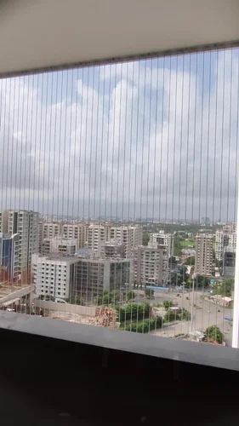

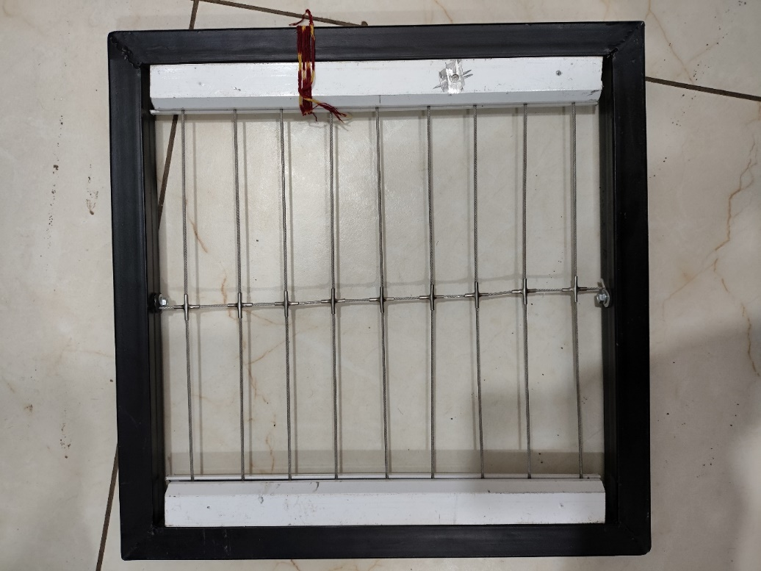

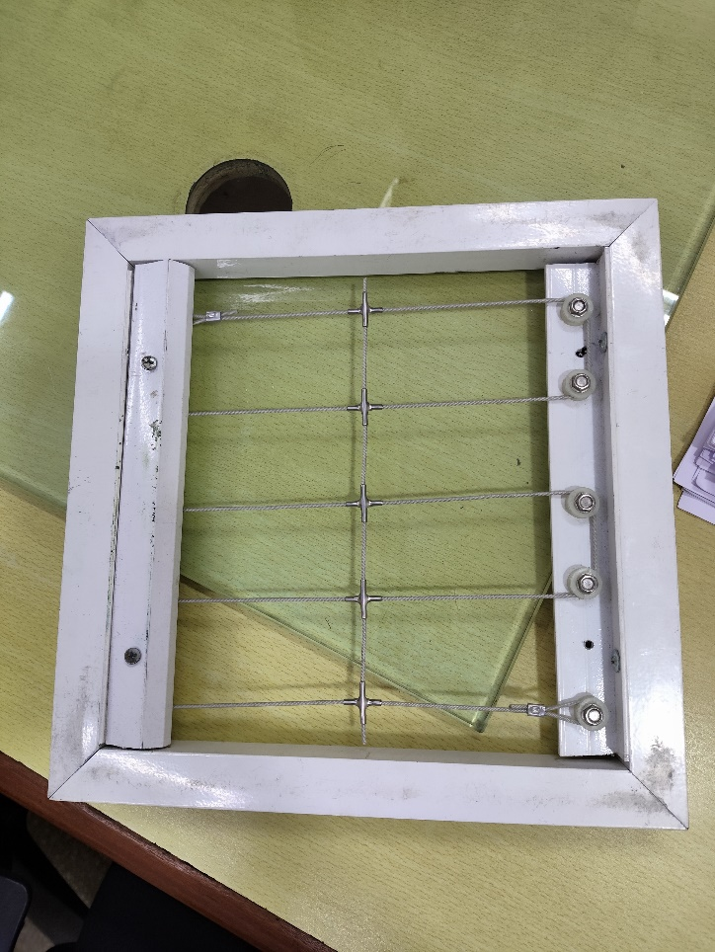

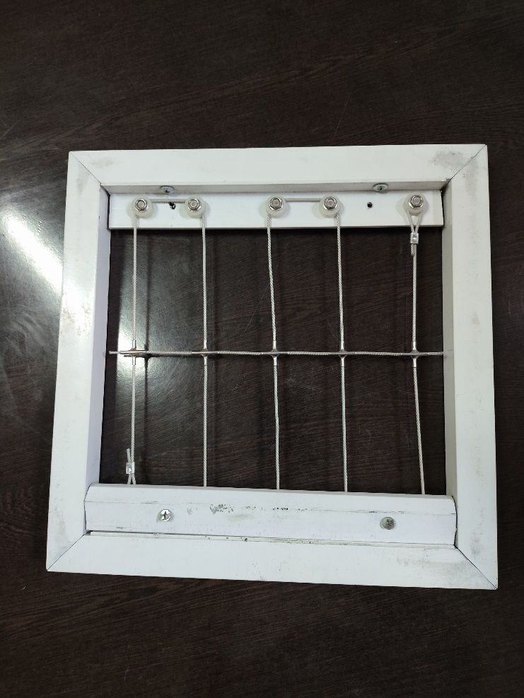

Commercial Bid: (in a separate sealed envelope/via email)

Bid for “Supply & Installation of Invisible grills for Monkey/ Bird proofing at Boys Hostel-4 Tower1 and Tower-2 and Girls hostel”
Tender No.: 2024-25/CWO/2B/LNM-888)

S No | PARTICULARS | UNIT | QTY | Rate | Amount
A | Supply and installation of invisible grills
 | Installation of invisible grills with the SS 304/316 rope wire and the wire will be fixed on roof with the support of Aluminium frame. The frame will be made with the bolts with Nylon washer.  Aluminium will be T-6063 alloy  Bolt space – 40 MM  Wall thickness – 2 MM  Heavy Base wires will be at every feet  Warranty of 3 Years | Sqft | 8000/-

Other T&C
- Taxes like GST should be clearly mentioned. If nothing is mentioned, these charges shall be deemed included.
- If the supplier does not have a particular item offered in the tender or a different make is being proposed by him, the same should be highlighted/mentioned especially by him.
- The prices should include everything (packing, forwarding, transit insurance, transportation, loading /unloading, installation etc.). Loading/unloading up to 50 mtr. shall be done by the supplier.
- Bid should be submitted for F.O.R delivery at the destination i.e. The LNM Institute of Information Technology, Gram – Rupa Ki Nangal, Post – Sumel, Via – Jamdoli, Jaipur- 302031
- The bid should be valid for a minimum period of 30 days. The Change in prices shall not be accepted within the validity period.
- The LNMIIT reserves the right to reject any quotation(s) without assigning any reasons.
- Payment terms shall be decided mutually.
- There should not be any conflict of interest (Declaration to be submitted by the Vendor).
- Bid should be on the company’s letterhead and should submit their bid in the LNMIIT format only.
- Item/Service not supplied by the supplier/service provider should be mentioned separately.
- Vendor should provide a photocopy of the cheque/cancelled cheque while presenting the Invoice to LNMIIT.
- Pre-bid meeting and pre-bid site visit can be done before quoting the rate in the tender to clear up any confusion regarding project details, the scope of work, and solicitation of documents.
- All charges applicable should be clearly mentioned in the offer. If nothing is mentioned in the offer, the quoted price shall be treated as final, and nothing extra shall be paid extra.

Signature with seal

