Tender No:. 2025-26/Estate/2B/LNM-1140

The LNM Institute of Information Technology, Jaipur

TENDER NOTICE

The LNM Institute of Information Technology, Jaipur is a Deemed-to-be-University, set up as a Non-Profit Making institute engaged in imparting higher learning in Engineering, Technology and Science. We are located at Gram-Rupa Ki Nangal, Post-Sumel, Via-Jamdoli, Jaipur, Pin 302031 Rajasthan, under the joint venture of the Government of Rajasthan and Lakshmi & Usha Mittal Foundation.
The institute invites proposals from competent vendors for “Comprehensive Terrace Waterproofing with or without Screed Protection and Ancillary Works”. Bidders can submit their sealed offers/s at the following address by Email/Speed-Post/ Registered Post/ By-hand/courier before 05:00 PM on 31/10/2025 (Last date of bid submission).
Filing of Tender:
Option 1: Physical submission of offers (hard copy) in sealed envelopes.
Bids shall be addressed to the undersigned and deposited in the tender box available at the main gate of the institute in person/ Speed-Post/ Registered Post/ By-hand/courier of the Institute after marking due entries in the Receipt Book available with the Security Officer at the main gate.
The tender subject and reference number must be mentioned on the envelope.

Director
The LNM Institute of Information Technology,
Gram – Rupa Ki Nangal, Post – Sumel,
Via – Jamdoli, Jaipur- 302031

Option 2: Password-protected online submission via Email
Password-protected offers can be submitted by the bidders via email at the below-mentioned email IDs.

tender-document@lnmiit.ac.in (password-protected document)
tender-password@lnmiit.ac.in (password only)
The tender subject and reference number must be mentioned in the subject line of the emails.

Bid Process:
Technical & Commercial details on the company’s letterhead, duly signed and sealed by the authorized signatory, are required to be submitted in two separate envelopes/emails.
Envelopes/Emails should be duly marked as follows:
- Technical bid for the “Comprehensive Terrace Waterproofing with or without Screed Protection and Ancillary Works”.
- Commercial Bid for the “Comprehensive Terrace Waterproofing with or without Screed Protection and Ancillary Works”.
Both Envelopes/files should be enclosed/attached in a single envelope/email bearing the heading “Bid for the “Comprehensive Terrace Waterproofing with or without Screed Protection and Ancillary Works” (Tender No. : 2025-26/Estate/2B/LNM-1140).
Bids are liable to be rejected:
- If the above-mentioned bid submission procedure is not followed.
- Incomplete and non-conforming bids.
- Arbitration: All disputes and differences arising between the two parties in connection with this order shall be mutually settled as far as possible, failing which, all such disputes shall be referred to arbitration and settlement under the provision of the Arbitration and Conciliation Act, 1996 and as amended from time to time or any such law for the time being prevailing in India. The venue of such arbitration shall be Jaipur.

Technical Bid: (in a separate sealed envelope/via email)

Bid for “Comprehensive Terrace Waterproofing with or without Screed Protection and Ancillary Works”

(Tender No. : 2025-26/Estate/2B/LNM-1140)

Bidder is required to furnish the requisite details as per the below mentioned table format and proof of such documents to be uploaded along with the bid under respective title/ headings as mentioned at column no ‘C’ accordingly.
SL NO. | Details sought | Details/ Certificate No. (Attached Y/N)
A | B | C
1. | Bidder Firm Name & Registration No,
2. | Bidder’s Company profile or brief note
3. | PAN Card No,.
4. | GST Number
5. | List of Directors/ Partners/Proprietor/ Members of the Bidder’s Firm
6. | Detail of other associated/sister concerns (if any) of Directors/Partners/ Proprietor/ Members
7. | Bidder Turnover - Average annual turnover for last three years

Scope of work

1. General
The work comprises complete repair, protection, and waterproofing of the lecture hall terrace area (≈ 3,369.963 m²). Contractor shall provide all materials, labour, tools, equipment, scaffolding, plant & machinery required for the execution and completion of works. All work to be carried out in compliance with IS codes, manufacturer specifications, and engineer-in-charge directions.

2. Detailed Scope

2.1 Waterproofing Works
• Cleaning and preparation of terrace surface (removal of debris, loose material, laitance).
• Treatment with liquid-applied waterproofing system for normal surface area and Fibre Reinforced elastomeric Membrane waterproofing system at severe location
• Application of protection screed over entire terrace.
• Division of treatment: 30% area severe leakage zone, 70% area normal leakage zone.
• Special waterproofing and flashing near drain outlets and vulnerable junctions.
• Slope correction and profile adjustment screed to ensure proper drainage towards outlets.
• Formation of small drain channels where required.
• Ponding/water testing after completion.

2.2 Parapet Wall, Expansion Joints & Testing
• Repair and replastering of parapet walls, inside and outside faces and fixing of cement Jali wherever required
• Repair/treatment of existing expansion joints with appropriate joint sealants and waterproof compounds.
• Testing of joints and adjoining areas for water tightness.
• Tentative Treatment area : 500 Sqm

2.3 Old Duct Vents & Slab Casting
• Demolition of up to 26 nos. old ducting vents (≈ 5 m² each) may be decrease to 18 nos
• Casting of RCC slab matching existing thickness, finish, and reinforcement detailing.
• Making good connections with surrounding slab.
• Tentative Treatment area : 170 Sqm(maximum)

Finishes – Grit Wash & Stone Cladding
• Removal of old grit wash plaster.
• Application of new grit wash plaster with waterproofing admixture.
• Removal and refixing of red stone cladding; replacement of broken/damaged stones.
• Tentative treatment area: 450 m².(Grit wash and Stone Cladding)
• Epoxy Coating for Red stone, Tentative treatment area: 70 Sqm

2.5 Plaster Repairs
• Removal of old/damaged plaster in mumty, internal & external walls, and elsewhere as required.
• Providing new plaster (waterproof cement plaster) to match existing.
• Tentative treatment area: 450 m².(Grit wash and Stone Cladding)

Interior Works
• Providing and fixing false ceiling under lecture halls where old ducting vents are removed.
• Repainting/touch-up where necessary after ceiling work.
• Tentative Treatment area: 170 Sqm(maximum)

2.7 MEP & Electrical
• Rerouting/refitting of open wires on terrace (wherever plastering or waterproofing works interfere).
• Plumbing and MEP work adjustments associated with duct vent closure and terrace drainage.
• Electrical works: conduit repair, wire refitting, fixture adjustments in affected areas.
• Tentative Treatment area: 3369.96 Sq(Lumpsum)

Miscellaneous / Contingencies
- Removal and disposal of debris from terrace and site.
- Any unforeseen repair works necessary to ensure complete watertightness of terrace.
- Tentative Treatment area: 3369.96 Sq (Lumpsum)
2.9 Special Location Treatment

Location | Treatment
Duct vents / shaft openings | Mesh reinforcement + PU sealant band + liquid coating (1 m radius).
Severe leakage patches | Open & repair with PMM + overlay fibre-reinforced coating.
Staircase | 3-coat PU system + coving up to 300 mm.
Inaccessible areas | Spray-applied PU/polyurea to ensure coverage.
Rainwater outlets | SS/HDPE spouts, mesh + 3 coat treatment (1 m × 1 m zone).
Parapet wall & coping | Repair cracks + fibre coating + elastomeric protective paint.

3. Quality Assurance
• All works to be supervised by qualified engineer/site in-charge.
• Materials shall be of approved make/brand.
• Waterproofing system shall carry minimum 5-year performance guarantee from contractor.
• Proper curing, workmanship, and testing to be ensured at each stage.

Approved Materials & Makes Schedule (Expanded for Terrace Works)

Sr. No. | Item / Material | Specification / Standard | Approved Makes (Indicative)
1 | Cement Sand Concrete Jali (2’x2’ or as required) | RCC precast with M-20 grade concrete, Fe-500 TMT reinforcement, IS 456:2000, IS 10262 | In-situ / Precast from approved vendor
2 | False Ceiling (Waterproof / Exterior Grade) | Fibre Cement Board / Calcium Silicate Board / PVC ceiling; GI framework zinc coated 120 gsm; IS 2095 / IS 14862 | Gyproc, Armstrong
3 | Wiring | FRLS copper conductor, multi-strand, 1100V grade; IS 694, IS 8130 | Polycab, Havells,
4 | Cable Tray | GI perforated / ladder type, min. 2 mm thickness, 50–100 micron powder coating; IS 10702 | Legrand, Schneider,
5 | PVC Conduit | Heavy-duty rigid PVC conduit, 2 mm wall thickness, ISI marked; IS 9537 (Part 3) | Precision, AKG, Polycab,
6 | Steel (Reinforcement) | TMT Fe-500D; IS 1786 | TATA, SAIL, JSW, Jindal,
7 | Steel (Structural) | Rolled sections; IS 2062 E250 | TATA, SAIL, JSW, Jindal,
8 | Cement | OPC 43/53 grade / PPC; IS 8112, IS 12269, IS 1489 | Ultratech, ACC,
9 | Sand | River sand, clean, well-graded; IS 383 | Approved local source
10 | Aggregates | 10 mm & 20 mm crushed stone aggregates; IS 383 | Approved local source
11 | Waterproofing Membrane (PU/Liquid Applied) | Liquid applied or membrane-based; IS 15875 (PU), ASTM D5147 (APP) | Fosroc, Dr. Fixit, Sika, BASF,
12 | Primer / Epoxy Coating | Solvent/epoxy primer; IS 3536 / ASTM standards | Fosroc, Sika, Berger, Asian Paints, Pidilite
13 | Crack Filling / Grout | Epoxy grout / polymer modified; IS 1347, ASTM C881 | Fosroc, Sika,
14 | Fibre Reinforcement (Polypropylene / Synthetic Fibres) | Micro / macro fibres, alkali resistant, 6–12 mm cut length; IS 16481:2017 (Synthetic microfibres for cementitious composites) | Fosroc (Reebakfibre), Sika (SikaFiber), BASF MasterFiber, Dr. Fixit (Pidilite),
15 | Elastomeric Waterproof Coating | Single/2-component acrylic / polyurethane-based, UV resistant, elongation > 250%, ASTM D6083 / IS 15875 | Fosroc Nitoproof / Brushbond, SikaTop Seal / Sikalastic, Dr. Fixit Newcoat, BASF MasterSeal,
16 | Flashing Sheet (Metal/Bitumen) | 24G GI / Aluminium / Bituminous flashing | Tata, Jindal,
17 | Rainwater Pipes & Fittings | uPVC / SWR ISI marked; IS 13592 | Supreme, Astral,
18 | Drain Cover / Grating | CI / SS gratings with anti-rust coating | Nezone, Local approved
19 | Paints (Exterior Protective) | Weatherproof acrylic / elastomeric paints; IS 15489 | Asian Paints Apex, Berger
20 | Adhesives / Sealants | PU / Silicon-based; ASTM C920 | Fosroc, Sika, Dr. Fixit, Pidilite
21 | Fasteners & Anchors | SS/GI heavy duty, ISI marked | Hilti, Fischer, Wurth, Unbrako
22 | Scaffolding / Safety Materials | ISI approved | Cuplock / H-frame type from approved vendor

4. Deliverables
• Terrace surface free of leakage and water stagnation.
• Repaired parapet walls, plaster, cladding, grit wash, and duct vent closures.
• Fully functional MEP and electrical services reinstated.
• Documentation: test reports, guarantee certificates, and as-built drawings (if applicable).

5. Proposal Requirements
Bidders are requested to submit their proposal on a lumpsum turnkey basis, considering the tentative quantities mentioned in the scope of work. The proposal should include:
- Detailed technical specifications of the materials and systems proposed.
- Specific methodology and sequence of execution, highlighting surface preparation, application process, curing/protection measures, and service rerouting.
- Compliance with relevant IS codes / DSR specifications.
- Warranty/guarantee period for the waterproofing system offered.
- Completion schedule with milestones

Special Conditions of Contract
- Turnkey Responsibility
The contractor shall be fully responsible for carrying out the work on a lumpsum turnkey basis, covering labour, material, tools, tackles, scaffolding, safety arrangements, and any other incidental items required for successful completion.

- Site Conditions
Bidders shall visit the site and acquaint themselves with the existing conditions before submission of the proposal. No claims will be entertained later for lack of site knowledge.

- Methodology & Approval
Detailed methodology and sequence of execution shall be submitted by the contractor and approved by the Engineer-in-Charge prior to commencement.

Any deviation from approved methodology must be pre-approved in writing.

- Quality of Materials
All materials shall conform to relevant IS codes / DSR specifications or equivalent international standards.

Manufacturer’s test certificates must be provided for all chemicals and waterproofing products.

- Workmanship & Protection
The contractor shall ensure proper slope, drainage, and flashing details to avoid water stagnation.
During execution, proper curing, protection, and safety measures must be ensured.

- Coordination of Ancillary Works
All rerouting/refixing of AC pipes, cables, ducts, plumbing, and false ceiling works shall be carried out in coordination with concerned agencies without disturbing existing services.

- Warranty / Guarantee
The contractor shall provide a minimum 10 years warranty against leakage/seepage from the treated terrace surface.

Any defects noticed during the warranty period shall be rectified by the contractor at no extra cost.

- Completion Time
The work must be completed within the stipulated period as per the agreed schedule. Delays will attract penalties as per contract terms.

- Payment Terms
Since the contract is on a lumpsum basis, interim payments may be released against certified progress, subject to retention/security deposit as per contract conditions.

- Safety & Housekeeping
All statutory safety norms must be followed.
Contractor shall maintain cleanliness and dispose of debris from the site regularly.

Technical specification:

Sr. No. | Item Name | Make & Model/Specification | Qty. | UOM
1 | Design, Execution and Completion of Comprehensive Terrace Waterproofing with or without Screed Protection, Slope/Drainage Correction, and Ancillary Civil, Plumbing, Electrical, MEP, and Finishing Works for Lecture Hall Terrace Area (Built-up Area: 3,584.63 Sq.m; Terrace Area: 3,369.96 Sq.m) | As mentioned in the document above | 3369.96 | Sqm

Signature with seal
Drawing/Photographs

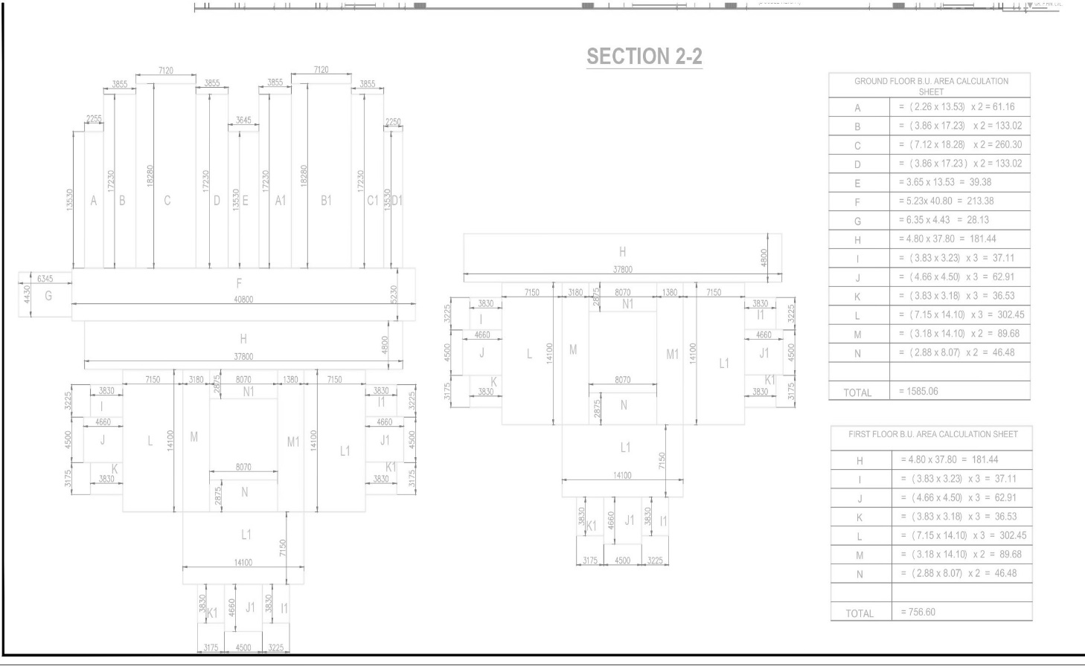

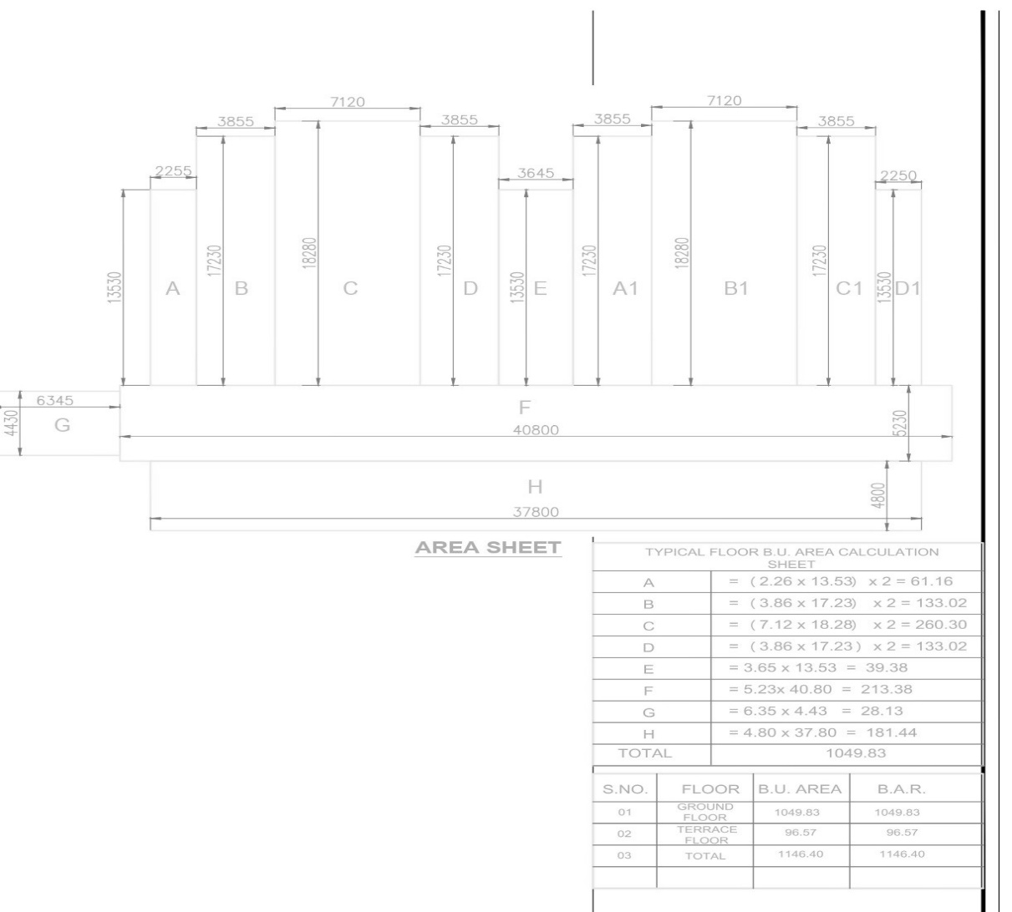

Commercial Bid: (in separate sealed envelope/password protected file via email)

Bid for “Comprehensive Terrace Waterproofing with or without Screed Protection and Ancillary Works”

(Tender No. : 2025-26/Estate/2B/LNM-1140)

S.No. | Item Name/ Description | Make & Model/Specification | Qty. | UOM | Rate | Amount
1. | “Tender for Design, Execution and Completion of Comprehensive Terrace Waterproofing with or without Screed Protection, Slope/Drainage Correction, and Ancillary Civil, Plumbing, Electrical, MEP, and Finishing Works for Lecture Hall Terrace Area (Built-up Area: 3,584.63 Sq.m; Terrace Area: 3,369.96 Sq.m)” | As mentioned in the technical bid document | 3369.96 | Sqm
2. | Transportation charges |  | 01 | Nos.
Total
GST
Total including GST

- Taxes like GST shall be clearly mentioned. If nothing is mentioned, these charges shall be deemed included.
- If the supplier does not have a particular item offered in the tender or a different make is being proposed by him, the same should be highlighted/mentioned especially by him.
- The prices should include everything (packing, forwarding, transit insurance, transportation, loading /unloading, installation etc.). Loading/unloading up to 50 mtr. shall be done by the supplier.
- Bid should be submitted for F.O.R delivery at the destination i.e. The LNM Institute of Information Technology, Gram – Rupa Ki Nangal, Post – Sumel, Via – Jamdoli, Jaipur- 302031
- The bid should be valid for a minimum period of 30 days. The Change in prices shall not be accepted within the validity period.
- The LNMIIT reserves the right to reject any quotation(s) without assigning any reasons.
- Payment terms shall be decided mutually.
- There should not be any conflict of interest (Declaration to be submitted by the Vendor).
- Bid should be on the company’s letterhead and should submit their bid in the LNMIIT format only.
- Item/Service not supplied by the supplier/service provider should be mentioned separately.
- Vendor should provide a photocopy of the cheque/cancelled cheque while presenting the Invoice to LNMIIT.
- Pre-bid meeting and pre-bid site visit can be done before quoting the rate in the tender to clear up any confusion regarding project details, the scope of work, and solicitation of documents.
- All charges applicable shall be clearly mentioned in the offer. If nothing is mentioned in the offer, the quoted price shall be treated as final, and nothing extra shall be paid extra.

Signature with seal

