Tender No:. 2025-26/ESTATE/2B/LNM-1169
The LNM Institute of Information Technology, Jaipur

TENDER NOTICE
The LNM Institute of Information Technology, Jaipur is a Deemed-to-be-University, set up as a Non-Profit Making institute engaged in imparting higher learning in Engineering, Technology and Science. We are located at Gram-Rupa Ki Nangal, Post-Sumel, Via-Jamdoli, Jaipur, Pin 302031 Rajasthan, under the joint venture of the Government of Rajasthan and Lakshmi & Usha Mittal Foundation.

The institute invites proposals from competent vendors for “Supply, installation, testing, and commissioning of 15 HP Star-Delta 3-Phase Starter Panel suitable for air cooling machines at Boys Hostel–1 & 2”. Bidders can submit their sealed offers/s at the following address by Email/Speed-Post/ Registered Post/ By-hand/courier before 05:00 PM on 15.11.2025 (Last date of bid submission).

Filing of Tender:

Option 1: Physical submission of offers (hard copy) in sealed envelopes.
Bids shall be addressed to the undersigned and deposited in the tender box available at the main gate of the institute in person/ Speed-Post/ Registered Post/ By-hand/courier of the Institute after marking due entries in the Receipt Book available with the Security Officer at the main gate.
The tender subject and reference number must be mentioned on the envelope.

Director
The LNM Institute of Information Technology,
Gram – Rupa Ki Nangal, Post – Sumel,
Via – Jamdoli, Jaipur- 302031

Option 2: Password-protected online submission via Email
Password-protected offers can be submitted by the bidders via email at the below-mentioned email IDs.

tender-document@lnmiit.ac.in (password-protected document)
tender-password@lnmiit.ac.in (password only)
The tender subject and reference number must be mentioned in the subject line of the emails.

Bid Process:
Technical & Commercial details on the company’s letterhead, duly signed and sealed by the authorized signatory, are required to be submitted in two separate envelopes/emails.
Envelopes/Emails should be duly marked as follows:
- Technical bid for the: Supply, installation, testing, and commissioning of 15 HP Star-Delta 3-Phase Starter Panel suitable for air cooling machines at Boys Hostel–1 & 2.
- Commercial Bid for the: Supply, installation, testing, and commissioning of 15 HP Star-Delta 3-Phase Starter Panel suitable for air cooling machines at Boys Hostel–1 & 2.

Both Envelopes/files should be enclosed/attached in a single envelope/email bearing the heading “Bid for the Supply, installation, testing, and commissioning of 15 HP Star-Delta 3-Phase Starter Panel suitable for air cooling machines at Boys Hostel–1 & 2, (Tender No. : 2025-26/Estate/2B/LNM-1169)”.

Bids are liable to be rejected:
- If the above-mentioned bid submission procedure is not followed.
- Incomplete and non-conforming bids.
- Arbitration: All disputes and differences arising between the two parties in connection with this order shall be mutually settled as far as possible, failing which, all such disputes shall be referred to arbitration and settlement under the provision of the Arbitration and Conciliation Act, 1996 and as amended from time to time or any such law for the time being prevailing in India. The venue of such arbitration shall be Jaipur.
Technical Bid: (in a separate sealed envelope/via email)

Bid for : Supply, installation, testing, and commissioning of 15 HP Star-Delta 3-Phase Starter Panel suitable for air cooling machines at Boys Hostel–1 & 2

(Tender No. : 2025-26/Estate/2B/LNM-1169)

Bidder is required to furnish the requisite details as per the below mentioned table format and proof of such documents to be uploaded along with the bid under respective title/ headings as mentioned at column no ‘C’ accordingly.

SL NO. | Title/ Heading  Details sought by buyer | Details/ Certificate No. (Attached Y/N)
A | B | C
1. | Bidder Firm Name & Registration No,
2. | Bidder’s Company profile or brief note
3. | PAN Card No,.
4. | GST Number
5. | List of Directors/ Partners/Proprietor/ Members of the Bidder’s Firm
6. | Detail of other associated/sister concerns (if any) of Directors/Partners/ Proprietor/ Members
7. | Bidder Turnover - Average annual turnover for last three years
8. | The Client List with some purchase orders and satisfactory certificate (to whom the vendor has delivered the goods/provided the services in the past (Three (03) purchase orders/work orders, at least one from each of the last three years, including the previous year.)
9. | If the bidder is authorized by the OEM/Manufacturer. Proof of the same is to be submitted with the Technical Bid

Scope of work
- The scope of work will cover the SITC of given items at LNMIIT Jaipur campus.
- The Vendor is required to submit the complete documentation of the supplied item after delivery.

Technical specification:

S. No. | Description | UNIT | QTY
 | Supply, installation, testing, and commissioning of 15 HP Star-Delta 3-Phase Starter Panel suitable for air cooling machines at Boys Hostel–1 & 2, including all necessary control wiring, protective devices, and accessories complete as required. | Set | 8
A | I/C | Set | 8
1 | MCCB 250A TP+N 36 Ka With T/M Based Over current & Short Circuit Protection_ 1 Nos. Make: Schneider/L&T | Set | 8
2 | Extended Rotary Handle _ 1 Nos. Make: Schneider/L&T | Set | 8
3 | Spreaders set 1 Nos. Make: Schneider/L&T | Set | 8
4 | Dig. MFM Meter 96*96 CL-0.5_ 1 nos. Make: Schneider/L&t | Set | 8
5 | Dig KWh Meter _ 1 Nos. Make: Schneider/L&T | Set | 8
6 | Indicating Lights (Red- 1 - Yellow - 1) - 2 nos. Make: L&T / Siemense | Set | 8
7 | Indicating Lights ( Blue - 1 ) _ 1 nos. Make: L&T / Siemense | Set | 8
8 | C. T. 250/5A CL 1.0 15VA _ 3 nos. Make : Alfa/ Matrix | Set | 8
9 | Control MCB 6A 1P 10 KA C Curve _ 3 Nos. Make: Schneider/L&t | Set | 8
B | O/G | Set | 8
 | S/D Starter 15 HP X 6 NOS. | Set | 8
1 | MCB 32A 3P 10 KA C Curve _6nos Make : Schneider/L&t | Set | 8
2 | Power Contactor 18A 3P AC3 Duty _ 12nos. Make : Schneider/L&t | Set | 8
3 | Power Contactor 12A 3P AC3 Duty_6 nos. Make : Schneider/L&t | Set | 8
4 | 1 NO+1 NC Aux. Block_ 18 Make : Schneider/L&t | Set | 8
5 | Thermal Overload Relay ( 9-15A ) _ 6 Nos. Make : Schneider/L&t | Set | 8
6 | Single Phase Priventer _ 6 nos. Make : Minilec/Viral/GIC | Set | 8
7 | Indicating Lights ( Red- 1 - Amber -1,Green-1 ) _ 18 nos. Make : Simens / L&T | Set | 8
8 | Push Button 22.5 ( Red - 1, Green - 1 ) _12 nos. Simens / L&T | Set | 8
9 | A/M Selector Switch _ 6 nos. Make :L&T Salzer | Set | 8
10 | S/D Timer_6 nos. L&T/GIC | Set | 8
11 | Control MCB 6A 1P 10 KA C Curve_ 6 nos. Make : Schneider/L&t | Set | 8
12 | 12 Dig. AMP Meter 96*96 CL-1 _ 6 nos. Make : Schneider/L&t | Set | 8
13 | C. T. 60/5A CL 1.0 15VA_ 6nos. Make : Alfa/ Matrix | Set | 8
14 | 2.0/1.6mm CRCA Sheet steel enclosure duly Powder coated with Red Including Including M.S. Ball Maunted Of mm Size Make :TATA / SAIL | Set | 8
15 | Missll.( Insulators, Acrylic Sheet , Baklight Sheet, Hardware, Wire, Name Plates,Lugs, Pvc Channel , Mcb Chanel , Lock,Hing , Bidding , Connectors, Netural Links, Sprial , Saddle & Packing Material ) | Set | 8
 | * Labour | Set | 8
 | Size of 15 HP Star-Delta 3-Phase Starter Panel - 2000mm x 1475mm | Set | 8
 | Cable Entery from Bottom | Set | 8
 | Fabrication Structure : 1.6mm Door, Side Panel _ 2.00mm, 5MM Foundation Hole, Busbar 400A TPN Al, | Set | 8
 | General Arrangement (GA) Drawing for Starter Panel_ Attached | Set | 8
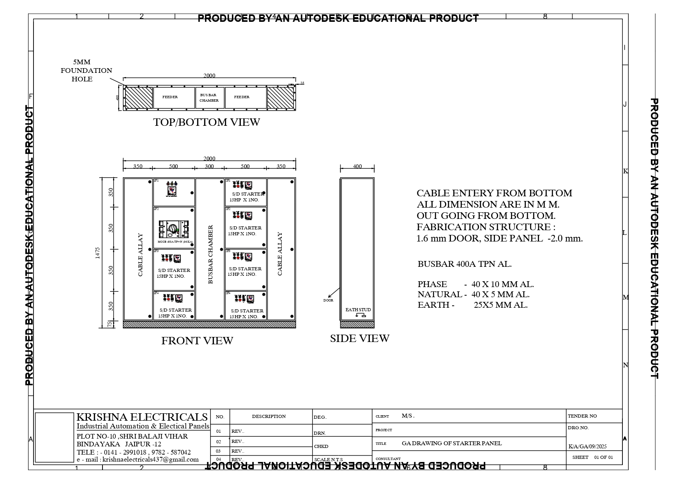
Commercial Bid: (in separate sealed envelope/password protected file via email)

Bid for : Supply, installation, testing, and commissioning of 15 HP Star-Delta 3-Phase Starter Panel suitable for air cooling machines at Boys Hostel–1 & 2

(Tender No. : 2025-26/Estate/2B/LNM-1169)

S. No. | Description | UNIT | QTY | Rate (Rs.) | Amount(Rs.)
 | Supply, installation, testing, and commissioning of 15 HP Star-Delta 3-Phase Starter Panel suitable for air cooling machines at Boys Hostel–1 & 2, including all necessary control wiring, protective devices, and accessories complete as required. | Set | 8
A | I/C
1 | MCCB 250A TP+N 36 Ka With T/M Based Over current & Short Circuit Protection_ 1 Nos. Make : Schneider/L&T
2 | Extended Rotary Handle _ 1 Nos. Make : Schneider/L&T
3 | Spreaders set 1 Nos. Make : Schneider/L&T
4 | Dig. MFM Meter 96*96 CL-0.5_ 1 nos. Make : Schneider/L&t
5 | Dig KWh Meter _ 1 Nos. Make : Schneider/L&T
6 | Indicating Lights ( Red- 1 - Yellow - 1) - 2 nos. Make : L&T / Siemense
7 | Indicating Lights ( Blue - 1 ) _ 1 nos. Make : L&T / Siemense
8 | C. T. 250/5A CL 1.0 15VA _ 3 nos. Make : Alfa/ Matrix
9 | Control MCB 6A 1P 10 KA C Curve _ 3 Nos. Make : Schneider/L&t
B | O/G
 | S/D Starter 15 HP X 6 NOS.
1 | MCB 32A 3P 10 KA C Curve _6nos Make : Schneider/L&t
2 | Power Contactor 18A 3P AC3 Duty _ 12nos. Make : Schneider/L&t
3 | Power Contactor 12A 3P AC3 Duty_6 nos. Make : Schneider/L&t
4 | 1 NO+1 NC Aux. Block_ 18 Make : Schneider/L&t
5 | Thermal Overload Relay ( 9-15A ) _ 6 Nos. Make : Schneider/L&t
6 | Single Phase Priventer _ 6 nos. Make : Minilec/Viral/GIC
7 | Indicating Lights ( Red- 1 - Amber -1,Green-1 ) _ 18 nos. Make : Simens / L&T
8 | Push Button 22.5 ( Red - 1, Green - 1 ) _12 nos. Simens / L&T
9 | A/M Selector Switch _ 6 nos. Make :L&T Salzer
10 | S/D Timer_6 nos. L&T/GIC
11 | Control MCB 6A 1P 10 KA C Curve_ 6 nos. Make : Schneider/L&t
12 | 12 Dig. AMP Meter 96*96 CL-1 _ 6 nos. Make : Schneider/L&t
13 | C. T. 60/5A CL 1.0 15VA_ 6nos. Make : Alfa/ Matrix
14 | 2.0/1.6mm CRCA Sheet steel enclosure duly Powder coated with Red Including Including M.S. Ball Maunted Of mm Size Make :TATA / SAIL
15 | Missll.( Insulators, Acrylic Sheet , Baklight Sheet, Hardware, Wire, Name Plates,Lugs, Pvc Channel , Mcb Chanel , Lock,Hing , Bidding , Connectors, Netural Links, Sprial , Saddle & Packing Material)
 | * Labour
 | Size of 15 HP Star-Delta 3-Phase Starter Panel - 2000mm x 1475mm
 | Cable Entery from Bottom
 | Fabrication Structure : 1.6mm Door, Side Panel _ 2.00mm, 5MM Foundation Hole, Busbar 400A TPN Al,
 | General Arrangement (GA) Drawing for Starter Panel_ Attached
 |  |  | Amount
 |  |  | GST@18%
 |  |  | Total With GST

Other T&C
- Taxes like GST should be clearly mentioned. If nothing is mentioned, these charges shall be deemed included.
- If the supplier does not have a particular item offered in the tender or a different make is being proposed by him, the same should be highlighted/mentioned especially by him.
- The prices should include everything (packing, forwarding, transit insurance, transportation, loading /unloading, installation etc.). Loading/unloading up to 50 mtr. shall be done by the supplier.
- Bid should be submitted for F.O.R delivery at the destination i.e. The LNM Institute of Information Technology, Gram – Rupa Ki Nangal, Post – Sumel, Via – Jamdoli, Jaipur- 302031
- The bid should be valid for a minimum period of 30 days. The Change in prices shall not be accepted within the validity period.
- The LNMIIT reserves the right to reject any quotation(s) without assigning any reasons.
- Payment terms shall be decided mutually.
- There should not be any conflict of interest (Declaration to be submitted by the Vendor).
- Bid should be on the company’s letterhead and should submit their bid in the LNMIIT format only.
- Item/Service not supplied by the supplier/service provider should be mentioned separately.
- Vendor should provide a photocopy of the cheque/cancelled cheque while presenting the Invoice to LNMIIT.
- Pre-bid meeting and pre-bid site visit can be done before quoting the rate in the tender to clear up any confusion regarding project details, the scope of work, and solicitation of documents.
- All charges applicable shall be clearly mentioned in the offer. If nothing is mentioned in the offer, the quoted price shall be treated as final, and nothing extra shall be paid extra.

Signature with seal

