Tender No: 2025-26/ECE/2B/LNM-1170

The LNM Institute of Information Technology, Jaipur

TENDER NOTICE
The LNM Institute of Information Technology, Jaipur is a Deemed-to-be-University, set up as a Non-Profit Making institute engaged in imparting higher learning in Engineering, Technology and Science. We are located at Gram-Rupa Ki Nangal, Post-Sumel, Via-Jamdoli, Jaipur, Pin 302031 Rajasthan, under the joint venture of the Government of Rajasthan and Lakshmi & Usha Mittal Foundation.
The institute invites proposals from competent vendors for “Setting up of Computer Laboratory on Turnkey Basis”. Bidders can submit their sealed offers/s at the following address by Email/Speed-Post/ Registered Post/ By-hand/courier before 05:00 PM on 13/12/2025 (Last date of bid submission).
Filing of Tender:
Option 1: Physical submission of offers (hard copy) in sealed envelopes.
Bids shall be addressed to the undersigned and deposited in the tender box available at the main gate of the institute in person/ Speed-Post/ Registered Post/ By-hand/courier of the Institute after marking due entries in the Receipt Book available with the Security Officer at the main gate.
The tender subject and reference number must be mentioned on the envelope.

Director
The LNM Institute of Information Technology,
Gram – Rupa Ki Nangal, Post – Sumel,
Via – Jamdoli, Jaipur- 302031

Option 2: Password-protected online submission via email
Password-protected offers can be submitted by the bidders via email at the below-mentioned email IDs.

tender-document@lnmiit.ac.in (password-protected document)
tender-password@lnmiit.ac.in (password only)
The tender subject and reference number must be mentioned in the subject line of the emails.

Bid Process:
Technical & Commercial details on the company’s letterhead, duly signed and sealed by the authorized signatory, are required to be submitted in two separate envelopes/emails.
Envelopes/Emails should be duly marked as follows:
- Technical bid for the “Setting up of Computer Laboratory on Turnkey Basis
- Commercial Bid for the “Setting up of Computer Laboratory on Turnkey Basis”.
Both Envelopes/files should be enclosed/attached in a single envelope/email bearing the heading “Setting up of Computer Laboratory on Turnkey Basis”. (Tender No.: 2024-25/ECE/2B/LNM-1170) ”.
Bids are liable to be rejected:
- If the above-mentioned bid submission procedure is not followed.
- Incomplete and non-conforming bids.
- Arbitration: All disputes and differences arising between the two parties in connection with this order shall be mutually settled as far as possible, failing which, all such disputes shall be referred to arbitration and settlement under the provision of the Arbitration and Conciliation Act, 1996 and as amended from time to time or any such law for the time being prevailing in India. The venue of such arbitration shall be Jaipur.

Technical Bid: (in a separate sealed envelope/via email)

Bid for “Setting up of Computer Laboratory on Turnkey Basis “

(Tender No.: 2025-26/ECE/2B/LNM-1170)

Bidder is required to furnish the requisite details as per the below mentioned table format and proof of such documents to be uploaded along with the bid under respective title/ headings as mentioned at column no ‘C’ accordingly.

SL NO. | Title/ Heading  Details sought by buyer | Details/ Certificate No. (Attached Y/N)
A | B | C
1. | Bidder Firm Name & Registration No,
2. | Bidder’s Company profile or brief note
3. | PAN Card No,.
4. | GST Number
5. | List of Directors/ Partners/Proprietor/ Members of the Bidder’s Firm
6. | Detail of other associated/sister concerns (if any) of Directors/Partners/ Proprietor/ Members
7. | Bidder Turnover - Average annual turnover for last three years
8. | The Client List with some purchase orders and satisfactory certificate (to whom the vendor has delivered the goods/provided the services in the past (Three (03) purchase orders/work orders, at least one from each of the last three years, including the previous year.)
9. | If the bidder is authorized by the OEM/Manufacturer. Proof of the same is to be submitted with the Technical Bid

Drawing/Photographs

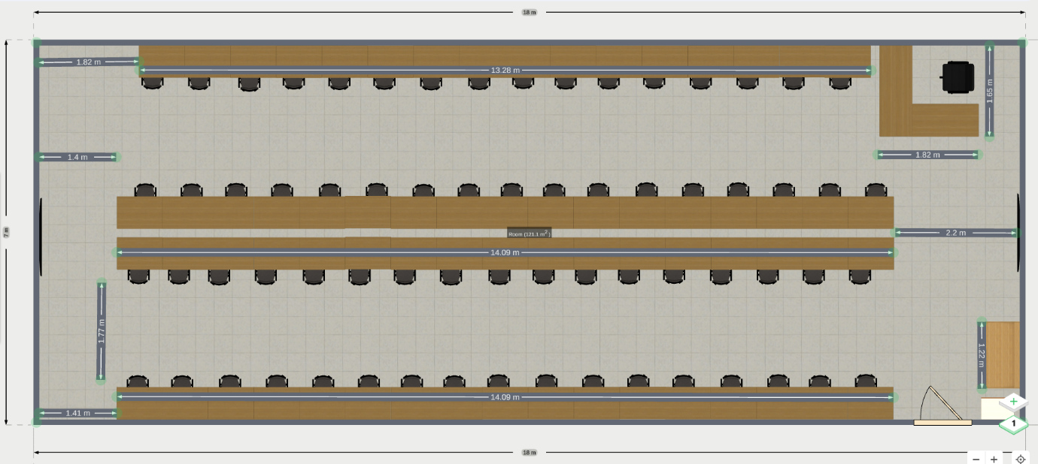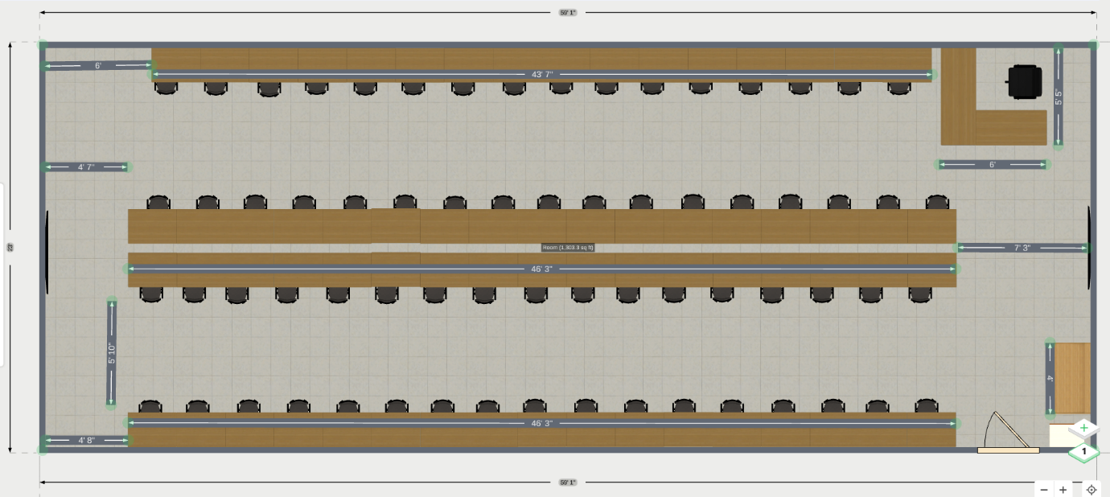

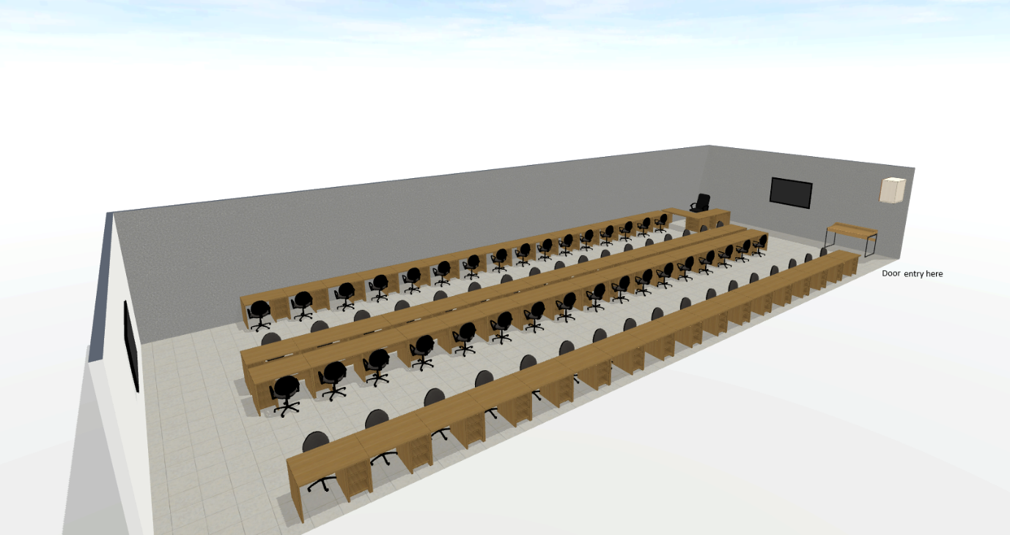

Technical specification:

Sr. No. | Item Name | Qty. | UOM
1 | The work involves setting up a Computer Laboratory with a seating capacity of 60 to 70 users in an existing room measuring 18.230 m × 7.130 m (Approximately)located in the Academic Area of the Institute. The scope of work shall be executed on a turnkey basis and shall broadly include the following:  1. Furniture & Fixtures  2. ICT & Networking  3. Electrical Works and HVAC works  4. Civil & Interior Works  5. General Conditions  6.Deliverables | 130 | Sqm

Introduction & Background
The Institute intends to establish a state-of-the-art Computer Laboratory in its Academic Area to accommodate 60–70 users. The work is to be carried out on a turnkey basis, including design, supply, installation, testing, and commissioning of all required furniture, ICT infrastructure, electrical, HVAC augmentation, and civil/interior works.

2. Project Details
- Location: Academic Area of the Institute
- Room Size: 18.230 m × 7.130 m (approx. 130 sq.m.)
- Seating Capacity: 60–70

3. General Scope of Work
The selected contractor shall be responsible for the following:

A. Furniture & Fixtures
- Supply and installation of computer tables and ergonomic chairs of approved make as per approved drawings.
- Provision of all accessories and supports required for functional seating arrangements.

B. ICT & Networking
- Supply and installation of ICT equipment.
- Structured cabling for internet/network connectivity to all seating points.
- Testing and commissioning of the complete ICT setup.

C. Electrical Works
- Complete internal electrification including wiring, switches, sockets, and distribution boards, lights and Fans etc as approved by LNMIIT representative.
- Augmentation of the existing VRV system by providing additional indoor units with approved drain pipes and accessories.
- Testing and commissioning of electrical and HVAC systems.

D. Civil & Interior Works
- Demolition and removal of existing Brick wall, ducting and aluminum partitions, and any other obsolete installations.
- Repairs and modifications of walls, ceilings, and flooring as required.
- Complete painting of the laboratory with approved materials.
- Supply and installation of window curtains of approved make.

E. General Conditions
- All works to conform to approved drawings, specifications, and directions of the Engineer-in-Charge.
- The contractor shall execute the project on a turnkey basis, providing all labor, materials, equipment, and tools.
- Any ancillary works not explicitly mentioned but necessary for the completion of the project shall be deemed included in the contractor’s scope.

4. Deliverables
- Approved layout plan and design drawings.
- Fully functional computer lab with furniture, ICT setup, electrification, HVAC, and interiors.
- Test reports and commissioning certificates.
- Handover of the completed lab to the Institute.

5. Submission of Proposal
Interested agencies shall submit their proposals in two-bid format:
- Technical Bid – Company profile, eligibility documents, proposed methodology, work plan, and compliance to scope of work.
- Financial Bid – Item-wise Bill of Quantity (BOQ) with unit rates, taxes, and total cost on turnkey basis.

Detailed Scope of works

1.Electrical Works
1.1 Scope of Electrical Work
Supply, installation, and commissioning of wiring using:
- All electrical cabling shall be conducted using surface-mounted PVC trunking (casing and capping) fixed on wall surfaces and furniture partitions. The trunking shall be securely fastened using screws and wall plugs at regular intervals. Wiring shall be enclosed within the trunking, ensuring segregation between power and data lines as per standard electrical practices.
- Payment will be made as per actual work on site.

1.2. Approved Makes
- Wires: Polycab (ISI-marked as per IS:694)
- Casing/Conduit: Precision (UPVC, IS:9537 Part-III)
- Switches & Accessories: Legrand Mylinc (ISI-marked, IS:3419-1988)

1.3. Wiring and Installation
- All wiring shall be conducted in accordance with IS 732: Code of Practice for Electrical Wiring.
- Wiring must be done in a neat, uniform manner, using appropriate colour coding and cable ties.
- All connections shall be properly crimped or terminated using suitable lugs and terminals.
- Junction boxes and faceplates must be flush-mounted and aligned properly.

1.4. Earthing
- Every point must include a 1.5 sq.mm copper earth wire drawn alongside the phase wire.
- Proper earthing continuity and bonding must be ensured for all metal body devices.
- Earthing resistance shall not exceed 1 ohm.

1.5. Trunking and Conduits
- Wiring shall be laid in recessed HMS UPVC conduits or surface mounted UPVC mini trunking, as per site requirements.
- All bends, elbows, and accessories must be ISI-marked and match the conduit/trunking make.
- Casing must be properly fixed using suitable clamps, screws, and spacing.

1.6. Switches, Sockets, Lights ,Fan & Accessories
- Modular switches and sockets shall be installed in approved modular faceplates with grid plates.
- Switches/sockets to be rigidly fixed, with all connections evaluated for continuity and polarity.
- Lights and Fan Shall be installed as per approval by LNMIIT Representative.

1.7. Testing and Commissioning
- Insulation resistance test, polarity test, and continuity test shall be conducted before commissioning.
- A final joint inspection will be conducted with the electrical in-charge or client representative.

1.8. Safety and Compliance
- All safety precautions shall be followed during installation (e.g., insulated tools, PPE).
- Live connections or energized panels must not be worked on without approval.
- All electrical work must comply with Indian Electricity Rules and IE Act.

1.9. Workmanship and Warranty
- The contractor shall guarantee the work for a minimum of 1 months from the date of commissioning.
- Any defect arising during the warranty period must be repaired/replaced free of cost.

1.10. General Conditions
- No deviation in wire size, quality, or make is permitted without written approval.
- Quantities executed must be as per actual site measurement and verified by the client/engineer.
- All waste material must be disposed of by the contractor, and the site should be cleaned daily.
- The department reserves the right to make minor changes during execution without extra cost.
- Any major deviation must be approved in writing.
- In case of dispute, the decision of the competent authority will be final.

1.11. Clean-up and Handover
- The site must be cleaned thoroughly after completion.
- All debris, waste, and packaging material must be disposed of legally.
- As-built drawings and test reports must be handed over.

2.Lab Table Material Specification
2.1. Table Dimensions
- Overall size: 13,500 mm (L) × 1,200 mm (W) × 750 mm (H)
- Seating Capacity: 30 seats per table
- Partition Height: 450 mm
2.2. Tabletop & Material
- Material: Plywood board, 19–20 mm thick (Softwood – Pine)
- Laminate: 1 mm thick, termite-resistant, fire-resistant, moisture-resistant
- Standards: As per IS: 1659, Type COM
- Year of Manufacture: 2025
- Make: Century Ply / Green Ply Sanik 710
2.3. Partition
- Material: Plywood
- Thickness: 75 mm
- Features: Double raceway—one for electrical, one for networking
- Partition Edges: Molded edges
- Height: 450 mm from tabletop
2.4. Hardware & Accessories
- Locks, keys, handles, channels, hinges, and other accessories
- Make: EBCO / Hettich
- Edges: All table edges covered with PVC edge bands (2 mm thick) / wooden molding
2.5. Additional Table Features
- Footrest: Provided along the length of the table
- Keyboard Tray: 600 mm width
- CPU Stand: 150 mm width
- Painting / Finishing: Putty and acrylic paint under the table where laminate is not applied
2.6. Electrical Provision
- Switches: Legrand-Mylinc
  - 15 Amp:
  - 5 Amp:
- Wiring: Polycab, concealed (no visible wiring)
2.7. Notes / Special Requirements
- Partition includes double raceway for power and networking.
- Table designed for ergonomic and safe use, with all exposed edges covered.
- All materials conform to quality and safety standards for academic laboratories.

3 Medium Back Chair Specification
3.1. General Description
- Type: Medium back ergonomic chair
- Make & Model: Amardeep Spirit 03
- Intended Use: Lab / computer workstation seating
3.2. Frame & Structure
- Base: 5-star nylon / PU-coated base with smooth-rolling casters
- Material: High strength engineered plastic and metal for structural support
- Finish: Powder-coated / high-quality polished finish
3.3. Seat & Backrest
- Seat Cushion: High-density foam, upholstered with approved fabric / mesh
- Backrest: Medium height, ergonomic contour for lumbar support
- Adjustments:
  - Seat height adjustable via gas lift
  - Tilt / recline mechanism with lockable tilt angle (if applicable)
3.4. Armrests
- Fixed / adjustable (as per approved specifications)
- Made of durable plastic / metal with soft padding
3.5. Accessories & Hardware
- Casters: Smooth rolling, non-marking
- Gas Lift: ISI certified, heavy-duty for 100–120 kg load
- Screws / Fasteners: ISI / OEM standard
3.6. Compliance & Standards
- Conforms to ergonomic and safety standards for office/lab seating
- Durable, fire-resistant, and easy-to-maintain materials
3.7. Notes
- Supply must match previously approved specifications and make
- Any deviation from the model Amardeep Spirit 03 must be approved before procurement

4.CIVIL WORK MATERIAL SPECIFICATIONS

4.1. Cement Plaster on Internal Walls
Scope of Work: - Apply 12 mm thick cement plaster in a single coat on internal brick masonry walls. - Mortar Mix: 1:6 (1 cement: 6 fine sand). - Finish: Smooth surface, ready for painting. - Includes: Cleaning, curing, scaffolding, and removal of debris. - Standards: CPWD norms and Engineer’s directions.
Materials: | Material | Specification / Remarks
Cement | OPC 43/53 grade, IS 8112 | | Sand | Fine, clean, IS 383 | | Water | Potable, clean | | Scaffolding | GI / bamboo / steel | | Tools | Trowel, float, mixer, buckets |

4.2. Vitrified Floor Tiles
Scope of Work: - Supply & installation of 600 × 600 mm double-charged vitrified floor tiles, approved color. - Base: PCC + 1:4 cement mortar bed. - Jointing: Cement grout. - Standards: CPWD norms and Engineer’s instructions.
Materials: | Material | Specification / Remarks
Tiles | 600×600 mm double-charged, approved sample | | Cement | OPC 43/53 grade | | Sand | Coarse & fine sand | | Adhesive / Grout | Tile adhesive or cement slurry | | Tools | Trowel, tile cutter, level, float, mallet |

4.3. Wall Painting (Plastic Emulsion)
Scope of Work: - Two or more coats of plastic emulsion paint. - Surface prep: Primer, putty, lippy, cracks filling, scaffolding. - Standards: CPWD norms & Engineer’s instructions.
Materials: | Material | Specification / Remarks
Primer | Acrylic / water-based, approved brand | | Putty | Moisture-resistant wall putty | | Paint | Acrylic, washable, approved brand & shade | | Tools | Brushes, rollers, spray equipment, scaffolding |
Notes / Recommendations: - Use ISI / BIS certified materials. - Curing as per CPWD procedures. - Measurements to be verified on-site. - Paint to be applied evenly over plastered surfaces.

ICT & Networking
S.No. | Item Name/ Description | Make & Model/Specification | Qty. | UOM | For Vender
1. | Desktop (For Staff) | Dell /HP Desktop / Intel core-i7 14Gen / 16 GB RAM / 256 GB SSD / 2 TB HDD / 22” Monitor with 5 Year Warranty | 1 | Nos
2. | Printer | HP LaserJet M208dw with 3 Year Warranty | 1 | Nos
3. | LFD with Installation | Samsung BQ65B / Equivalent with 3 Year Warranty | 1 | Nos
4. | Teachmint X 1 Pro Digital Interactive Smart board 75 inch with Installations | - Android 13 True 4k UHD 3840X2160@60Hz, Octa Core A311D2 (4* ARM Cortex – A73 @ 2.212 Ghz + 4* ARM Cortex – A53@ 23.02 Ghz), Single Core: 352 Multi Core: 1324 GPU: 1919, Mali G52MP2 GPU, 8 GB Ram, 128Gb Rom, 4K (48MP) Inbuild Camera, 8 Array Omni Directional Inbuilt Mic, Inbuilt Speakers (32 Watt, 16 W X 3, 8), Dual Band (2.4GHz & 5GHz), Wi-Fi, 3.2mm Toughend Gless MoHs Level 7 Hardness, 400 nits Brightness, 10Bit / 1.07 Billion Display Colours, with 3 Year Warranty  - OPS: - Intel CoreTMi5 / 10th Gen / 8 Gb Ram / 256 GB SSD  - Dell Premier Multi-Device Wireless keyboard Mouse  - Movable Stand: - Screen Trolly | 1 | Nos
5. | HDMI Repeater | HDMI Splitter 1 in 2 out 4k with 1 Year Warranty | 1 | Nos
6. | HDMI Cable | 15 Mtr. 4K | 1 | Nos
7. | 48 port Switch | Cisco C9200L-48T-4G (non-PoE) with 5 Year Warranty | 2 | Nos
8. | LAN Cable | UTP Cable  Make: - Molex  Type: - Cat 6 | 3500 Mtr. Approx. | Mtr.
9. | Audio cable | Make: -AWG  Type: -Speaker Wire | 100 Mtr. Approx. | Mtr.
10. | Cable Laying work  (Molex Cat 6E Cable and Speaker Cable) | Laying of Cable: - Molex Cat 6E cables, Speaker Cable, including laying in casing / conduiting and flexible.  Preferred Make/Model: - For casing / conduit: AKG/Precision  End-to-end termination of network, surveillance, audio-visual, biometric and telephony components. | As per Actual of above mentioned cable s.no.8,9 | Mtr.
11. | 1 Mtr. Patch Cords | Molex | 100 | Nos.
12. | 2 Mtr. Patch Cords | Molex | 100 | Nos.
13. | Network Rack | 12 U Rack | 1 | Nos.
14. | Jack Panel | Cisco with 5 Year Warranty | 4 | Nos.
15. | POE Injector | Cisco 65W with 1 Year Warranty | 6 | Nos.
16. | Access Point | Cisco C9115AXI-D with 5 Year Warranty | 1 | Nos.
17. | IP Camera | Prama/Hikvision PT-NC341P1-WNAMS(D2) (2.8mm) with License 5 Year Warranty | 2 | Nos.
18. | Amplifier | Ahuja Amplifier SSA-250DP 250 Watts with 1 Year Warranty | 1 | Nos.
19. | Speaker | BOSCH LBD3903-D 12W with 1 Year Warranty | 6 | Nos.
20. | Cordless Mic Set | Ahuja Mic AWM-495VHL with 1 Year Warranty | 1 | Nos.
21. | Biometric Machine with Metal Box | Biomax Indigo Face 8 with 1 Year Warranty | 2 | Nos.
22. | Installation, Configuration and Documentation | Installation Report  Setup and Configuration Document  Project Handover Document | 1 | Job

Special Conditions of Contract
- Turnkey Responsibility
The contractor shall be fully responsible for carrying out the work on a lumpsum turnkey basis, covering labour, material, tools, tackles, scaffolding, safety arrangements, and any other incidental items required for successful completion.
- Site Conditions
Bidders shall visit the site and acquaint themselves with the existing conditions before submission of the proposal. No claims will be entertained later for lack of site knowledge.
- Methodology & Approval
Detailed methodology and sequence of execution shall be submitted by the contractor and approved by the Engineer-in-Charge prior to commencement.
Any deviation from approved methodology must be pre-approved in writing.
- Quality of Materials
All materials shall conform to relevant IS codes / DSR specifications or equivalent international standards.
Manufacturer’s test certificates must be provided for all chemicals and waterproofing products.
- Workmanship & Protection
The contractor shall ensure proper slope, drainage, and flashing details to avoid water stagnation.
During execution, proper curing, protection, and safety measures must be ensured.
- Coordination of Ancillary Works
All rerouting/refixing of AC pipes, cables, ducts, plumbing, and false ceiling works shall be carried out in coordination with concerned agencies without disturbing existing services.
- Completion Time
The work must be completed within the stipulated period as per the agreed schedule. Delays will attract penalties as per contract terms.
- Payment Terms
Since the contract is on a lumpsum basis, interim payments may be released against certified progress, subject to retention/security deposit as per contract conditions.
- Safety & Housekeeping
All statutory safety norms must be followed.
Contractor shall maintain cleanliness and dispose of debris from the site regularly.

Commercial Bid: (in separate sealed envelope/password protected file via email)

Bid for “Setting up of Computer Laboratory on Turnkey Basis “

(Tender No.: 2025-26/ECE/2B/LNM-1170)

S.No. | Item Name/ Description | Qty. | UOM | Rate | Amount
1. | The work involves setting up a Computer Laboratory with a seating capacity of 60 to 70 users in an existing room measuring 18.230 m × 7.130 m (Approximately) located in the Academic Area of the Institute. The scope of work shall be executed on a turnkey basis and shall broadly include the following:  1. Furniture & Fixtures  2. ICT & Networking  3. Electrical Works and HVAC Works  4. Civil & Interior Works  5. General Conditions  6.Deliverables | 130 | sqm
Total
GST
Total including GST

- Taxes like GST shall be clearly mentioned. If nothing is mentioned, these charges shall be deemed included.
- If the supplier does not have a particular item offered in the tender or a different make is being proposed by him, the same should be highlighted/mentioned especially by him.
- The prices should include everything (packing, forwarding, transit insurance, transportation, loading /unloading, installation etc.). Loading/unloading up to 50 mtr. shall be done by the supplier.
- Bid should be submitted for F.O.R delivery at the destination i.e. The LNM Institute of Information Technology, Gram – Rupa Ki Nangal, Post – Sumel, Via – Jamdoli, Jaipur- 302031
- The bid should be valid for a minimum period of 30 days. The Change in prices shall not be accepted within the validity period.
- The LNMIIT reserves the right to reject any quotation(s) without assigning any reasons.
- Payment terms shall be decided mutually.
- There should not be any conflict of interest (Declaration to be submitted by the Vendor).
- Bid should be on the company’s letterhead and should submit their bid in the LNMIIT format only.
- Item/Service not supplied by the supplier/service provider should be mentioned separately.
- Vendor should provide a photocopy of the cheque/cancelled cheque while presenting the Invoice to LNMIIT.
- Pre-bid meeting and pre-bid site visit can be done before quoting the rate in the tender to clear up any confusion regarding project details, the scope of work, and solicitation of documents.
- All charges applicable shall be clearly mentioned in the offer. If nothing is mentioned in the offer, the quoted price shall be treated as final, and nothing extra shall be paid extra.

Signature with seal

