Tender No:. 2025-26/Estate/2B/LNM-1153
The LNM Institute of Information Technology, Jaipur

TENDER NOTICE

The LNM Institute of Information Technology, Jaipur is a Deemed-to-be-University, set up as a Non-Profit Making institute engaged in imparting higher learning in Engineering, Technology and Science. We are located at Gram-Rupa Ki Nangal, Post-Sumel, Via-Jamdoli, Jaipur, Pin 302031 Rajasthan, under the joint venture of the Government of Rajasthan and Lakshmi & Usha Mittal Foundation.
The institute invites proposals from competent vendors for “Design, supply, installation, and commissioning of prefabricated toilet blocks”. Bidders can submit their sealed offers/s at the following address by Email/Speed-Post/ Registered Post/ By-hand/courier before 05:00 PM on 17/01/2026 (Last date of bid submission).
Filing of Tender:
Option 1: Physical submission of offers (hard copy) in sealed envelopes.
Bids shall be addressed to the undersigned and deposited in the tender box available at the main gate of the institute in person/ Speed-Post/ Registered Post/ By-hand/courier of the Institute after marking due entries in the Receipt Book available with the Security Officer at the main gate.
The tender subject and reference number must be mentioned on the envelope.

Director
The LNM Institute of Information Technology,
Gram – Rupa Ki Nangal, Post – Sumel,
Via – Jamdoli, Jaipur- 302031

Option 2: Password-protected online submission via Email
Password-protected offers can be submitted by the bidders via email at the below-mentioned email IDs.

tender-document@lnmiit.ac.in (password-protected document)
tender-password@lnmiit.ac.in (password only)
The tender subject and reference number must be mentioned in the subject line of the emails.

Bid Process:
Technical & Commercial details on the company’s letterhead, duly signed and sealed by the authorized signatory, are required to be submitted in two separate envelopes/emails.
Envelopes/Emails should be duly marked as follows:
- Technical bid for the “Design, supply, installation, and commissioning of prefabricated toilet blocks”.
- Commercial Bid for the “Design, supply, installation, and commissioning of prefabricated toilet blocks”.
- Both Envelopes/files should be enclosed/attached in a single envelope/email bearing the heading for “Design, supply, installation, and commissioning of prefabricated toilet blocks”.(Tender No. : 2025-26/Estate/2B/LNM-1153) ”.

Bids are liable to be rejected:
- If the above-mentioned bid submission procedure is not followed.
- Incomplete and non-conforming bids.
- Arbitration: All disputes and differences arising between the two parties in connection with this order shall be mutually settled as far as possible, failing which, all such disputes shall be referred to arbitration and settlement under the provision of the Arbitration and Conciliation Act, 1996 and as amended from time to time or any such law for the time being prevailing in India. The venue of such arbitration shall be Jaipur.
Technical Bid: (in a separate sealed envelope/via email)

Design, supply, installation, and commissioning of prefabricated toilet blocks

(Tender No.: 2025-26/Estate/2B/LNM-1153)

While submitting quotations, the following procedure/ formalities and conditions may kindly be adhered.
- Company profile or brief note about the bidder's company, PAN number, and GST number should be submitted by the Vendor.
- The List of Directors/Partners/Proprietor/Members of the Firm to be attached.
- Detail of other associated/sister concerns (if any) of Directors/Partners/ Proprietor/ Members to be provided.
- Turnover for the last three years to be mentioned. (Copy to be enclosed)
- List of the client to whom the vendor has delivered the goods or provided the services in the past.
- Specification as mentioned below, shall be provided as per the details given below:

Drawing/Photographs (Typical)

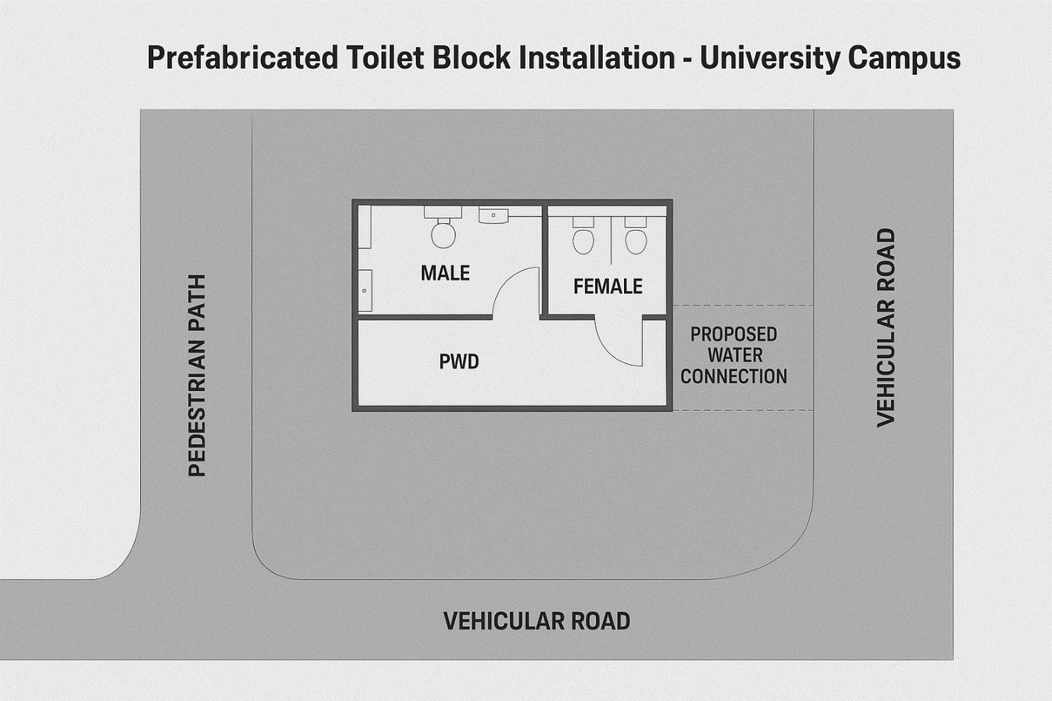

1. Scope of Work
The work includes the complete design, manufacture, transportation, installation, testing, and commissioning of factory-built readymade prefabricated toilet blocks, including all associated civil, plumbing, electrical, and finishing works, as described below:

1.1 Prefabricated Toilet Block (Item A)
- Design, fabrication, and supply of a fully finished prefabricated toilet unit (approx. 6.0 m × 3.0 m × 2.8 m).
- The block shall consist of separate sections for Male, Female, and PWD (Divyang) users.
- Construction shall include:
    - MS structural frame (powder-coated / anti-corrosive paint finish).
    - PUF/FRP wall panels and insulated roofing.
    - Tiled floor finish with proper slope and skirting.
    - Internal partitions, FRP/PVC doors, and ventilation.
    - Factory-fitted sanitary fixtures, plumbing, internal wiring, lights, and exhaust fans.
    - Factory testing and delivery in ready-to-install condition.

2. Civil & Site Preparation Works (Item B1)
- Earthwork in excavation and backfilling for the plinth and base.
- Construction of PCC foundation (1:4:8 mix, 150 mm thick) with proper leveling.
- Plinth beam / tie beam arrangement and anchor bolt provision for fixing the prefab unit.
- Construction of approach ramp (PWD-compliant), steps, and paving around the block.
- Minor boundary edging, platform, and drain provision to ensure proper drainage

3. Plumbing & External Utilities (Item B2)
- Laying of external water supply line (approx. 25 m from nearest source) using CPVC / HDPE pipes, including valves and fittings.
- Laying of external sewer line (approx. 25 m) with PVC pipes (minimum 6" dia), slope, and connection to existing manhole or septic tank.
- Construction of one inspection chamber / manhole with brick masonry and RCC cover.
- Testing of all joints, pressure testing, and final flushing before handover.
- Provision of inlet and outlet points with couplers for easy connection to prefab unit.

4. Electrical & Solar Provision (Item B3)
- Laying of underground armored cable (approx. 25 m) from nearest distribution point.
- Installation of mini distribution board, MCBs, and wiring connections to lighting and exhaust points.
- Internal wiring (concealed / surface as per prefab design).
- Supply and fixing of LED lights, exhaust fans, switches, sockets, and outdoor light near the entrance.
- Provision for solar lighting system (optional) for emergency use.
- Testing of insulation resistance, earthing continuity, and load verification

5. Transportation, Erection & Commissioning (Item B4)
- Transportation of prefab units from manufacturer’s facility to campus (including loading/unloading).
- Lifting and placement at designated location using crane or manual means.
- Alignment, leveling, and bolting with foundation anchors.
- Joint sealing, inspection, and leak testing.
- Commissioning of all electrical and plumbing systems.
- Removal of debris, cleaning, and handover in ready-to-use condition.

6. Finishing, Signage & Handover (Item B5)
- Fixing of signage boards (“Male”, “Female”, “PWD”, and “Do’s & Don’ts”).
- Installation of mirrors, soap dispensers, tissue holders, and dustbins.
- External touch-up painting and sealant work.
- Final inspection and demonstration of all fittings.
- Submission of warranty certificates, test reports, and as-built drawings.

7. General Requirements
- All materials shall be ISI-marked / approved make.
- The bidder shall submit design drawings, fabrication layout, and product data for approval before manufacturing.
- The prefab structure shall carry a minimum 1-year defect liability warranty and expected life 10-15 years with routine maintenance
- Work shall comply with relevant IS standards, CPWD specifications, and local building bylaws.
- Safety of workers and environment protection measures to be ensured during installation.

8. Deliverables
- Prefabricated toilet block (complete in all respects) – 2 nos. at designated campus locations.
- Foundation drawings, connection details, and O&M manual.
- Test certificates for plumbing and electrical systems.
- Photographic documentation before, during, and after installation.

9. Completion Time
- Supply & installation of each unit: 45 days from date of work order.
- Total project completion: 75 days at both locations
Technical specification:

Sr. No. | Item Name | Qty. | UOM
1 | Design, supply, installation, and commissioning of prefabricated toilet blocks with plumbing, electrical, and sewage connections.  Each block shall include:  1. Separate sections for male, female, and PWD (Persons with Disabilities) users.  2. Water-efficient fixtures, adequate ventilation, and solar-powered lighting (where feasible).  3. On-site plumbing connection to existing sewer lines or septic tanks.  4. Hand wash basins, mirrors, dustbins, and signage. | 2 | Nos
Note: - The size of the platform may vary depending upon actual site conditions, final size of prefab block and is subject to change as per requirements at site.

Signature with seal
Commercial Bid: (in separate sealed envelope/password protected file via email)

Design, supply, installation, and commissioning of prefabricated toilet blocks

(Tender No.: 2025-26/Estate/2B/LNM-1153)

S.No. | Item Name/ Description | Qty. | UOM | Rate | Amount
1. | Design, supply, installation, and commissioning of prefabricated toilet blocks with plumbing, electrical, and sewage connections.  Each block shall include:  1. Separate sections for male, female, and PWD (Persons with Disabilities) users.  2. Water-efficient fixtures, adequate ventilation, and solar-powered lighting (where feasible).  3. On-site plumbing connection to existing sewer lines or septic tanks.  4. Hand wash basins, mirrors, dustbins, and signage. | 2 | Nos
Total
GST@_______________
Total including GST
Note:- The size of the platform may vary depending upon actual site conditions, final size of prefab block and is subject to change as per requirements at site.

- Taxes like GST shall be clearly mentioned. If nothing is mentioned, these charges shall be deemed included.
- If the supplier does not have a particular item offered in the tender or a different make is being proposed by him, the same should be highlighted/mentioned especially by him.
- The prices should include everything (packing, forwarding, transit insurance, transportation, loading /unloading, installation etc.). Loading/unloading up to 50 mtr. shall be done by the supplier.
- Bid should be submitted for F.O.R delivery at the destination i.e. The LNM Institute of Information Technology, Gram – Rupa Ki Nangal, Post – Sumel, Via – Jamdoli, Jaipur- 302031
- The bid should be valid for a minimum period of 30 days. The Change in prices shall not be accepted within the validity period.
- The LNMIIT reserves the right to reject any quotation(s) without assigning any reasons.
- Payment terms shall be decided mutually.
- There should not be any conflict of interest (Declaration to be submitted by the Vendor).
- Bid should be on the company’s letterhead and should submit their bid in the LNMIIT format only.
- Item/Service not supplied by the supplier/service provider should be mentioned separately.
- Vendor should provide a photocopy of the cheque/cancelled cheque while presenting the Invoice to LNMIIT.
- Pre-bid meeting and pre-bid site visit can be done before quoting the rate in the tender to clear up any confusion regarding project details, the scope of work, and solicitation of documents.
- All charges applicable shall be clearly mentioned in the offer. If nothing is mentioned in the offer, the quoted price shall be treated as final, and nothing extra shall be paid extra.

Signature with seal

