Tender No:. 2025-26/Estate/2B/LNM-1168

The LNM Institute of Information Technology, Jaipur

TENDER NOTICE

The LNM Institute of Information Technology, Jaipur is a Deemed-to-be-University, set up as a Non-Profit Making institute engaged in imparting higher learning in Engineering, Technology and Science. We are located at Gram-Rupa Ki Nangal, Post-Sumel, Via-Jamdoli, Jaipur, Pin 302031 Rajasthan, under the joint venture of the Government of Rajasthan and Lakshmi & Usha Mittal Foundation.
The institute invites proposals from competent vendors for “Supply & fixing of Steel Grating with Construction of Concrete floor Drain”. Bidders can submit their sealed offers/s at the following address by Email/Speed-Post/ Registered Post/ By-hand/courier before 05:00 PM on 17/01/2026 (Last date of bid submission).
Filing of Tender:
Option 1: Physical submission of offers (hard copy) in sealed envelopes.
Bids shall be addressed to the undersigned and deposited in the tender box available at the main gate of the institute in person/ Speed-Post/ Registered Post/ By-hand/courier of the Institute after marking due entries in the Receipt Book available with the Security Officer at the main gate.
The tender subject and reference number must be mentioned on the envelope.

Director
The LNM Institute of Information Technology,
Gram – Rupa Ki Nangal, Post – Sumel,
Via – Jamdoli, Jaipur- 302031

Option 2: Password-protected online submission via Email
Password-protected offers can be submitted by the bidders via email at the below-mentioned email IDs.

tender-document@lnmiit.ac.in (password-protected document)
tender-password@lnmiit.ac.in (password only)
The tender subject and reference number must be mentioned in the subject line of the emails.

Bid Process:
Technical & Commercial details on the company’s letterhead, duly signed and sealed by the authorized signatory, are required to be submitted in two separate envelopes/emails.
Envelopes/Emails should be duly marked as follows:
- Technical bid for Supply & fixing of Steel Grating with Construction of Concrete floor Drain”. (Technical bid must be submitted without password protection)
- Commercial Bid for the Supply & fixing of Steel Grating with Construction of Concrete floor Drain”. (The Commercial bid must be submitted with password protection.)
- Both Envelopes/files should be enclosed/attached in a single envelope/email bearing the heading for Supply & fixing of Steel Grating with Construction of Concrete floor Drain (Tender No. : 2025-26/Estate/2B/LNM-1168) ”.

Bids are liable to be rejected:
- If the above-mentioned bid submission procedure is not followed.
- Incomplete and non-conforming bids.
- Arbitration: All disputes and differences arising between the two parties in connection with this order shall be mutually settled as far as possible, failing which, all such disputes shall be referred to arbitration and settlement under the provision of the Arbitration and Conciliation Act, 1996 and as amended from time to time or any such law for the time being prevailing in India. The venue of such arbitration shall be Jaipur.
Technical Bid: (in a separate sealed envelope/via email)

Bid for Supply & fixing of Steel Grating with Construction of Concrete floor Drain
(Tender No. : 2025-26/Estate/2B/LNM-1168)

Bidder is required to furnish the requisite details as per the below mentioned table format and proof of such documents to be uploaded along with the bid under respective title/ headings as mentioned at column no ‘C’ accordingly.

SL NO. | Title/ Heading  Details sought by buyer | Details/ Certificate No. (Attached Y/N)
A | B | C
1. | Bidder Firm Name & Registration No,
2. | Bidder’s Company profile or brief note
3. | PAN Card No,.
4. | GST Number
5. | List of Directors/ Partners/Proprietor/ Members of the Bidder’s Firm
6. | Detail of other associated/sister concerns (if any) of Directors/Partners/ Proprietor/ Members
7. | Bidder Turnover - Average annual turnover for last three years
8. | The Client List with some purchase orders and satisfactory certificate (to whom the vendor has delivered the goods/provided the services in the past (Three (03) purchase orders/work orders, at least one from each of the last three years, including the previous year.)
9. | If the bidder is authorized by the OEM/Manufacturer. Proof of the same is to be submitted with the Technical Bid

Drawing/Photographs (Typical)

1. Scope of Work:
The work includes all materials, labour, equipment, and supervision required for constructing a concrete drain (0.6 m wide × 14.60 m long) with a stainless-steel grating cover, along with necessary dismantling and patch-up Kota stone flooring repairs near the drain edges.
All work shall be executed as per specifications, drawings (if any), and directions of the Engineer-in-Charge.
2. Detailed Description of Work:

a) Site Preparation & Dismantling
- Carefully cut and dismantle existing Kota stone flooring along the proposed drain alignment (approx. 0.6 m width × 14.60 m length).
- Remove debris and mortar completely from the site without damaging the adjacent flooring.
- Expose the base for drain concreting.

b) Drain Construction (in Concrete)
- Construct drain walls and base in reinforced cement concrete (RCC) or plain cement concrete (PCC) as directed.
- Recommended mix: PCC 1:2:4 (M15) or RCC M20, minimum thickness 75 mm for base and 50 mm for side walls.
- Provide proper slope towards the outlet to ensure smooth water flow.
- Internal surface of the drain shall be finished with neat cement mortar (1:3) and smooth trowel finish.
- Provide necessary reinforcement (if RCC) — 8 mm bars @ 150 mm c/c both ways, or as approved.
- Formwork and curing to be done as per standard practice.
c) Stainless Steel Grating and Frame
- Supply and fix Stainless Steel Grating with frame, of approved design, to match drain width 0.6 m and total length 14.60 m.
- Grating to be fabricated from SS 304 grade, 4–5 mm thick flat bars, welded and polished to a brushed finish.
- The frame shall be securely embedded into the concrete top surface with proper level and alignment.
- Grating shall be removable for cleaning and designed to take light trolley or kitchen traffic load.
d) Kota Stone Flooring Patch Repair
- After completion of drain, carry out patch-up Kota stone flooring near drain edges to match existing finish.
- Provide and lay 25 mm / matching to existing thickness Kota stone over 20 mm thick cement mortar (1:4) bed.
- Fill joints with cement slurry tinted to match stone shade, then rub and polish for a uniform appearance.
e) Finishing, Cleaning & Testing
- Apply cement grouting at junctions between Kota stone and concrete drain.
- Test the drain for smooth flow of water — no stagnation or leakage.
- Clean the site thoroughly and dispose of all debris as directed.
3. Materials and Standards
Material | Specification
Cement | OPC 43 grade (IS 269) or PPC (IS 1489)
Aggregate | Crushed stone, IS 383, graded for concrete mix
Sand | River /Crush sand, clean and sharp
Steel Grating | SS 304, IS 6911 compliant
Kota Stone | Hard, durable, uniform color, mirror polished finish

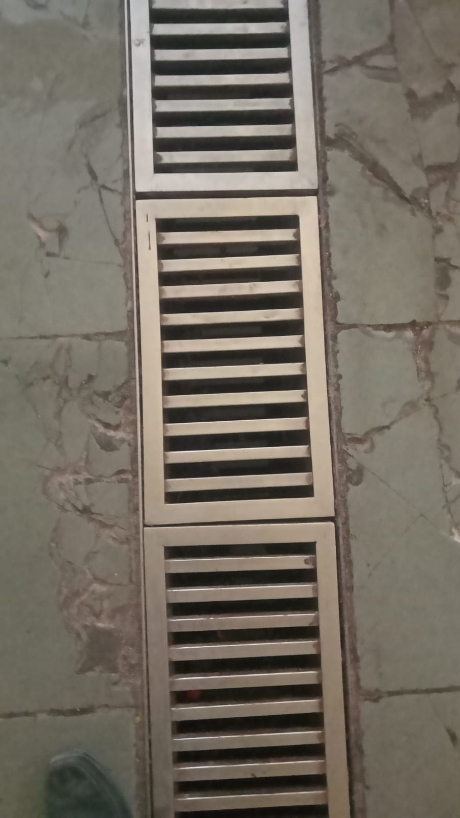

Technical specification:
Sr. No. | Item Name | Make & Model/Specification | Qty. | UOM
1 | Construction of concrete floor drain with stainless steel grating cover, including dismantling of existing flooring and patch-up repair with Kota stone near drain edges. | As per Scope | 14.6 | Rmt.
2 | Supply and fix Stainless Steel Grating with frame, of approved design, to match drain width 0.6 m and total length 14.60 m. | As per Scope | 14.6 | Rmt.
Note: - “The actual scope of work is indicative and may change as per site conditions and the instructions of the Engineer-in-Charge. Final approval shall be obtained at site before execution.”

Signature with seal
Commercial Bid: (in separate sealed envelope/password protected file via email)

Bid for Supply & fixing of Steel Grating with Construction of Concrete floor Drain
(Tender No. : 2025-26/Estate/2B/LNM-1168)
S.No. | Item Name/ Description | Make & Model/ Specification | Qty. | UOM | Rate | Amount
1. | Construction of concrete floor drain with stainless steel grating cover, including dismantling of existing flooring and patch-up repair with Kota stone near drain edges. | As per Scope | 14.6 | Rmt.
2. | Supply and fix Stainless Steel Grating with frame, of approved design, to match drain width 0.6 m and total length 14.60 m. | As per Scope | 14.6 | Rmt.
Total
GST
Total including GST

Note: - “The actual scope of work is indicative and may change as per site conditions and the instructions of the Engineer-in-Charge. Final approval shall be obtained at site before execution.”

- Taxes like GST shall be clearly mentioned. If nothing is mentioned, these charges shall be deemed included.
- If the supplier does not have a particular item offered in the tender or a different make is being proposed by him, the same should be highlighted/mentioned especially by him.
- The prices should include everything (packing, forwarding, transit insurance, transportation, loading /unloading, installation etc.). Loading/unloading up to 50 mtr. shall be done by the supplier.
- Bid should be submitted for F.O.R delivery at the destination i.e. The LNM Institute of Information Technology, Gram – Rupa Ki Nangal, Post – Sumel, Via – Jamdoli, Jaipur- 302031
- The bid should be valid for a minimum period of 30 days. The Change in prices shall not be accepted within the validity period.
- The LNMIIT reserves the right to reject any quotation(s) without assigning any reasons.
- Payment terms shall be decided mutually.
- There should not be any conflict of interest (Declaration to be submitted by the Vendor).
- Bid should be on the company’s letterhead and should submit their bid in the LNMIIT format only.
- Item/Service not supplied by the supplier/service provider should be mentioned separately.
- Vendor should provide a photocopy of the cheque/cancelled cheque while presenting the Invoice to LNMIIT.
- Pre-bid meeting and pre-bid site visit can be done before quoting the rate in the tender to clear up any confusion regarding project details, the scope of work, and solicitation of documents.
- All charges applicable shall be clearly mentioned in the offer. If nothing is mentioned in the offer, the quoted price shall be treated as final, and nothing extra shall be paid extra.

Signature with seal

