Tender No:. 2025-26/Estate/2B/LNM-1180

The LNM Institute of Information Technology, Jaipur

TENDER NOTICE
The LNM Institute of Information Technology, Jaipur is a Deemed-to-be-University, set up as a Non-Profit Making institute engaged in imparting higher learning in Engineering, Technology and Science. We are located at Gram-Rupa Ki Nangal, Post-Sumel, Via-Jamdoli, Jaipur, Pin 302031 Rajasthan, under the joint venture of the Government of Rajasthan and Lakshmi & Usha Mittal Foundation.

The institute invites proposals from competent vendors for “Providing and Laying of New CPVC Pipeline from 500 KLD STP to Gardening Area (Approx. 1300 m)”. Bidders can submit their sealed offers/s at the following address by Email/Speed-Post/ Registered Post/ By-hand/courier before 05:00 PM on 17.01.2026 (Last date of bid submission).

Filing of Tender:

Option 1: Physical submission of offers (hard copy) in sealed envelopes.
Bids shall be addressed to the undersigned and deposited in the tender box available at the main gate of the institute in person/ Speed-Post/ Registered Post/ By-hand/courier of the Institute after marking due entries in the Receipt Book available with the Security Officer at the main gate.

The tender subject and reference number must be mentioned on the envelope.

Director
The LNM Institute of Information Technology,
Gram – Rupa Ki Nangal, Post – Sumel,
Via – Jamdoli, Jaipur- 302031

Option 2: Password-protected online submission via Email
Password-protected offers can be submitted by the bidders via email at the below-mentioned email IDs.

tender-document@lnmiit.ac.in (password-protected document)
tender-password@lnmiit.ac.in (password only)
The tender subject and reference number must be mentioned in the subject line of the emails.

Bid Process:
Technical & Commercial details on the company’s letterhead, duly signed and sealed by the authorized signatory, are required to be submitted in two separate envelopes/emails.

Envelopes/Emails should be duly marked as follows:

- Technical bid for the “Providing and Laying of New CPVC Pipeline from 500 KLD STP to Gardening Area (Approx. 1300 m)”.
- Commercial Bid for the “Providing and Laying of New CPVC Pipeline from 500 KLD STP to Gardening Area (Approx. 1300 m)”.

Both Envelopes/files should be enclosed/attached in a single envelope/email bearing the heading “Bid for the Providing and Laying of New CPVC Pipeline from 500 KLD STP to Gardening Area (Approx. 1300 m) (Tender No. : 2025-26/Estate/2B/LNM-1180)”.

Bids are liable to be rejected:
- If the above-mentioned bid submission procedure is not followed.
- Incomplete and non-conforming bids.
- Arbitration: All disputes and differences arising between the two parties in connection with this order shall be mutually settled as far as possible, failing which, all such disputes shall be referred to arbitration and settlement under the provision of the Arbitration and Conciliation Act, 1996 and as amended from time to time or any such law for the time being prevailing in India. The venue of such arbitration shall be Jaipur.

Technical Bid: (in a separate sealed envelope/via email)

Bid for Providing and Laying of New CPVC Pipeline from 500 KLD STP to Gardening Area (Approx. 1300 m)

(Tender No. : 2025-26/Estate/2B/LNM-1180)

Bidder is required to furnish the requisite details as per the below mentioned table format and proof of such documents to be uploaded along with the bid under respective title/ headings as mentioned at column no ‘C’ accordingly.

SL NO. | Title/ Heading  Details sought by buyer | Details/ Certificate No. (Attached Y/N)
A | B | C
1. | Bidder Firm Name & Registration No,
2. | Bidder’s Company profile or brief note
3. | PAN Card No,.
4. | GST Number
5. | List of Directors/ Partners/Proprietor/ Members of the Bidder’s Firm
6. | Detail of other associated/sister concerns (if any) of Directors/Partners/ Proprietor/ Members
7. | Bidder Turnover - Average annual turnover for last three years
8. | The Client List with some purchase orders and satisfactory certificate (to whom the vendor has delivered the goods/provided the services in the past (Three (03) purchase orders/work orders, at least one from each of the last three years, including the previous year.)
9. | If the bidder is authorized by the OEM/Manufacturer. Proof of the same is to be submitted with the Technical Bid

Scope of work
- The scope of work will cover the supply and installation of given items at LNMIIT Jaipur campus.
- The Vendor is required to submit the complete documentation of the supplied item after delivery.

Drawing / Layout
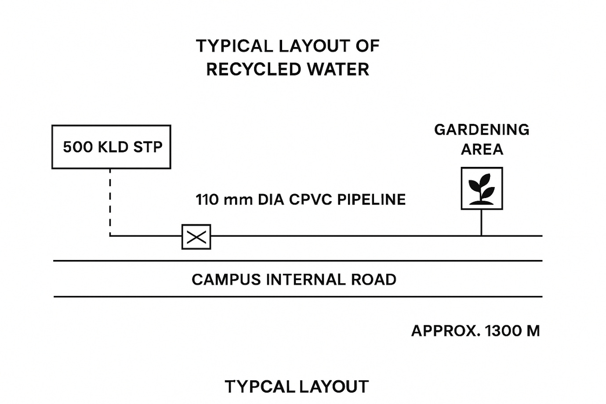
Scope of Work

1. OBJECTIVE:
To execute the complete work of providing, laying, testing, and commissioning a new CPVC pipeline system for the conveyance of recycled treated sewage water from the newly constructed 500 KLD Sewage Treatment Plant (STP) to the designated gardening areas within the campus, including all associated works, removal and reinstatement of existing surface features and services, as directed by the Engineer-in-Charge.
2. WORK LOCATION:
Within the existing campus premises — from the outlet point of the newly constructed 500 KLD STP to the gardening irrigation points, running parallel to the internal road over an approximate length of 1300 meters.
3. SCOPE OF WORK:
A. Supply:
- Supply of CPVC pipes (110 mm dia, SDR 11 or equivalent) conforming to relevant IS/ASTM standards.
- Supply of CPVC fittings such as elbows, tees, reducers, couplers, and end caps.
- Supply of gate valves/ball valves and air release valves at appropriate intervals.
- Supply of solvent cement, gaskets, clamps, pipe supports, and accessories.
- Supply of materials for valve chambers, including masonry, concrete, and covers.
B. Site Preparation and Incumbrance Removal:
- Identification and marking of existing utilities along the proposed alignment.
- Careful removal or temporary shifting of existing encumbrances, paving blocks, kerbstones, etc.
- Protection of existing utilities during excavation.
- Reinstallation/restoration of removed items to original condition after pipeline completion.
C. Civil Works:
- Excavation of trench (0.6 m wide × 0.8 m deep) along internal road shoulders.
- Sand bedding (50 mm thick) and laying of pipes with solvent welded joints.
- Construction of valve chambers at required locations.
- Backfilling, compaction, and leveling to original grade.
- Surface reinstatement of all disturbed areas to their original condition.
D. Testing and Commissioning:
- Hydraulic pressure testing of the entire pipeline.
- Flushing, cleaning, and commissioning of the pipeline network.
4. STANDARDS AND SPECIFICATIONS:
- CPVC Pipes & Fittings: IS 15778 / ASTM D2846
- Valves: IS 778 or equivalent
- Testing Pressure: 1.5 times operating pressure (min. 6 kg/cm²)
5. SAFETY & QUALITY CONTROL:
- Works to comply with site safety norms.
- Proper barricading, signage, and PPE for all workers.
- Daily inspection and quality checks.
6. DELIVERABLES:
- Material delivery and approval records.
- Hydraulic test reports.
- As-built drawings and completion report.
7. COMPLETION CRITERIA:
Completion after successful testing, commissioning, and site reinstatement.
Material Specifications
1. GENERAL REQUIREMENTS:
All materials shall be new, of first quality, and from approved manufacturers conforming to IS/ASTM standards. The system shall be suitable for recycled treated water service.
2. CPVC PIPES:
- Type: CPVC, SDR 11 / Class 3
- Size: 110 mm nominal diameter
- Standard: IS 15778:2007 / ASTM D 2846
- Color: Light cream/beige
- Jointing: Solvent welded with approved cement
- Make: Astral / Supreme / Finolex / Ashirvad
3. CPVC FITTINGS:
- Type: Elbows, Tees, Reducers, Couplers, End Caps
- Standard: ASTM D2846 / IS 15778
- Pressure Rating: Same as pipeline class
4. VALVES:
a) Gate / Ball Valves:
- Material: uPVC/CPVC or Gunmetal
- Standard: IS 778:1984 / ISO 7259
- Pressure Rating: PN10
- Make: Kirloskar / Zoloto / Astral
b) Air Release Valves:
- Type: Single/Double orifice
- Size: 25 mm or 40 mm
- Make: Kirloskar / KSB / Equivalent
5. PIPE JOINTING MATERIALS:
- Solvent Cement: ASTM F493, same make as pipe
- Cleaning Solution: As recommended by manufacturer
6. BEDDING AND BACKFILL MATERIAL:
- Bedding: 50 mm thick sand cushion
- Backfill: Selected earth compacted in 150 mm layers
7. VALVE CHAMBERS:
- Brick masonry in 1:6 cement mortar
- PCC bed (1:4:8), RCC cover slab (M20 grade)
- Internal plaster (1:4), CI or RCC cover
8. PIPE SUPPORTS/CLAMPS:
- GI/MS with rubber lining
- Spacing: 2.0 m
9. TESTING AND COMMISSIONING MATERIALS:
- Pressure gauge 0–16 kg/cm², calibrated
- Clean water for pressure testing
10. IDENTIFICATION & MARKING:
- Warning tape: “RECYCLED WATER LINE BELOW” 300 mm above pipe
- Valve chambers labeled “RECYCLED WATER – CPVC LINE”
11. APPROVED MAKES:
CPVC Pipes & Fittings: Astral / Supreme / Finolex / Ashirvad
Valves: Kirloskar / Zoloto / Astral
Air Valves: Kirloskar / KSB / Equivalent
Solvent Cement: Astral / Finolex / Supreme
12. DOCUMENTATION:
- Manufacturer test certificates
- Pressure test reports
- As-built drawings and completion records

Technical specification:

Sr. No. | Item Name | Qty. | UOM
1 | To execute the complete work of providing, laying, testing, and commissioning a new CPVC pipeline system for the conveyance of recycled treated sewage water from the newly constructed 500 KLD Sewage Treatment Plant (STP) to the designated gardening areas within the campus, including all associated works, removal and reinstatement of existing surface features and services, as directed by the Engineer-in-Charge. | 1300 | Rmt
Note: - The length and size of pipeline are indicative may vary depending upon actual design as per site conditions, final length and size of pipeline are subject to change as per requirements at site.

Signature with seal
Commercial Bid: (in separate sealed envelope/password protected file via email)

Bid for Providing and Laying of New CPVC Pipeline from 500 KLD STP to Gardening Area (Approx. 1300 m)

(Tender No. : 2025-26/Estate/2B/LNM-1180)

S.No. | Item Name/ Description | Qty. | UOM | Rate | Amount
1 | To execute the complete work of providing, laying, testing, and commissioning a new CPVC pipeline system for the conveyance of recycled treated sewage water from the newly constructed 500 KLD Sewage Treatment Plant (STP) to the designated gardening areas within the campus, including all associated works, removal and reinstatement of existing surface features and services, as directed by the Engineer-in-Charge. | 1300 | Rmt

Total

GST _________%

Total with GST

Other T&C

- Taxes like GST should be clearly mentioned. If nothing is mentioned, these charges shall be deemed included.
- If the supplier does not have a particular item offered in the tender or a different make is being proposed by him, the same should be highlighted/mentioned especially by him.
- The prices should include everything (packing, forwarding, transit insurance, transportation, loading /unloading, installation etc.). Loading/unloading up to 50 mtr. shall be done by the supplier.
- Bid should be submitted for F.O.R delivery at the destination i.e. The LNM Institute of Information Technology, Gram – Rupa Ki Nangal, Post – Sumel, Via – Jamdoli, Jaipur- 302031
- The bid should be valid for a minimum period of 30 days. The Change in prices shall not be accepted within the validity period.
- The LNMIIT reserves the right to reject any quotation(s) without assigning any reasons.
- Payment terms shall be decided mutually.
- There should not be any conflict of interest (Declaration to be submitted by the Vendor).
- Bid should be on the company’s letterhead and should submit their bid in the LNMIIT format only.
- Item/Service not supplied by the supplier/service provider should be mentioned separately.
- Vendor should provide a photocopy of the cheque/cancelled cheque while presenting the Invoice to LNMIIT.
- Pre-bid meeting and pre-bid site visit can be done before quoting the rate in the tender to clear up any confusion regarding project details, the scope of work, and solicitation of documents.
- All charges applicable shall be clearly mentioned in the offer. If nothing is mentioned in the offer, the quoted price shall be treated as final, and nothing extra shall be paid extra.

Signature with seal

