Tender No:. 2026-27/Estate/2B/LNM-1379
The LNM Institute of Information Technology, Jaipur

TENDER NOTICE
The LNM Institute of Information Technology, Jaipur is a Deemed-to-be-University, set up as a Non-Profit Making institute engaged in imparting higher learning in Engineering, Technology and Science. We are located at Gram-Rupa Ki Nangal, Post-Sumel, Via-Jamdoli, Jaipur, Pin 302031 Rajasthan, under the joint venture of the Government of Rajasthan and Lakshmi & Usha Mittal Foundation.
The institute invites proposals from competent vendors for “Supply and installation of Normal and Cold-water cooler 150/150 full stainless steel (NCW FSS) Warranty One year (Make Voltas/Usha Shriram/Rockwell) (Item Name)”. Bidders can submit their sealed offers/s at the following address by Email/Speed-Post/ Registered Post/ By-hand/courier before 05:00 PM on 06.06.2026 (Last date of bid receiving).
Filing of Tender:
Option 1: Physical submission of offers (hard copy) in sealed envelopes.
Bids shall be addressed to the undersigned and deposited in the tender box available at the main gate of the institute in person/ Speed-Post/ Registered Post/ By-hand/courier of the Institute after marking due entries in the Receipt Book available with the Security Officer at the main gate.
The tender subject and reference number must be mentioned on the envelope.
Director
The LNM Institute of Information Technology,
Gram – Rupa Ki Nangal, Post – Sumel,
Via – Jamdoli, Jaipur- 302031

Option 2: Password-protected online submission via Email
Password-protected offers can be submitted by the bidders via email at the below-mentioned email IDs.

tender-document@lnmiit.ac.in (password-protected document)
tender-password@lnmiit.ac.in (password only)
The tender subject and reference number must be mentioned in the subject line of the emails.

Bid Process:
Technical & Commercial details on the company’s letterhead, duly signed and sealed by the authorized signatory, are required to be submitted in two separate envelopes/emails.
Envelopes/Emails should be duly marked as follows:
- Technical bid for the “Supply and installation of Normal and Cold-water cooler 150/150 full stainless steel (NCW FSS) Warranty One year (Make Voltas/Usha Shriram/Rockwell)”. (Item Name) (Technical bid must be submitted without password protection)
- Commercial Bid for the “Supply and installation of Normal and Cold-water cooler 150/150 full stainless steel (NCW FSS) Warranty One year (Make Voltas/Usha Shriram/Rockwell)”. (Item Name) )” (The Commercial bid must be submitted with password protection.)
Both Envelopes/files should be enclosed/attached in a single envelope/email bearing the heading “Bid for the “Supply and installation of Normal and Cold-water cooler 150/150 full stainless steel (NCW FSS) Warranty One year (Make Voltas/Usha Shriram/Rockwell)”) (Item Name) (Tender No. : 2026-27/Estate/2B/LNM-1379) ”.
Note: The bidders/vendors are requested to go through the tender document carefully and ensure compliance with all specifications/instructions in this tender
Bids are liable to be rejected:
- If the above-mentioned bid submission procedure is not followed.
- Incomplete and non-conforming bids.
- Arbitration: All disputes and differences arising between the two parties in connection with this order shall be mutually settled as far as possible, failing which, all such disputes shall be referred to arbitration and settlement under the provision of the Arbitration and Conciliation Act, 1996 and as amended from time to time or any such law for the time being prevailing in India. The venue of such arbitration shall be Jaipur.
Technical Bid: (in a separate sealed envelope/via email)

Bid for the Supply and installation of Normal and Cold-water cooler 150/150 full stainless steel (NCW FSS) Warranty One year (Make Voltas/Usha Shriram/Rockwell) (Item Name)

(Tender No. : 2026-27/Estate/2B/LNM-1379)

Bidder is required to furnish the requisite details as per the below mentioned table format and proof of such documents to be uploaded along with the bid under respective title/ headings as mentioned at column no ‘C’ accordingly.

S.No. | Title/ Heading  Details sought by buyer | Details/ Certificate No. (Attached Y/N)
A | B | C
1. | Bidder Firm Name & Registration No,
2. | Bidder’s Company profile or brief note
3. | PAN Card No,.
4. | GST Number
5. | List of Directors/ Partners/Proprietor/ Members of the Bidder’s Firm
6. | Detail of other associated/sister concerns (if any) of Directors/Partners/ Proprietor/ Members
7. | Bidder Turnover - Average annual turnover for last three years
8. | The Client List with some purchase orders and satisfactory certificate (to whom the vendor has delivered the goods/provided the services in the past (Three (03) purchase orders/work orders, at least one from each of the last three years, including the previous year.)
9. | If the bidder is authorized by the OEM/Manufacturer. Proof of the same is to be submitted with the Technical Bid
10. | An undertaking (self-certificate) that the agency has not been blacklisted by a Central/State/UT Government Institutions and there has been no litigation with any government department/institution on account of any services/supplies.
11. | Scanned copy of EMD/ Tender Fees paid through RTGS/NEFT (if required/asked in the tender)
12 | Xerox copies of MoUs with previous colleges (minimum three) must be attached. (Applicable for student fest only).

Scope of work

- The scope of work will cover the supply /arrangement of given items at LNMIIT Jaipur campus.
- The Vendor is required to submit the complete documentation of the supplied item after delivery.

Technical specification:

150/150 Ltr Water Coolers (150L Cooling/150L Storage) typically require ISI-marked (IS-1475) These industrial-grade, stainless steel tanks use either copper or specialized high-grade, food-safe piping to facilitate heat transfer from the water to the refrigerant, ensuring efficiency and hygienic cooling.
Key Cooling Features of Voltas Water Coolers:
Cooling System: Uses a hermetically sealed, reciprocating, or rotary compressor and R134a or R22 refrigerant for consistent, high-capacity cooling.
Cooling Coil: 100% Copper Cooling Coil with 5 Year Warranty, Compressor
Insulation: Features In-Situ PUF (Polyurethane Foam) insulation to keep water cold for longer, minimizing heat gain.
Capacity: 150 Ltr Storage / 150 Ltr Cooling per hour.
Body/Tank: Food-grade Stainless Steel (SS 304).: The storage tanks and cooling surfaces are made of food-grade stainless steel (SS 304 or 18-8 or similar) to ensure water safety and long life.
Installation: Installation requires a standard water inlet pipe connected to a potable source and a drainpipe, often installed by professionals
Taps: 2 Cold Water Taps
Voltage: 230V, Single Phase, 50 Hz AC.
Warranty: Minimum 1 year on machine, 5 years on Heavy-Duty compressor

Bid for Supply and installation of Normal and Cold-water cooler 150/150 full stainless steel (NCW FSS) Warranty One year (Make Voltas/Usha Shriram/Rockwell

Tender No.: 2024-25/Estate/2B/LNM-705)”.

S.No. | Item Name/ Description | Detailed scope of work | Qty. | UOM
1 | Supply and installation of Water Cooler | Normal and Cold-water cooler 150/150 full stainless steel (NCW FSS) Warranty One year (Make Voltas/Usha Shriram/Rockwell) | 5 | Nos.

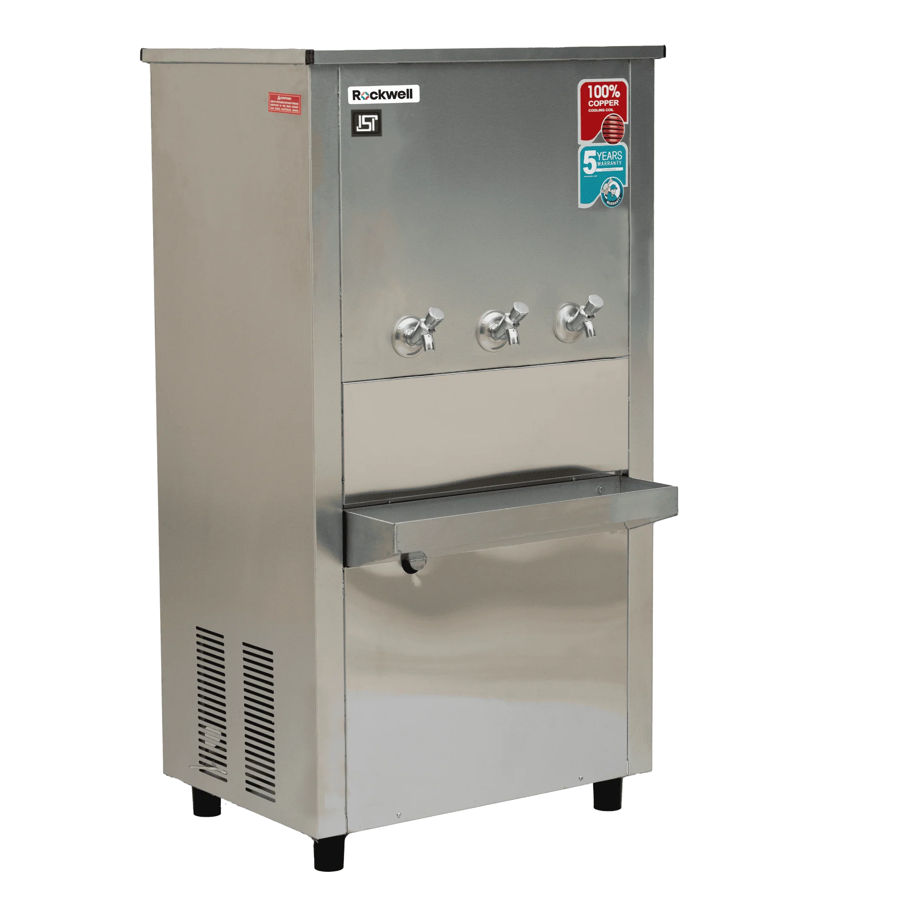

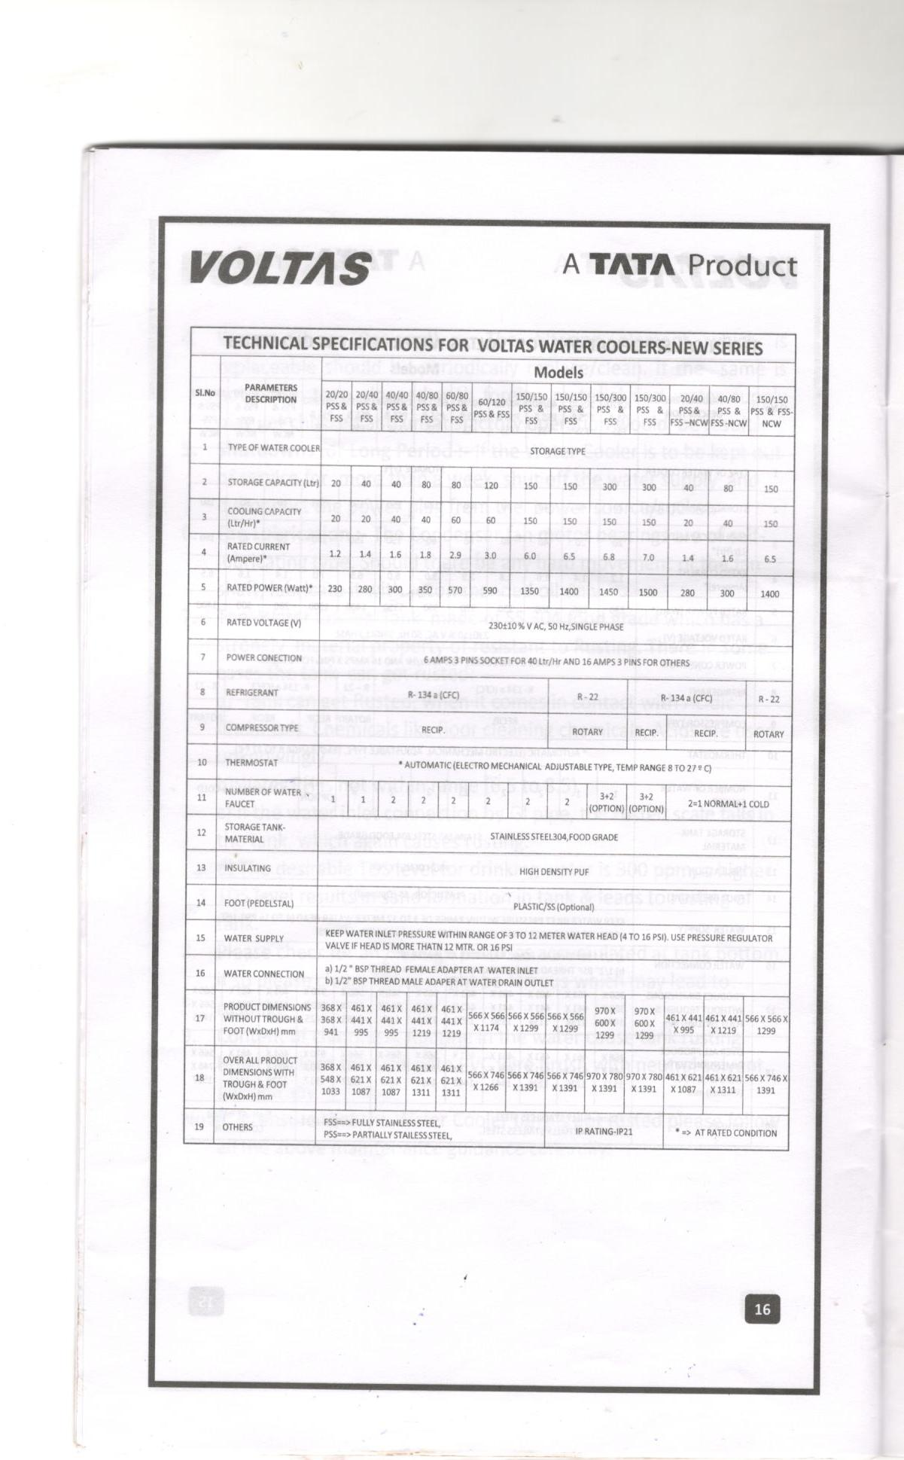

Signature with seal

Annexure
To Whomsoever It May Concern
This is to confirm that we, the undersigned, intend to participate in Tender No. : 2026-27/Estate/2B/LNM-1379 for the tender/work titled: “Bid for the “Supply and installation of Normal and Cold-water cooler 150/150 full stainless steel (NCW FSS) Warranty One year (Make Voltas/Usha Shriram/Rockwell) (Item Name) ”

We hereby certify the following:
No Conflict of Interest:
- We declare that we have no conflict of interest in participating in the above tender. We further confirm that we are not engaged in any activity or association that may compromise, or be perceived to compromise, our impartiality or ability to fulfil the obligations of the tender.

Undertaking on Blacklisting & Litigation (Self-Certificate):
- We hereby undertake that:
- Our agency/firm has never been blacklisted or debarred by any Central Government, State Government, Union Territory administration, or any other Institution/Organization.
- There is no ongoing or past litigation against our agency/firm with any Central Government, State Government, Union Territory administration, or any other Institution/Organization on account of any services/supplies.
- If at any stage the above declaration is found to be false, the Institute shall have the right to take any action as deemed appropriate, including rejection of our bid.

Site Visit /Understanding:
- We confirm that we have visited the site/clearly understood the requirements and expectations of the college authorities.

Scope of Work:
- We have thoroughly reviewed the scope of work mentioned in the bid document. The entire inventory/requirement/work has been verified and found to be in order. We also confirm that no additional items beyond the listed inventory/requirement will be required for successful completion of the work. However, if any additional item is required during execution, the same shall be provided by us as per the requirement.

Bidder Details

Name of Bidder: ______________________________________

Address: _____________________________________________

Contact Person: _______________________________________

Mobile No.: ___________________________________________

Email ID: _____________________________________________

Authorized Signatory: __________________________________

Signature & Stamp: ____________________________________

Date: _________________
Place: ________________
Commercial Bid: (in separate sealed envelope/password protected file via email)

Bid for the Supply and installation of Normal and Cold-water cooler 150/150 full stainless steel (NCW FSS) Warranty One year (Make Voltas/Usha Shriram/Rockwell) (Item Name)

(Tender No. : 2026-27/Estate/2B/LNM-_1379)

S.No. | Item Name/ Description | Qty. | UOM | Rate | Amount
1. | Supply and installation of Water Cooler  Specifications  Normal and Cold-water cooler 150/150 full stainless steel (NCW FSS) Warranty One year (Make Voltas/Usha Shriram/Rockwell | 5 | Nos.
2 | Transportation, Loading Unloading charges | 1 | Nos.
Total
GST
Total including GST

GENERAL TERMS AND CONDITIONS:
- All applicable taxes such as GST must be clearly mentioned. If not specified, it shall be deemed that all such charges are included in the quoted price.
- If the supplier does not have a particular item or proposes a different make than that specified in the tender, the same must be clearly highlighted in the bid.
- Prices must be inclusive of all charges such as packing, forwarding, transit insurance, transportation, loading, unloading (up to 50 meters), installation, and any other incidental expenses.
- Bid must be submitted on an F.O.R. basis for delivery at: The LNM Institute of Information Technology, Gram – Rupa Ki Nangal, Post – Sumel, Via – Jamdoli, Jaipur – 302031.
- Bid shall remain valid for a minimum period of 30 days. No change in prices will be accepted during the validity period.
- The LNMIIT reserves the right to reject any quotation without assigning any reason.
- Payment terms shall be mutually decided and agreed upon between the Institute and the vendor.
- The bidder must submit a No Conflict of Interest Declaration along with the bid.
- The bid must be submitted on the company’s letterhead and in the LNMIIT-prescribed format only.
- Any item or service not being supplied by the bidder must be clearly mentioned separately in the bid.
- Vendors must provide a photocopy of their cheque/cancelled cheque along with the invoice for payment processing.
- Prices shall be quoted in Indian Rupees (INR) only.
- Total prices shall be quoted for the complete scope of work as per technical specifications, inclusive of all taxes, duties, insurance, packing, forwarding, and incidental charges.
- Agencies or individuals who are debarred or blacklisted are not permitted to participate in the tendering process. Any agency engaging a debarred person for negotiations or representation is also liable to be debarred.
- If the work is not completed within the stipulated time mentioned in the work order, the competent authority of LNMIIT reserves the right to accept partial work on suitable terms, cancel the supply/work order, withhold or stop payment, forfeit the Earnest Money Deposit, or debar the agency. The decision of the Competent Authority shall be final and binding.
- In case two or more bidders quote the same rates, the final selection shall be made through a draw of lots conducted by a committee comprising LNMIIT administrative members(PCC).
- Vendors are required to visit the site and conduct a detailed survey before submitting their bid to understand the exact requirements. No request for additional items or modifications will be entertained later.
- A pre-bid meeting and/or site visit may be arranged prior to submission of bids to clarify any doubts regarding project details, scope of work, and required documents.

Signature with seal

