The LNM Institute of Information Technology, Jaipur

TENDER NOTICE

“The LNM Institute of Information Technology, Jaipur is a Deemed-to-be-University, set up as a Non-Profit Making institute located at Gram-Rupa Ki Nangal, Post-Sumel, Via-Jamdoli, Jaipur, Pin 302031 Rajasthan, under the joint venture of Government of Rajasthan and Lakshmi & Usha Mittal Foundation.

The institute invites proposals from competent vendors for “Supply of Kinect Sensor + Adapter, Camera Stand, and Raspberry Pi Speaker”. Bidders can submit their sealed offer/s at the following address by Speed-post/Registered Post/By-hand (but not by Courier) before 05:00 PM on 15.06.2022.

Bids shall be addressed to the undersigned and deposited in the tender box available at the main gate of the Institute after marking due entries.

Director
The LNM Institute of Information Technology,
Gram – Rupa Ki Nangal, Post – Sumel,
Via – Jamdoli, Jaipur- 302031
Email: directoroffice@lnmiit.ac.in

Bidders can also submit their offer/s via Email with password-protected document/file at the below-mentioned email IDs (E-mail must be sent on both mail IDs) before 05:00 PM on 15.06.2022.

The Password protected document/file is to be sent to the purchase officer at the email id: purchase.officer@lnmiit.ac.in, and the password should be sent to Chairman-PCC at the email id: chairman.pcc@lnmiit.ac.in.

purchase.officer@lnmiit.ac.in
chairman.pcc@lnmiit.ac.in

Bid Process:
Technical & commercial details of the offer shall be enclosed in two separate envelopes/ files, duly marked as “Technical Bid for Supply of Kinect Sensor + Adapter, Camera Stand, and Raspberry Pi Speaker” and “Financial Bid for Supply of Kinect Sensor + Adapter, Camera Stand, and Raspberry Pi Speaker”. Both Envelopes/ files shall be enclosed in a single envelope/ mail bearing the heading “Bid for ”Supply of Kinect Sensor + Adapter, Camera Stand, and Raspberry Pi Speaker”. Bids are liable to be rejected if any or both of the technical or commercial offers are found in open condition, or required information is not found with the offer.

Technical Bid: (in separate sealed envelope/Email)
While submitting quotations, the following procedure/ formalities and conditions may kindly be adhered to.
- The relevant literature and pamphlets about the product should be sent along with the tenders/quotations.
- Copy of authorisation/certificate from the OEM in the case supplied by a vendor who is not a manufacturer of the product.
- Company profile or brief note about the bidder's company, PAN number, and GST number should be submitted by the Vendor.
- List of Directors/Partners/Proprietors/Members of the Firm to be attached.
- Detail of other associated/sister concerns ((if any) of Directors/Partners/ Proprietor/ Members to be provided.
- Turn over for the last three years to be mentioned. (Copy to be enclosed)
- List clients to whom the vendor has delivered the goods or provided the services in the past.
- Specification, as mentioned below, shall be provided as per the details given below:

Technical specification - ” Supply of Kinect Sensor + Adapter, Camera Stand, and Raspberry Pi Speaker”

Scope of Work/ITEM DETAIL
- Supply of Kinect Sensor + Adapter
Brand | MICROSOFT
Model | Xbox One Kinect Sensor + Adapter for XBOX One S & Windows
Colour | Black
Platform | Xbox One
Interface | Wired
Sales Package | One sensor bar, one adapter
- Camera Stand
Sales Package | 1 Tripod x 1Mobille Holder x 1 Carry Bag
Head Type | Bubble Head
Head Mount Thread Size | 1/4"
Other Features | 3 WAY HEAD WITH ADJUSTABLE PAN, MULTIPURPOSE QUICK RELEASE HEAD, QUICK RELEASE LEG LOCKS, ACCESSORY HOOK

- Raspberry Pi Speaker
Brand | Dhruva
Type | Microphone
Wired/Wireless | Wireless

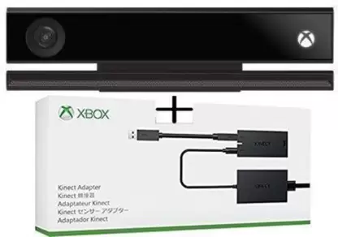

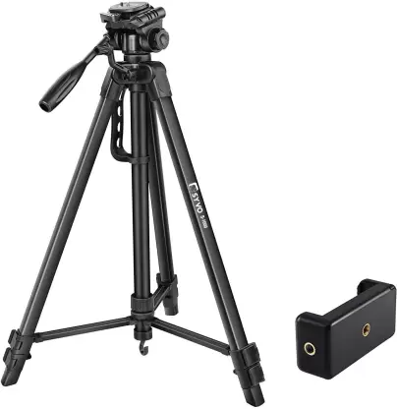

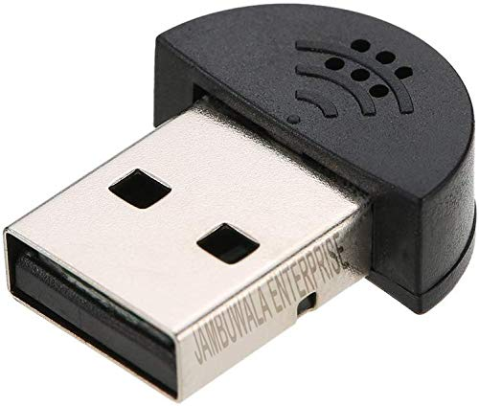

Commercial Bid: (in a separate sealed envelope)

Financial Bid
”Supply of Kinect Sensor + Adapter, Camera Stand, and Raspberry Pi Speaker”

S.No. | Item Name | Qty. | UOM | RATE | Amount
1. | Supply of Kinect Sensor + Adapter | 2
2. | Camera Stand | 1
3. | Raspberry Pi Speaker | 2
 |  | Total
 |  | Tax
 |  | Ground Total
- Taxes like GST shall be mentioned. If nothing is said, these charges shall be deemed included.
- The prices should be including all (Packing, forwarding, Transit Insurance, Transportation Loading/unloading, Installation etc.)
- Bid should be submitted for F.O.R delivery at the destination, i.e. The LNM Institute of Information Technology, Gram – Rupa Ki Nangal, Post – Sumel, Via – Jamdoli, Jaipur- 302031
- Bid should be valid for a minimum period of 30 days.
- The LNMIIT reserves the right to reject any quotation(s) without assigning any reasons.
- Payment terms shall be decided mutually.
- There should not be any conflict of interest (Declaration submitted by the Vendor).
- Bid should be on the company’s letterhead and should submit their bid in the LNMIIT format only
- Item/Service not supplied by the supplier/service provided should be mentioned separately.
- Vendor should provide the photocopy of the cheque/cancelled cheque while presenting the Invoice to LNMIIT.
All charges applicable shall be mentioned with the offer. If nothing is mentioned in the offer, the quoted price shall be treated as final, and nothing extra shall be paid.

Signature with seal (Company/Firm)

