The LNM Institute of Information Technology, Jaipur

TENDER NOTICE

“The LNM Institute of Information Technology, Jaipur is a Deemed-to-be-University, set up as a Non-Profit Making institute located at Gram-Rupa Ki Nangal, Post-Sumel, Via-Jamdoli, Jaipur, Pin 302031 Rajasthan, under the joint venture of Government of Rajasthan and Lakshmi & Usha Mittal Foundation.

The institute invites proposals from competent vendors for “Chair repairing work”. Bidders can submit their sealed offer/s at the following address by Speed-post/Registered Post/By-hand (but not by Courier) before 05:00 PM on 25.07.2022.

Bids shall be addressed to the undersigned and deposited in the tender box available at the main gate of the Institute after marking due entries.

Director
The LNM Institute of Information Technology,
Gram – Rupa Ki Nangal, Post – Sumel,
Via – Jamdoli, Jaipur- 302031
Email: directoroffice@lnmiit.ac.in

Bidders can also submit their offer/s via Email with password-protected document/file at the below-mentioned email IDs (E-mail must be sent on both mail ID) before 05:00 PM on 25.07.2022.

The Password protected document/file to be sent to the purchase officer at the email id: purchase.officer@lnmiit.ac.in and the password should be sent to the Chairman-PCC at the email id: chairman.pcc@lnmiit.ac.in .

purchase.officer@lnmiit.ac.in
chairman.pcc@lnmiit.ac.in

Bid Process:
Techno=-commercial offer shall be in envelopes/ files, duly marked as “Techno-commercial Bid for Chair repairing work”. Bid/s are liable to be rejected if offers are found in open condition or required information is not found with the offer.

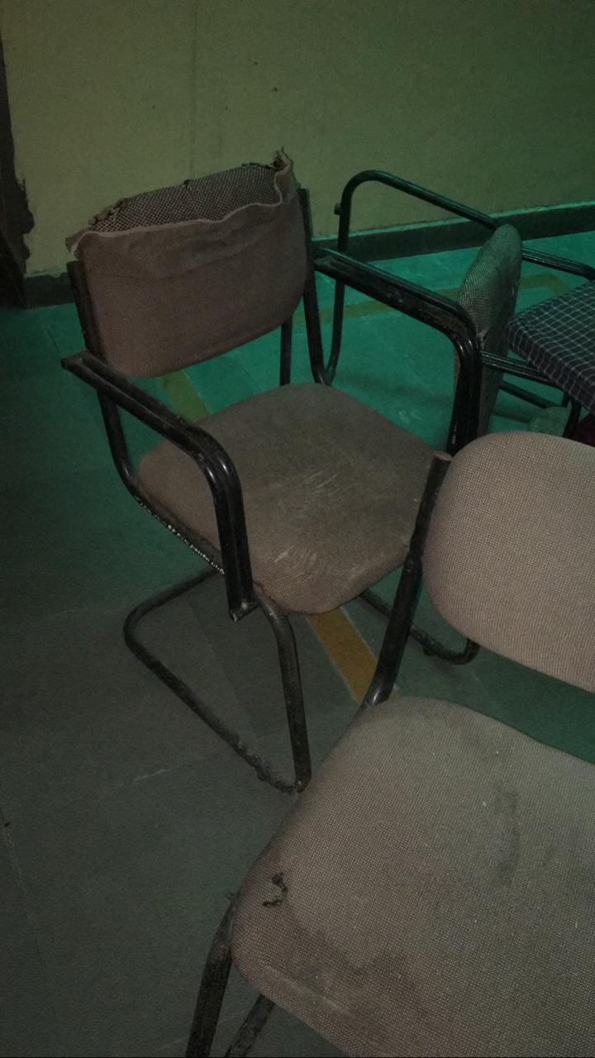

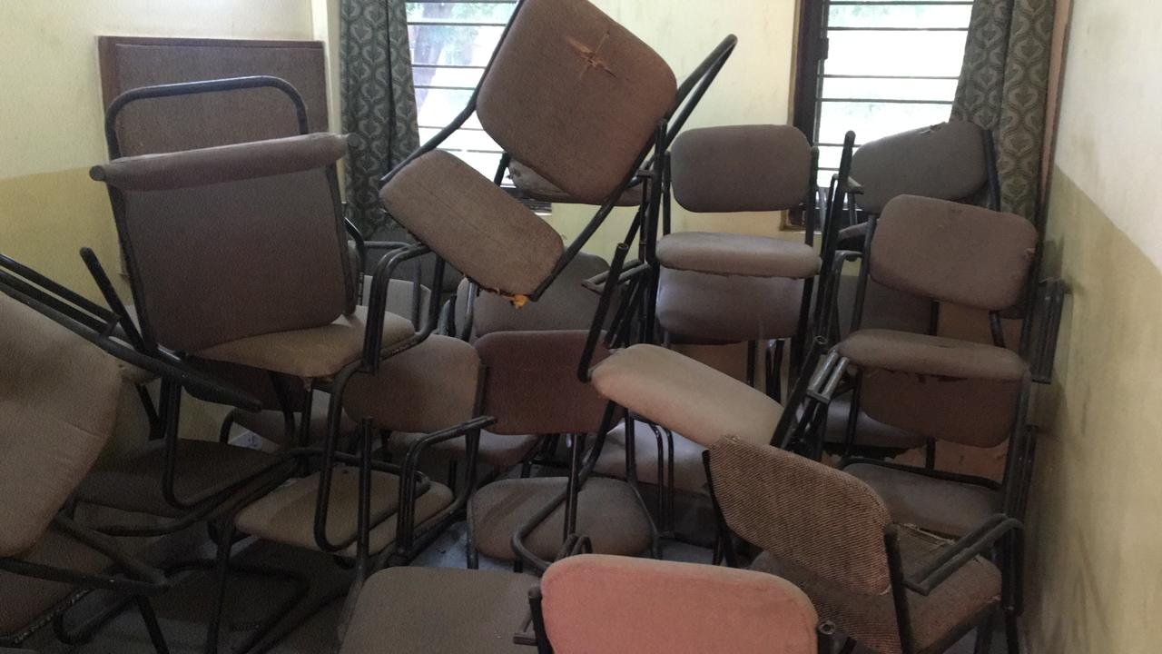

Commercial Bid: (in separate sealed envelope)
Financial Bid
Techno-commercial Bid for Chair repairing work

S. No | Items | Qty. & UOM | Rate | Amount
01 | Chair repairing work – Cloth replacement with foam | 200 Nos.
Total
Tax
Grand Total
- Taxes like GST shall be clearly mentioned. If nothing is mentioned, these charges shall be deemed included.
- If the supplier does not have a particular item offered in the tender or a different make is being proposed by him, the same should be highlighted/mentioned especially by him.
- The prices should be including all (Packing, forwarding, Transit Insurance, Transportation Loading, unloading up to 50mtr., Installation etc.).
- Bid should be submitted for F.O.R delivery at the destination i.e. The LNM Institute of Information Technology, Gram – Rupa Ki Nangal, Post – Sumel, Via – Jamdoli, Jaipur- 302031
- Bid should be valid for a minimum period of 30 days. The Change in prices shall not be accepted within the validity period.
- The LNMIIT reserves the right to reject any quotation(s) without assigning any reasons.
- Payment terms shall be decided mutually.
- There should not be any conflict of interest (Declaration to be submitted by the Vendor).
- Bid should be on the company’s letterhead and should submit their bid in the LNMIIT format only
- Item/Service not supplied by the supplier/service provide should be mentioned separately.
- Vendor should provide the photocopy of the cheque/cancelled cheque while presenting the Invoice to LNMIIT.

All charges applicable shall be clearly mentioned with the offer. If nothing is mentioned in the offer, the quoted price shall be treated as final and nothing extra shall be paid extra.

Signature with seal

