The LNM Institute of Information Technology, Jaipur

TENDER NOTICE

The LNM Institute of Information Technology, Jaipur is a Deemed-to-be-University, set up as a Non Profit Making institute engaged in imparting higher learning in Engineering, Technology and Science. We are located at Gram-Rupa Ki Nangal, Post-Sumel, Via-Jamdoli, Jaipur, Pin 302031 Rajasthan, under the joint venture of the Government of Rajasthan and Lakshmi & Usha Mittal Foundation.
The institute invites proposals from competent vendors for “Providing and Fixing of false ceiling/ false tiles repair and replacement work as already existing works in the buildings”. Bidders can submit their sealed offer/s at the following address by Speed-Post/ Registered Post/ By-hand (but not by Courier)/ before 05:00 PM on 15.07.2023
Bids shall be addressed to the undersigned and deposited in the tender box available at the main gate of the Institute after marking due entries.

Director
The LNM Institute of Information Technology,
Gram – Rupa Ki Nangal, Post – Sumel,
Via – Jamdoli, Jaipur- 302031
Email: directoroffice@lnmiit.ac.in\

Bidders can also submit their offer/s via Email with password protected document/file at the below mentioned email IDs (E-mail must sent on both mail ID) before 05:00 PM on 15.07.2023.

The Password protected document/file to be sent to purchase officer at the email id: purchase.officer@lnmiit.ac.in and password should be sent to Chairman-PCC at the email id: chairman.pcc@lnmiit.ac.in .

purchase.officer@lnmiit.ac.in
chairman.pcc@lnmiit.ac.in

Bid Process:

Technical & Commercial details on the company’s letterhead, duly signed and sealed by the authorized signatory are required to be submitted in two separate envelopes/files. Both envelopes/files should be duly marked as “Technical bid for “Providing and Fixing of false ceiling/ false tiles repair and replacement work as already existing works in the buildings” and “Commercial Bid for “Providing and Fixing of false ceiling/ false tiles repair and replacement work as already existing works in the buildings” respectively. Both Envelopes shall be enclosed in a single envelope bearing the heading “Bid for Providing and Fixing of false ceiling/ false tiles repair and replacement work as already existing works in the buildings”. Bids are liable to be rejected if any or both of the technical or commercial offers are found in open condition or required information is not found with the offer.
Bids can be sent via email as per the process mentioned above.
Technical Bid: (in a separate sealed envelope)
While submitting quotations, the following procedure/ formalities and conditions may kindly be adhered.
- Company profile or brief note about the bidder's company, PAN number, and GST number should be submitted by the Vendor.
- The List of Directors/Partners/Proprietor/Members of the Firm to be attached.
- Detail of other associated/sister concerns (if any) of Directors/Partners/ Proprietor/ Members to be provided.
- Turn over for the last three years to be mentioned. (Copy to be enclosed)
- List of the client to whom the vendor has delivered the goods or provided the services in past.
- The vendor and his team shall follow the complete safety measures at site during work and should finish the work within maximum 7 days only. No LNMIIT person shall responsible for any casualty.
- The company/ vendor shall contact to the purchase team before quoting the rate according to the technical details mentioned and discussed during visit/ meeting.
- Area of the work :- Lecture Halls, Sports Complex Area.
- Specification as mentioned below, shall be provided as per the details given below:

Scope of work, Technical data sheet and Specification of the item/s

S.No. | Item Name/ Description | Qty. | UOM
1 | Providing and Fixing of false ceiling/ false tiles repair and replacement work as already existing works in the buildings upto the maximum height of 9m, including scaffolding, and other required tools n materials for the work completion.  False ceiling/ tiles size 600 mm x 600 mm | 350 | Sqft

LOCATION PHOTOGRAPHS

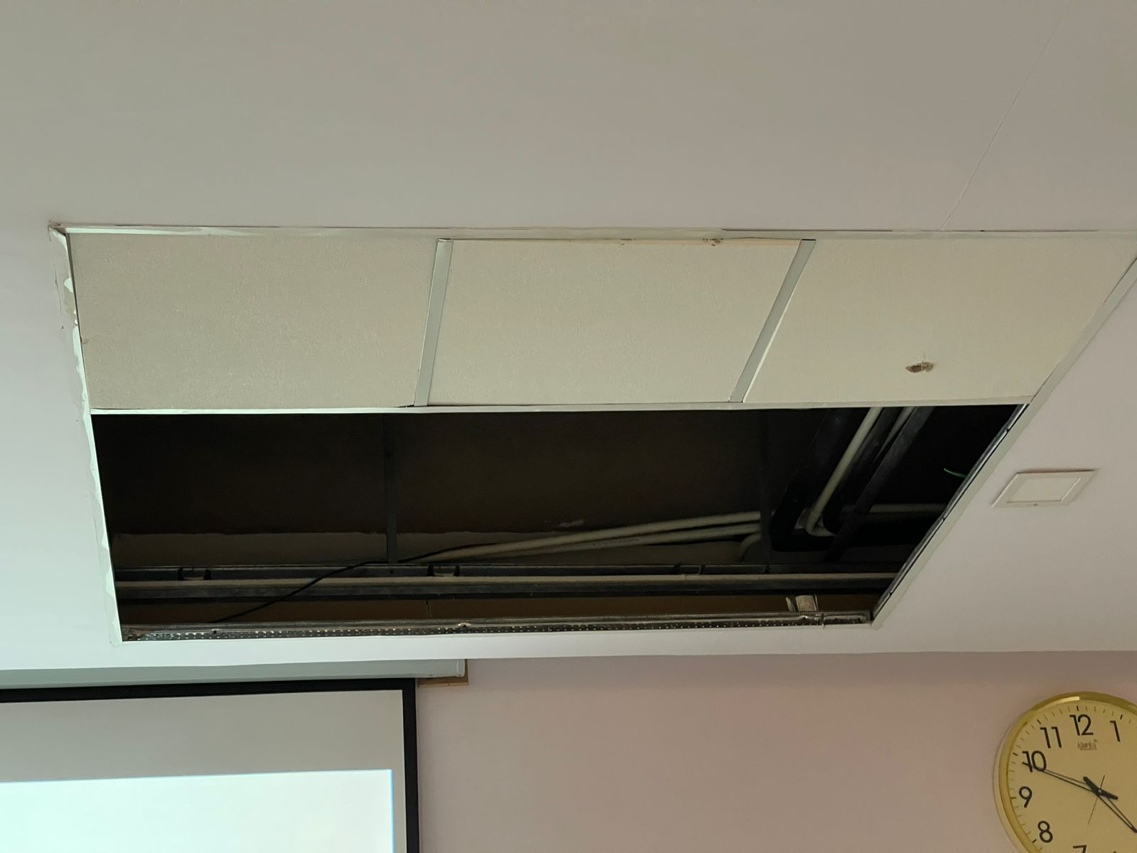

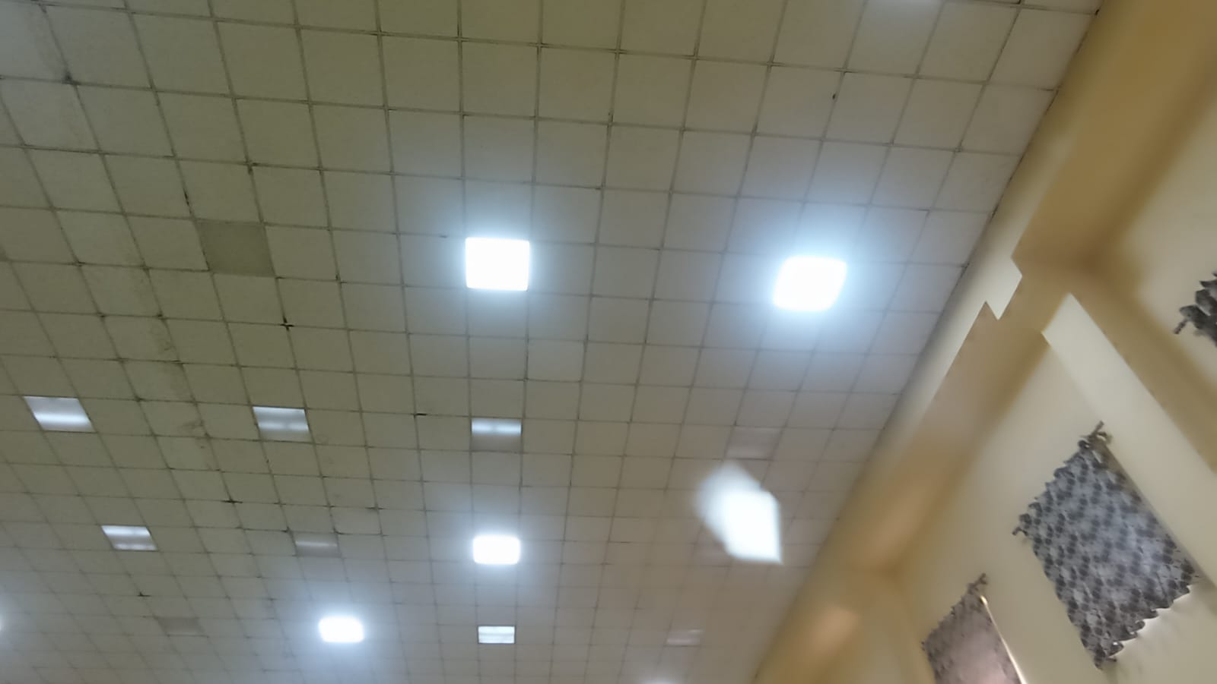
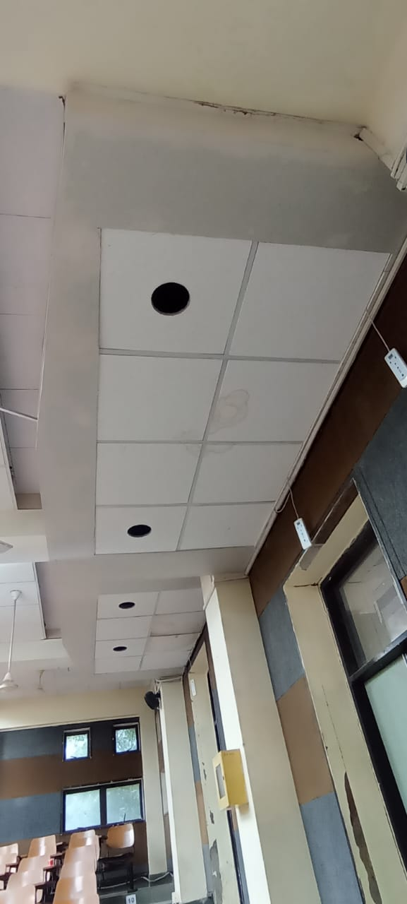

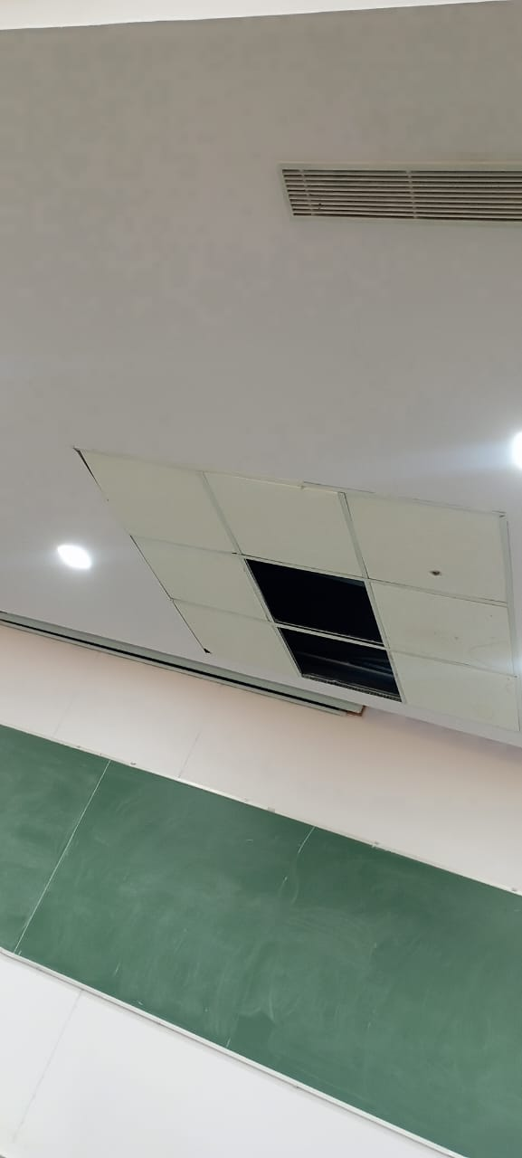

Commercial Bid: (in separate sealed envelope)

Bid for “Providing and Fixing of false ceiling/ false tiles repair and replacement work as already existing works in the buildings”

S.No. | Item Name/ Description | Qty. | UOM | Rate | Amount
1 | Providing and Fixing of false ceiling/ false tiles repair and replacement work as already existing works in the buildings upto the maximum height of 9m, including scaffolding, and other required tools n materials for the work completion.  False ceiling/ tiles size 600 mm x 600 mm | 350 | Sqft.
Total
GST
Total including GST

- Taxes like GST shall be clearly mentioned. If nothing is mentioned, these charges shall be deemed included.
- If the supplier does not have a particular item offered in the tender or a different make is being proposed by him, the same should be highlighted/mentioned especially by him.
- The prices should be including all (Packing, forwarding, Transit Insurance, Transportation Loading/unloading, Installation etc.). Loading/unloading up to 50 Mtr. shall be done by the supplier.
- Bid should be submitted for F.O.R delivery at the destination i.e. The LNM Institute of Information Technology, Gram – Rupa Ki Nangal, Post – Sumel, Via – Jamdoli, Jaipur- 302031
- Bid should be valid for a minimum period of 30 days. The Change in prices shall not be accepted within the validity period.
- The LNMIIT reserves the right to reject any quotation(s) without assigning any reasons.
- Payment terms shall be decided mutually.
- There should not be any conflict of interest (Declaration to be submitted by the Vendor).
- Bid should be on the company’s letterhead and should submit their bid in the LNMIIT format only
- Item/Service not supplied by the supplier/service provider should be mentioned separately.
- Vendor should provide a photocopy of the cheque/cancelled cheque while presenting the Invoice to LNMIIT.
- Pre-bid meeting and pre-bid site visit can be done before quoting the rate in the tender to clear up any confusion regarding project details, the scope of work, and solicitation of documents.

All charges applicable shall be clearly mentioned with the offer. If nothing is mentioned in the offer, the quoted price shall be treated as final, and nothing extra shall be paid extra.

Signature with seal

