

TENDER DOCUMENT

for
Supply and Installation of 50 LPH Capacity Reverse Osmosis (RO) System with Grade 304 Stainless Enclosed Body

From

The LNM institute of Information Technology
Rupa Ki Nangal, Post - Sumel, Via – Jamdoli,
Jaipur – 302 031 (Raj.) INDIA

The LNM Institute of Information Technology, Jaipur

TENDER DOCUMENT

The LNM Institute of Information Technology, Jaipur is a Deemed-to-be-University, set up as a Non-Profit Making institute engaged in imparting higher learning in Engineering, Technology and Science. We are located at Gram-Rupa Ki Nangal, Post-Sumel, Via-Jamdoli, Jaipur, Pin 302031 Rajasthan, under the joint venture of the Government of Rajasthan and Lakshmi & Usha Mittal Foundation.
The institute invites proposals from competent vendors for “Supply and Installation of 50 LPH Capacity Reverse Osmosis (RO) System with Grade 304 Stainless Enclosed Body”. Bidders can submit their sealed offers/s at the following address by Email/Speed-Post/ Registered Post/ By-hand (but not by Courier)/ before 05:00 PM on 10-12-2023.

Finance Officer
The LNM Institute of Information Technology,
Gram – Rupa Ki Nangal, Post – Sumel,
Via – Jamdoli, Jaipur- 302031
www.lnmiit.ac.in

Bidders can also submit their offer/s via Email with password protected document/file at the below mentioned email IDs before 05:00 PM on 10-12-2023.

The Password protected document/file along with password to be sent at the email id: Chairman-PCC subcommittee chairman.pcc.projects@lnmiit.ac.in

Bid Process:
Technical & Commercial details on the company’s letterhead, duly signed and sealed by the authorized signatory are required to be submitted in two separate envelopes/files. Both envelopes/files should be duly marked as “Technical bid for “Supply and Installation of 50 LPH Capacity Reverse Osmosis (RO) System with Grade 304 Stainless Enclosed Body” and “Commercial Bid for “Supply and Installation of 50 LPH Capacity Reverse Osmosis (RO) System with Grade 304 Stainless Enclosed Body” respectively. Both Envelopes shall be enclosed in a single envelope bearing the heading “Bid for “Supply and Installation of 50 LPH Capacity Reverse Osmosis (RO) System with Grade 304 Stainless Enclosed Body”.
Bids are liable to be rejected if any or both technical or commercial offers are found in open condition or required information is not found with the offer.

Technical Bid: (in a separate sealed envelope)
While submitting quotations, the following procedure/ formalities and conditions may kindly be adhered.
- Company profile or brief note about the bidder's company, PAN number, and GST number should be submitted by the Vendor.
- The List of Directors/Partners/Proprietor/Members of the Firm to be attached.
- Detail of other associated/sister concerns (if any) of Directors/Partners/ Proprietor/ Members to be provided.
- Turnover for the last three years to be mentioned. (Copy to be enclosed)
- List of the client to whom the vendor has delivered the goods or provided the services in the past.
- Details of similar works carried out during FY 2020-21, 2021-22, 2022-23. (Attach copies)

Year | Name of the Organization | Work order ref. and Date

- Specification as mentioned below, shall be provided as per the details given below:

Name and signature of Vendor

Seal

Date:
Place:

Scope of Work, Technical Data Sheet, and Specification of the Item/s

Supply and Installation of 50 LPH Capacity Reverse Osmosis Systems with Grade 304 Stainless Steel Enclosed Body

Technical Specification of 50 LPH R.O System

- DESIGN BASIS:
The chemical composition of raw water is considered as follows:
T D S | : 2000ppm
- PRODUCT WATER QUALITY
TDS: <100 ppm
- SCOPE OF SUPPLY FOR R.O. PLANT & FACILITIES:
- Technology: RO+UV+UF+TDS Control
- Operation Mode: Automatic
- Membrane: Thin Film composite (Spiral Bound) – Multilayer
- Purification Capacity: 50 Liters per Hour (LPH)
- Storage Tank: 100 Liters
- Filter Cartridge: Sediment, Activated Carbon, UF, Post Carbon
- Number of Purification Stages: 7 Nos.
- Power Consumption: 75 Watt
- Voltage: 230 V AC
- Frequency: 50 Hz
- Dimensions (L x W x H): 300 x 485 x 840 mm
- Weight: 45 Kg
- Made By: - KENT/AQUAGUARD Reviva/HI- TECH/MAXPURE/ DOUCHE
- Warranty: 2 Years
- ACTIVATED CARBON FILTER
- Make and size: Wave Cyber
- MICRON FILTER
Housing:
• Make: Amete / Gentee, USA
Cartridge:
• Make: Filterite / Pratham /Ametek USA

- R.O. MEMBRANES
• Make of Membrane: Hydraunatics / Koch / Dow / Trisep (All USA)
• System Recovery: 50-60 %

- ELECTRICAL PANEL
A control panel is provided as a safety measure for the pump & other electrical
items.
• Puss Buttons
• Incomer, Auto manual Switches

8. Pipeline
- CPVC pipeline from sand filter to high pressure pump and CPVC pipe from high pressure pump to end point of system.
- Type of Body: Enclosed & Wall mounted body
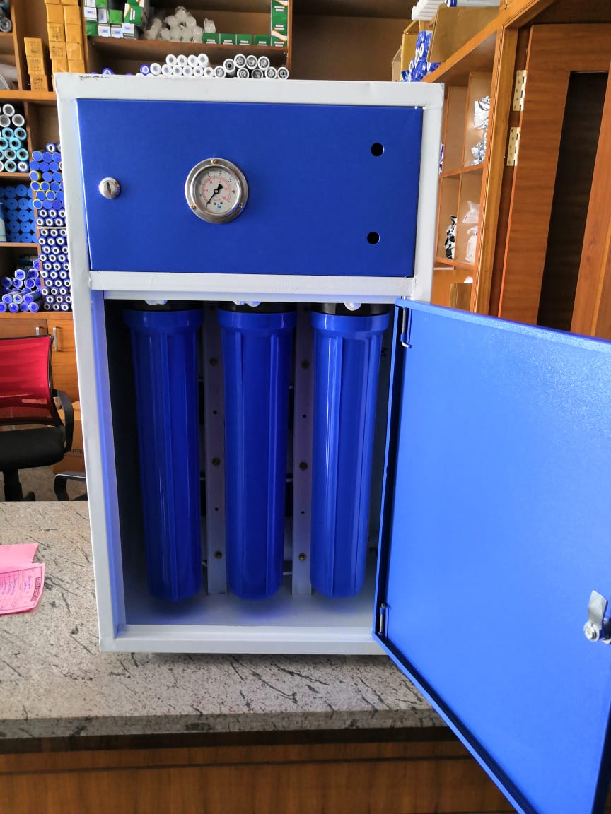

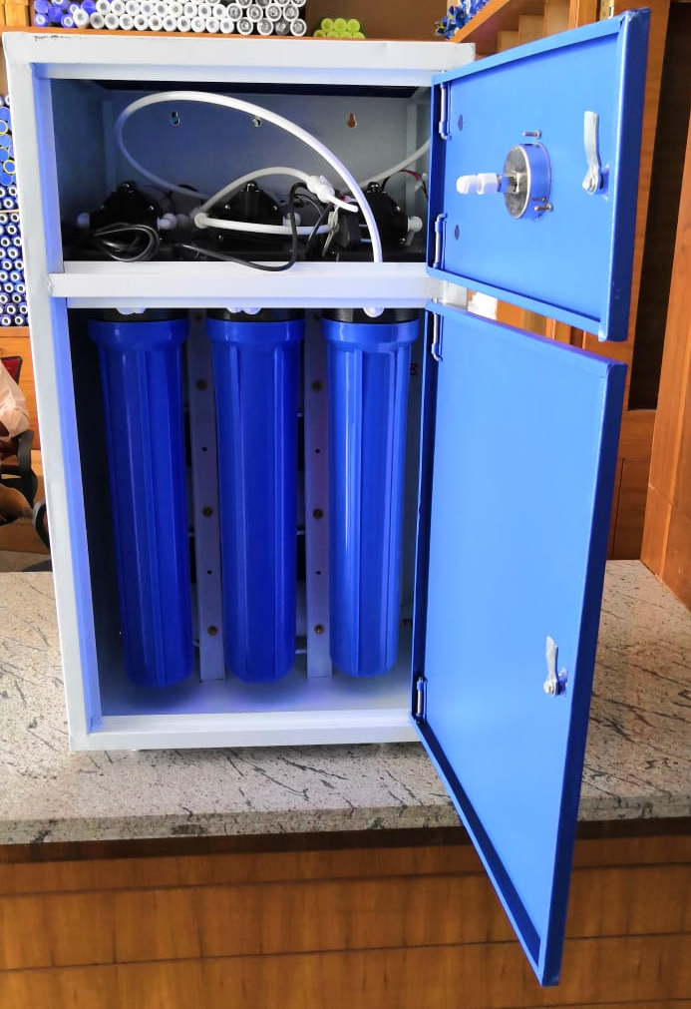

Commercial Bid: (in separate sealed envelope)

Bid for “Supply and Installation of 50 LPH Capacity Reverse Osmosis (RO) System with Grade 304 Stainless Enclosed Body”

S.No. | Particulars | Make | Qty. | UOM | Rate | Amount
1 | Supply and Installation of 50 LPH Capacity Reverse Osmosis (RO) System with Grade 304 Stainless Enclosed Body |  | 2 | Nos.
GST @18%
Total with GST

- Taxes like GST shall be clearly mentioned. If nothing is mentioned, these charges shall be deemed included.
- If the supplier does not have a particular item offered in the tender or a different make is being proposed by him, the same should be highlighted/mentioned especially by him.
- The prices should be including all (Packing, forwarding, Transit Insurance, Transportation Loading/unloading, Installation etc.). Loading/unloading up to 50 Mtr. shall be done by the supplier.
- Bid should be submitted for F.O.R delivery at the destination i.e. The LNM Institute of Information Technology, Gram – Rupa Ki Nangal, Post – Sumel, Via – Jamdoli, Jaipur- 302031
- Bid should be valid for a minimum period of 30 days. The Change in prices shall not be accepted within the validity period.
- The LNMIIT reserves the right to reject any quotation(s) without assigning any reasons.
- Payment terms shall be decided mutually.
- There should not be any conflict of interest (Declaration to be submitted by the Vendor).
- Bid should be on the company’s letterhead and should submit their bid in the LNMIIT format only.
- Item/Service not supplied by the supplier/service provider should be mentioned separately.
- Vendor should provide a photocopy of the cheque/cancelled cheque while presenting the Invoice to LNMIIT.
- Pre-bid meeting and pre-bid site visit is mandatory before quoting the rate in the tender to clear up any confusion regarding project details, the scope of work, and solicitation of documents.
- In case of any query, please contact.

Mr. Ashok Salecha,
Finance Officer finanace@lnmiit.ac.in,
Mobile number-9413341246

Request kindly attach your company Profile.

All charges applicable shall be clearly mentioned with the offer. If nothing is mentioned in the offer, the quoted price shall be treated as final, and nothing extra shall be paid extra.

Signature with seal

