

TENDER DOCUMENT

for
Supply and Installation of 250 LPH Capacity Reverse Osmosis (RO) System with Grade 304 Stainless Enclosed Body

From

The LNM institute of Information Technology
Rupa Ki Nangal, Post - Sumel, Via – Jamdoli,
Jaipur – 302 031 (Raj.) INDIA

The LNM Institute of Information Technology, Jaipur

TENDER DOCUMENT

The LNM Institute of Information Technology, Jaipur is a Deemed-to-be-University, set up as a Non-Profit Making institute engaged in imparting higher learning in Engineering, Technology and Science. We are located at Gram-Rupa Ki Nangal, Post-Sumel, Via-Jamdoli, Jaipur, Pin 302031 Rajasthan, under the joint venture of the Government of Rajasthan and Lakshmi & Usha Mittal Foundation.
The institute invites proposals from competent vendors for “Supply and Installation of 250 LPH Capacity Reverse Osmosis (RO) System with Grade 304 Stainless Enclosed Body”. Bidders can submit their sealed offers/s at the following address by Email/Speed-Post/ Registered Post/ By-hand (but not by Courier)/ before 05:00 PM on 31/03/2024.

Finance Officer
The LNM Institute of Information Technology,
Gram – Rupa Ki Nangal, Post – Sumel,
Via – Jamdoli, Jaipur- 302031
www.lnmiit.ac.in

Bidders can also submit their offer/s via Email with password protected document/file at the below mentioned email IDs before 05:00 PM on 31-03-2024.

The Password protected document/file along with password to be sent at the email id: Chairman-PCC subcommittee chairman.pcc.projects@lnmiit.ac.in

Bid Process:
Technical & Commercial details on the company’s letterhead, duly signed and sealed by the authorized signatory are required to be submitted in two separate envelopes/files. Both envelopes/files should be duly marked as “Technical bid for “Supply and Installation of 250 LPH Capacity Reverse Osmosis (RO) System with Grade 304 Stainless Enclosed Body” and “Commercial Bid for “Supply and Installation of 250 LPH Capacity Reverse Osmosis (RO) System with Grade 304 Stainless Enclosed Body” respectively. Both Envelopes shall be enclosed in a single envelope bearing the heading “Bid for “Supply and Installation of 250 LPH Capacity Reverse Osmosis (RO) System with Grade 304 Stainless Enclosed Body”.
Bids are liable to be rejected if any or both technical or commercial offers are found in open condition or required information is not found with the offer.

Technical Bid: (in a separate sealed envelope)
While submitting quotations, the following procedure/ formalities and conditions may kindly be adhered.
- Company profile or brief note about the bidder's company, PAN number, and GST number should be submitted by the Vendor.
- The List of Directors/Partners/Proprietor/Members of the Firm to be attached.
- Detail of other associated/sister concerns (if any) of Directors/Partners/ Proprietor/ Members to be provided.
- Turnover for the last three years to be mentioned. (Copy to be enclosed)
- List of the client to whom the vendor has delivered the goods or provided the services in the past.
- Details of similar works carried out during FY 2020-21, 2021-22, 2022-23. (Attach copies)

Year | Name of the Organization | Work order ref. and Date

- Specification as mentioned below, shall be provided as per the details given below:

Name and signature of Vendor

Seal

Date:
Place:

Scope of Work, Technical Data Sheet, and Specification of the Item/s

Supply and Installation of 250 LPH Capacity Reverse Osmosis Systems with Grade 304 Stainless Steel Enclosed Body

Technical Specification of 250 LPH R.O System

DESIGN BASIS:
The chemical composition of raw water is considered as follows:
T D S | : 2000ppm
PH | : 7.5
PRODUCT WATER QUALITY
TDS : <100 ppm
PH: 7.6
SCOPE OF SUPPLY FOR R.O. PLANT & FACILITIES:
Flow Rate: 250 Liters per Hour
Raw Water Feed Flow: 1500 Liters per Hour
Recovery: 50-60%
1. RAW WATER PUMP
- Flow Rate: 1500 LPH
- Head: 35 m
- Power: (.5HP)
- Quantity: 2 Nos.
- Make: Kirloskar / Crompton Greaces /CRI
- Type : Self Priming Centrifugal
- Pressures : 3-4 Kg/Cm2
2. MULTI GRADE/PRESSURE SAND FILTER
- Make and size: Wave Cyber (1054)
- MOC: FRP
- Dia :10 Inch
- Height :54 Inch
- Back Wash time : 10 to 15 minutes
- Quantity: 1 Nos.
- Multi-Port Valve : ¾ Inch
- Volume : 50 Liter

3. ACTIVATED CARBON FILTER
- Make and size: Wave Cyber (1054)
- MOC: FRP
- Quantity: 1 No.
- Equipped with 1” Muli port Valve, Media and respective Pipeline
- Dia : 10 Inch
- Height : 54 Inch
- Volume : 50 liter
4. ANTISCALANT DOSER
Antiscalant dosing system
- Pump Type: Electronic Metering/Electronic Diaphragm type
- Pump Flow: Maximum 0-5 Liters / Hour
- Maximum Pressure: 5-6 Bar
- Tank MOC: HDPE
- Tank Capacity: 100 Ltrs
- Power requirement: 25 W
- Dosing pump: 1 Nos.
- Make : I- smart /Kyro or Equivalent
5. MICRON FILTER
Housing:
• Make : Amete / Gentee, USA
• MOC of Housing : PP
• Length X Diameter : 20” X 4”
• Quantity : 1 No.
Cartridge:
• Make: Filterite / Pratham /Ametek USA
• Cartridge MOC: Polypropylene
• Length: 20”
• Diameter: 4”
• Quantity: 1 No.
• Micron rating: 5 Micron

6. HIGH PRESSURE PUMP
• MOC: Stainless Steel
• Type: Vertical Centrifugal Multistage
• Flow Rate: 3500 Liters per Hour
• Head: 125 M
• Power Supply: 2 HP, 220 V
• Make: C.R.I/Shakti /Lubi
• Quantity: 2 Nos.
7. R.O. MEMBRANES
• Type of Membrane: HR /TFC (Poly Amide)/ OVEY/UKL
• Diameter of Membrane: 4.0 inch
• Length of Membrane: 40 inch
• No. of Membrane: 1
• Make of Membrane: Hydraunatics / Koch / Dow / Trisep (All USA)
• System Recovery: 50-60 %
8. R.O. HOUSING
Specifications
• MOC: FRP
• Diameter of Pressure Vessel: 4 inch
• Length of Pressure Vessel: 40 inch
• No. of Pressure Vessels: 1
• No. of Membrane per Vessel: 1
• Make: Advance / Wave Cyber/Sealux
• Position: Horizontal
9. R.O. CLEANING/ FUNGUS REMOVAL SYSTEM:
• Flushing time: 20 Minutes
• Flushing Media: Treated Water / Chemical
• Flushing Tank Size: 100 Ltrs
• Tank MOC: HDPE (Sintex / Sheetal)
10. FLUSHING PUMP
• Flow Rate: 1000 LPH
• Head: 35 M
• Power: (.5HP)
• Quantity: 1 No

11. ELECTRICAL PANEL
A control panel is provided as a safety measure for the pump & other electrical
items.
• Complete Starters, Overload Relays, Single Phase Preventer for Pump
• Voltmeter, Ammeter, MCB’s, Indicating Lights
• Puss Buttons
• Rocker switches for dozers
• Incomer, Auto-manual Switches
12. INSTRUMENTATION
• Rotameter : To measure the online flow of water
• Low Pressure Switch : To Protect RO Pump from dry running
• High Pressure Switch : To protect RO pump from back pressure
• Pressure Gauges : For calculate ^P for each unit in RO System
• Rotameter:
• Quantity : 2 Nos (permeate & Reject Line)
• Flow Rate : 3000 ltr/hr
• Pressure Switch:
• Quantity : 2 Nos (Low & High)
• Range : 20 – 125 psi
• Make : Orion / Eqv, India
• Pressure Gauges
• Quantity : 5 Nos
• Range : 0 – 7, 0 – 21 bar
• Dial Size : 2.5 inch
• Type : Line Mounted / Panel Mounted
• Make : Dynamic / Gluck / Reputed, India
13 Pipe Line
- CPVC pipe line from sand filter to high pressure pump and CPVC pipe from high pressure pump to end point of system.
- Type of Body : Enclosed & floor mounted body
14. SCHEDULE OF EXCLUSION:
1. All Civil Works such as plant foundation of the equipment’s, mass concreting etc.
2. Supply of power to Motors, regeneration chemicals for trial run and commissioning.
3. Laboratory testing facility, Instruments and reagents.
4. Lubricants, oil and Greece as and when required.
5. Raw water storage tank and Raw Water Pump.
6. All equipment’s, works and services not specifically mentioned in our proposal.
7. Storage and site security.

15. TERMINATION POINTS:
1. Suction of Raw Water Pump.
2. Permeate / Reject Out Let of Reverse Osmosis System.
3. Outlet of Final U.V. Outlet Water.
4. Overflow or drain pipe work of all vessels.
5. Power control termination at High pressure pump, RO Product / Raw water transfer pump.
16. PRE-TREATMENT SCHEME
A. PRE-TREATMENT: MULTI GRADE SAND FILTER
The Raw Water from the Raw Water Storage tank is passed through Multi Grade Sand Filter. Before passing through the sand filter the water is chlorinated in Raw Water tank and effective chlorination will be possible only if retention is provided for 2-3 hrs. This is a FRP Pressure vessel with internal arrangements and Media of different grades of Sands. The Purpose of Sand Filter is for reduction of Turbidity and Suspended Solids. The Filter should be backwashed whenever the Pressure drop increases beyond 0.8 Kg/cm2 or after 22 Hrs of operations, whichever occurs first.
ACTIVATED CARBON FILTER
From Sand Filter the Filtered Water is passed through Activated Carbon Filter. The Activated Carbon Filter is a FRP pressure vessel having a bed of carbon in order to remove the Color, Odour& Traces of Organics & free chlorine present in the filter water.
ANTISCALENT DOSING PUMP:
We are proposing Antiscalent dosing system, which prevents saturation of various organic salts on R.O. membrane surface. The system comprises of dosing pump and solution preparation tank.
MICRON CARTRIDGE FILTER
We have provided micron filter unit, which removes fine suspended solids, which may have escaped from upstream units. This unit can remove fine solids up to 5 micron, which if carried over can clog the RO membrane.
B. R.O. SECTION.
HIGH PRESSURE PUMP
The Filtered Water is then pumped to a R.O. System through a High Pressure Pump. For the
development of High pressure required for RO System we have offered HORIGENTAL PROCON Pumps.
REVERSE OSMOSIS SYSTEM
the R.O. System consists of spirally wound R.O Membranes with FRP Pressure tubes. The R.Osystem is offered for Salt reduction so as to achieve the desired treated water quality. Normally the RO Membranes has a salt rejection of 90-95% as per manufacturer standard tests procedures.

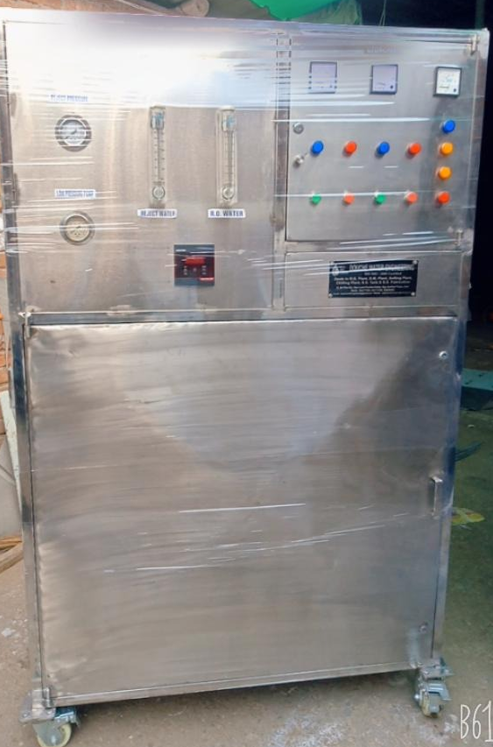

Made By: - KENT/AQUA GUARD/HI- TECH/MAXPURE/ DOUCHE
Warranty: 2 Years

Commercial Bid: (in separate sealed envelope)

Bid for “Supply and Installation of 250 LPH Capacity Reverse Osmosis (RO) System with Grade 304 Stainless Enclosed Body”

S.No. | Particulars | Make | Qty. | UOM | Rate | Amount
1 | Supply and Installation of 250 LPH Capacity Reverse Osmosis (RO) System with Grade 304 Stainless Enclosed Body |  | 2 | Nos.
GST @18%
Total with GST

- Taxes like GST shall be clearly mentioned. If nothing is mentioned, these charges shall be deemed included.
- If the supplier does not have a particular item offered in the tender or a different make is being proposed by him, the same should be highlighted/mentioned especially by him.
- The prices should be including all (Packing, forwarding, Transit Insurance, Transportation Loading/unloading, Installation etc.). Loading/unloading up to 50 Mtr. shall be done by the supplier.
- Bid should be submitted for F.O.R delivery at the destination i.e. The LNM Institute of Information Technology, Gram – Rupa Ki Nangal, Post – Sumel, Via – Jamdoli, Jaipur- 302031
- Bid should be valid for a minimum period of 30 days. The Change in prices shall not be accepted within the validity period.
- The LNMIIT reserves the right to reject any quotation(s) without assigning any reasons.
- Payment terms shall be decided mutually.
- There should not be any conflict of interest (Declaration to be submitted by the Vendor).
- Bid should be on the company’s letterhead and should submit their bid in the LNMIIT format only.
- Item/Service not supplied by the supplier/service provider should be mentioned separately.
- Vendor should provide a photocopy of the cheque/cancelled cheque while presenting the Invoice to LNMIIT.
- Pre-bid meeting and pre-bid site visit is mandatory before quoting the rate in the tender to clear up any confusion regarding project details, the scope of work, and solicitation of documents.
- In case of any query, please contact.

Mr. Ashok Salecha,
Finance Officer finanace@lnmiit.ac.in,
Mobile number-9413341246

Request kindly attach your company Profile.

All charges applicable shall be clearly mentioned with the offer. If nothing is mentioned in the offer, the quoted price shall be treated as final, and nothing extra shall be paid extra.

Signature with seal

